Final Technical Report August 1975
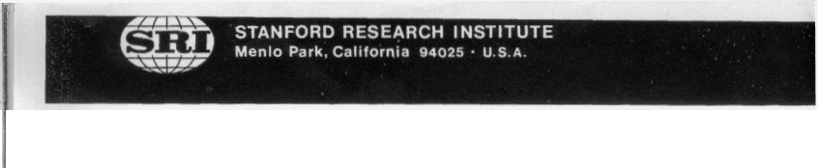
REPRODUCED BY: NTIS U.S~ Department of Commerce
National Technical Information Service Springfield, Vir~jir,iu 22161
ADAOI 7405

FEASIBILITY STUDY FOR DESIGN OF A BIOCYBERNETIC COMMUNICATION SYSTEM

Prepared for:

DIRECTOR, ADVANCED RESEARCH PROJECTS AGENCY
ARCHITECT BUILDING, 1400 WILSON BOULEVARD
ARLINGTON, VIRGINIA 22209
Attention: DR. GEORGE LAWRENCE, PROGRAM MANAGER

ARPA Order No. 2034 CONTRACT DAHC-15--72-C-0167
Program Code No. 2020 Principal Investigators:
Contractor: Stanford Research Institute Dr. L. R. Pinneo
Effective Date of Contract: (415) 326-6200 (Ext. 3666)
9 February 1972 Mr. D. J. Hall
Contract Expiration Date: (415) 326-6200 (Ext. 3729)
31 August 1975 Short Title:
Amount of Contract: $338,254 Biocybernetic Communication

SRI Project LSU-1936

Approved by:

W.A. SKINNER.’ Executive Director
Life Sciences Division

CONTENTS

LIST OF ILLUSTRATIONS v

LIST OF TABLES ix

PREFACE xi

ACKNOWLEDGMENTS xiii

SUMMARY 1

Part I- -Biocybernetic Communication
Off-Line Analysis, Overt Classification
Off-Line Analysis, Covert Classification .
Articulatory, Semantic, and Contextual Components
On-Line Analysis
Conclusions
Part Il--Hemispheric Laterality
Dichotic Correlations
EEC Asymmetry and Word Classification
Target Recognition and EEG Alpha Asymmetry . .
2
2
3
3
4
6
.. 7
7
.. 7
9

Rationale of Approach, Biocybernetic Communication
Rationale of Approach, Hemispheric Laterality
13
15
Introduction 17
Off-Line Analysis, Overt Classification 17
Subjects 17
Apparatus 17
Procedure 22
Data Analysis 23
Results 34
Analysis of Covert Speech 44
Introduction 44
Methods 44
Results 45
Error Reduction 48

PART 1--BIOCYBERNETIC COMMUNICATION (Continued)

Articulatory, Semantic, and Contextual Components 50
Introduction 50
Subjects and Apparatus 52
Language Task 52
Procedure 53
Data Collection and Analyses 53
Results 54
On-Line Analysis 64
Introduction 64
Methods and Procedures 65
Results 67
Concluding Statement About On-Line Analysis 73

DISCUSSION OF BIOCYBERNETIC COMMUNICATION 77

PART II- -HEMISPHERIC LATERALITY 81

Introduction 81

Dichotic Correlations 82
EEC Asymmetry and Word Classification 84
Introduction 84
Methods 86
Results 91
Discussion 96
Target Recognition and EEG Alpha Symmetry 106
Introduction 106
Experiment 1- -EEG Asymmetry and Performance 108
Methods 108
Results 118
Discussion 126
Experiment 2--On-Line Trigger of Words and Patterns by
EEC Alpha Power Asymmetry 132
Methods 133
Results 133
Experiment 3--Asymmetry of Contingent Negative
Variation 138

REFERENCES 143

1 Muscles of the Face . 19
2 Electrode Placements for 10/20 System of EEG Recording . . . 20
3 Block Diagram of Stimulus, Recording, and Data Processing
Equipment 21
4 Dynograph Recording of Stimulus—Response of EMG and EEC
for the Word “COOL” 25
5 Plots of Linc—8 CRT for Time Justification of Electro—
physiological Response to Word “TIP” with Onset of Vocal
ization at t = 3 Seconds 26

6 Averaging of EMG Responses (Electrode 13/16) for Word 28
7 Classification of TIP 2 as TIP with Respect to Another
Template (COOL) Using RNS Difference 29
8 F—Ratios for EMG Electrode 13/16, Subject C5, All Words . 31
9 F—Ratios for Subject C5, EEG Electrode F7, All Words . . . . 32
10 Templates (Averages of 10 Responses Each) for the Six
Electrodes, Subject C5, for the Word COUGHDROP 35
11 Variability of Average Responses of the Six Electrodes,
Subject C5, for the Word COUGHDROP 36
12 Two EMG Responses (Electrode 13/16, Subject CS) to TIP,
Confused with COOL Due to Time Shift and Amplitude
Variation 42
13 EEC Responses Accompanying Overt and Covert Verbal Reading
of SCHOOLBOY, Subject B7 46
14 Stability of Response as Shown in Templates for EEG
Electrode T5 for Same Subject on Different Sessions and
for Overt and Covert Conditions, Subject B 47
15 Templates for All Electrodes for CVC Words PAN and BAN,
Subject Y2 55
16 Templates for All Electrodes for CVC Words MAN and FAN,
Subject Y2 56

17 Templates for All Electrodes for Homonyms WRITE and RITE,
Subject Y2 57
18 Templates for All Electrodes for Homonyms RIGHT and RIT,
Subject Y2 58
19 Visual Pattern Recognition and Time Justification for
Subject SM, Session 1, Class 6 74
20 Stimuli for the Music Task and the Combined Music and
Verbal Task 87
21 Sample Chart Page Showing EEG Channels, CNTLSTIN Interval,
and Voice Response 89
22 Alpha Amplitudes of Stutterers and Nonstutterers During
Verbal, Music, and Combined Tasks for Combined Sessions 92
23 V/M Ratios in Individual Right—Eared Stutterers and
Nonstutterers 97
24 V/M Ratios in Individual Nonright—Eared Stutterers and
Nonstutterers 98
25 Moderately Difficult Set of Dot Patterns Used in the
Spatial Task 110
26 Example of Mean Square Difference Display with Variable
Upper and Lower Thresholds 113
27 Average EEC Frequency Spectra from Three Subjects Showing
Individual Differences of Spectral Shapes in the Alpha
Band and the Limits Set for Alpha Activity in These
Subjects 119
28 Average Parietal and Occipital Alpha Power in Verbal and
Spatial Tasks 120
29 Average Parietal and Occipital Alpha Frequency in Verbal
and Spatial Tasks 121
30 Reaction Time as a Function of Performance Set, R/L Average
Power, R/L Alpha Frequency, R/L Activation Index =
Frequency/Power 124
31 Comparison of RT Performance and EEG Alpha Power Asymmetry
Ratios Using Two Different Methods of Defining the Alpha
Band——On an Individual Basis for Each Subject or in a
Standard Manner 127
32 Examples of Average Evoked Potentials to Patterns and Words
in Right and Left Parietal Cortex 129

33 Number of Instances in 15 EEG and Performance Measures
that Each Subject Deviated from the Average Trend Across
Subjects . . . 130
34 Mean Reaction Time as a Function of EEG Alpha Power
Assymetry When Subject PY’s Data Were Normal or Reversed
in Light of EP Differences, Suggesting a Right Hemisphere
Language Location in the Subject 131

35 Equipment Configuration Used to Detect and Display Hemisphere
Differences in Mean Square EEG Alpha Activity 134
36 Example of Bilateral EEG Tracings, Their Mean Squares, and
the Difference of Mean Square Voltage in the Two Hemi
spheres 135
37 Example from One Subject of Average CNVs from Left and Right Parietal
Areas During Performance in a Word— Anticipation and -Discrimination Test that was Intermixed
with a Spatial Task . . 140

38 Average CNV Amplitudes Across Subjects in Parietal and
Frontal Leads During Anticipation of Words or Patterns . . 141

1 Language Task Words 22
2 Nearest Percentage of Correct Responses and Rank Order of
Electrodes as Classifiers, Sample Points 101—200, Subject C,
Within and Between Sessions 38
3 Nearest Percentage of Correct Responses and Rank Order of
Electrodes as Classifiers, Sample Points 101—200, All
Subjects, All Sessions 39
4 Summary Confusion Matrix, All Subjects, All Channels, Within
Sessions . 41
5 Percentage of Correct Response—Word Classifications for EEC
for Overt and Covert Speech for Subject B7 . . . . 48
6 List of Words, Phrases, and Controls Used for Testing
Articulatory and Semantic Components 52
7 Percentage of Correct Responses for All Subjects and Sessions,
Within Session Classification, Sample Points 104—210 59
8 Summary Confusion Matrices for All Subjects and Sessions,
EMG and EEG Responses 61
9 Ratios of Number of Correctly Classified Responses to Number
of Confused Responses Within Confusion Blocks for EMG and
EEG . . 62
10 Normal Curve Deviations (Z) for the Significance of the
Differences Between Various Ratios in Table 9 63
11 Typical Sheet for On—Line Analyses 68
12 Percentage of Correct Classification of Initial On—Line EEG
for Each Subject on Best Word and Over All Words for Overt
andCovertSpeech 69
13 Rank Order Comparison Between Hemispheric EEC Dominance and
Ear Dominance 83
14 Verbal—to—Music Ratios (VIM) of Average Alpha Amplitude . . 93

15 Rank Correlation Between T3 V/N Ratios and Dichotic Scores 95
16 Percentage of Correct Word Classification by Dichotic Groups
and Alpha Asymmetries 101

17 Rank Correlation Between Percentage of Correct EEG Classification
(All Temporal Electrodes) and Strong Dichotic Ear
Preference 103

18 Correlation Between Percentage of Classification and V/M
RatioatT3 104
19 Word Categories 109
20 Performance Data 112
21 Example of Computer Quantification of EEC Spectra 115

22 Mean Reaction Times and R/L Ratio Scores in Four Performance
Sets 123

23 Means and Standard Deviations of RT as a Function of R/L
Asymmetry Scores 125

24 Mean RT as a Function of Task and Hemisphere During On-Line
Triggering of Stimuli 136

25 Number of Subjects with RT Patterns Defined by the Four
Quadrants 137

PREFACE

The work described herein was carried out over the period 9 February 1972 through 30 June 1975. This report summarizes the work of many people on a complex topic. Most of the experiments and results have been detailed in the six semi—annual technical progress reports. This technical report describes only those relevant experiments that led to the conclusions discussed on page 77.

Various portions of this research program have been presented orally in several scientific forums. The participants made critical and constructive comments that, in most cases, were later incorporated into the project. The more important of these forums were the following:

• The San Francisco Bay Area Neurolinguistics Society meeting, Stanford University, Dr. Karl Pribram, Chairman.

• The Department of Linguistics, University of California, Berkeley, sponsored by Dr. William Wong.

• The Electroencephalographic Laboratory of the Langley Porter
Institute of Psychiatry, University of California Medical
Center, San Francisco, under the direction of Dr. Enoch
Calloway.

• The Brain and Language Symposium at the Brain Research Institute, University of California at Los Angeles, under the sponsorship of Dr. Donald Walters.

The most useful and critical forums, however, were the several Contractor’s Meetings of the ARPA—sponsored Biocybernetic Program, from which much valuable advice was received.

We thank the many individuals who participated substantively in this research. In particular, we acknowledge the contributions of Mr. David Hall, formerly of SRI and initially co—principal investigator, who helped formulate the original problem and guided the off—line pattern recognition programs; Mr. Daniel Wolf who wrote the off—line CDC—6400 computer programs that gave us the first sense of success; Mrs. Rebecca Mahoney who wrote the on—line Linc—8 programs and helped collect and analyze data; Dr. Richard Singleton who helped us analyze the many possible mathematical formulations so as to select the proper one for interpretation of the data; and Dr. Peter MacNeilage, Departments of Linguistics and Psychology, University of Texas at Austin, whose substantial knowledge of brain and language behavior aided us in solving many problems. The greatest gratitude is expressed to the subjects who sat unselfishly for boring hours repeatedly saying and thinking words, words, words

SUMMARY

The purpose of this three-year research program was to test the feasibility of designing a close-coupled, two-way communication link between man and computer using biological information from muscles of the vocal apparatus and the electrical activity of the brain during overt and covert (verbal thinking) speech.

The research plan was predicated on existing evidence that verbal ideas or thoughts are subvocally represented in the muscles of the vocal apparatus. If the patterns of this muscle activity are at all similar to those involved in normal overt speech, a reasonable assumption is that the electrical activity of the brain during verbal thinking may be similar to that during overt speech.

During the first two years, we simultaneously recorded electro— myographic signals from the facial muscles involved in speech and the correlated electroencephalographic (EEG) signals from overlying areas of the cerebral cortex involved in speech. We digitized the analog output for computer processing and, using statistics designed to reveal patterns of cortical activity, formulated a computer pattern-recognition program to identify features in the physiological data that were associated with specific words, whether overtly or covertly produced.

During the third year, we concentrated on improving predictive power, by searching and eliminating sources of error, and on devising computer programs for real-time analysis of the EEG, as would be used in an on-line biocybernetic communications system. In addition, extensive investigations were conducted on the role of cerebral hemispheric EEG asymmetry related to language and nonlanguage tasks and to performance.

The results are reported in two parts. Part I concerns the off-line and on-line analysis of the EEG coincident with overt and covert speech as it might be used in biocybernetic communication, and Part II concerns the hemispheric laterality difference.

Off-Line Analysis, Overt Classification

We conducted a computer analysis of EMG and EEC recordings from each of three subjects during performance of a language task on two separate occasions so as to determine whether the computer could correctly classify 15 overtly spoken English words based on these electrophysiological patterns alone. Several statistics later were applied to the EMG and EEC responses that were coincident with the 15 word utterances (each repeated ten Umes at each of the two sessions), but only one statistic was found useful for successful pattern recognition. This was based on calculating an average response for each electrode for the period three seconds before and three seconds after the onset of vocalization of a word. Each of the 15 average responses per electrode (six electrodes, or 90 average responses for the 15 words per subject per session) then served as a template against which individual responses were compared. These comparisons were made by calculating the RMS (root-mean-square) difference between a single response of each electrode and the 15 word templates for that electrode. The individual electrode response was then classified as the word for that template with which the RNS difference was a minimum.

The significant results were:

(1) Both EMG and EEG responses, taken separately or together, were used to classify any one or all of the 15 overtly spoken words. The percentage of correct classifications for all electrodes of the three subjects for two sessions each ranged from 9 to 84%.

(2) Out of 5,400 possible correct classifications across all subjects and sessions, 74% of the words were classified correctly by EMG responses alone, 63% by EMG plus all EEC responses, and 34% by EEC responses alone. Chi square tests of significance showed that these correct classifications would have occurred by chance with a probability of less than 1 in 1,000.

(3) Reliability within each subject from one session to the other was high. Templates for one session of a given subject could serve to classify words correctly based on EMC and EEG responses of the other session nearly as well as templates within a session. In addition, the rate of correct classifications was higher for the second session than for the first for all three subjects, indicating a learning or habituation effect that lowered response variability

(4) When templates of one subject were used to classify words based on individual responses of another subject, the percentage of correct classifications for EEG responses was no greater than chance expectation. The percentage
- of correct classifications for EMG was greater than chance, butnot nearly so good as within subjects. Thus, each subject’s biological patterns associated with speech appear to be unique.

(5) Six possible sources of error in word classification were identified, and their relative contribution to decreased success was evaluated. It was determined that, if all sources of error could be eliminated, significant gains in correct word classification using biological responses would be achieved (perhaps approaching 9O% or better).

We conclude from these results that it is feasible for a human to communicate verbally overtly with a computer, using biological information alone, with a high degree of accuracy and reliability, at least under conditions of a limited vocabulary.

Off-Line Analysis, Covert Classification

This portion of the report describes attempts to determine whether EEC responses associated with covert speech resemble those associated with overt speech of the same words and whether they also can be classified by the computer. Subjects were two right-handed female volunteers. Covert speech was defined as the silent reading of words visually projected on a rear-vision screen. Five words were used for each subject, and covert speech results were compared with overt speech results for the same subjects on the same words during the same session.

EEC responses for covert speech mimicked those of overt speech for the same subject, electrode, and spoken word. When sources of error were reduced as much as possible, correct computer classification rates ranged from 52 to 72%, which was significant at p < 0.001. We conclude that both overt and covert speech can be identified by computer classification of electrophysiological responses and that a practical biocybernetic communication system is feasible, providing the sources of error can be removed.

Articulatory, Semantic, and Contextual Components

These experiments were designed to determine whether semantic and motor components are in the EEG response and are associated with overt

speech. We compared computer classification of the EEC and EMG during speaking of similarly pronounced words and during speaking of homonyms.

When spoken in isolation, both similarly pronounced words and homonyms were classified poorly by the computer unless definite mechanical (articulatory) differences existed. However, the percentages of correct responses improved significantly, especially in the EEC, when the words were used in a contextual phrase, indicating a semantic discrimination when used in context.

On-Line Analysis

The results from the off-line computer analysis of the EEC coincident with overt and covert speech were sufficiently above chance expectation for us to conclude that a biocybernetic communication system, as originally proposed, is feasible. However, to be useful, such a communication system must be employable in real-time, with direct on-line communication between a man’s brain and a computer. The last section of Part I describes our results toward this end.

A total of 31 subjects were run for a total of 140 experimental sessions. Subjects were both male and female volunteers, ranging in age from 21 to 50 years. Data analysis included normalization of data, comparison of machine versus human time justification, template updating using an exponential decay method, and comparison of the Mean Square Difference method of EEG classification with a correlation method. A wide variety of parameters were investigated, including comparison of repetitively presented stimulus words versus random presentation, overt versus covert speech, left versus right versus both cerebral hemispheres, trained versus nontrained subjects, and “best word” percentage of correct classifications versus averages over all words.

The significant results were:

(1) On-line classification techniques using the Linc-8 computer provided EEC classification equal to or better than classification using the original off-line (CDC 6400) analysis techniques.

(2) Covert responses generally were classified correctly less often than overt responses, although the reverse was true in all cases for one subject and in two cases for another subject.

(3) In about half the subjects, the right hemisphere tended to be equal or superior to the left hemisphere and both hemispheres taken together in the classification of EEC responses to both overt and covert speech. For the other half, the left hemisphere tended to be superior.

(4) Practice was a vital element in improving classification, particularly for covert EEC responses. The data clearly indicated that words are classified correctly more often after the first few repetitions (i.e., practice responses).

(5) Single “best words” usually were classified correctly a high percentage of the time (70 to 100%), indicating the strong feasibility of improving overall correct classification rates.

(6) The “over all words” percentage of correct classification rates were lower than those for “best words.”

(7) EEGs associated with repetitively produced words were classified correctly significantly more often by on-line computer analysis than those for randomly produced words, suggesting that anticipation improves the consistency of the EEC associated with a particular word. This may be related to level or strength of cortical organization, in which good cortical organization for language may depend on preparation or set.

(8) Trained subjects generally had a higher percentage of correct classifications than nontrained subjects.

(9) The Mean Square Difference method of machine classification was slightly superior to the correlation method, although results were inconsistent across the various parameters.

(10) Exponential updating of templates was superior to simple averaging in machine classification.

(11) Human visual time justification was superior to machine time justification, significantly improving the percentage of correct classifications (up to 60%).

The above results were based on either single electrode analysis or analysis of the average response over four or eight electrodes. If eight individual responses were strung together as a single response, however, correct classification rates were improved up to 55%, without either visual or machine time justification.

Conclusions

Nan-machine interaction using the EEG coincident with overt or covert speech is feasible as a biocybernetic communication system. However, further research, especially in the areas of EEG variability, covert speech, and pattern recognition techniques, must be conducted before a practical system is realizable. From our observations, optimum parameters may be specified for an accurate brain-computer intercommunication system as follows:

(1) Subjects who have strong hemispheric lateralization for language should be chosen. This may be predetermined by dichotic listening tests (see Part II).

(2) As many as six to eight electrodes should be employed on the side of cerebral dominance for language, with emphasis on cortical areas involved in speech-, word-, and auditory-association areas.

(3) Subjects should be trained in the operating system, especially temporal training for covert responses, and to speak or think words as consistently as possible.

(4) Subjects should know what words will be said or thought next; i.e., they should have a “set” to respond.

(5) Words for speaking or thinking should have some meaning for the subject or should be used in a meaningful context.

(6) Data collected from each EEC electrode should be limited as nearly as possible to the time required for actual utterance or thought.

(7) Data from all EECs should be strung together in-line, as a single response, and should be smoothed sufficiently to eliminate high-frequency components.

(8) Pattern-recognition algorithms the computer employs should time-justify the single, combined response, much as a human observer would do with visual pattern recognition.

(9) Stored patterns shouldbe “refreshed” periodically (i.e., new templates should be formed and updated) to take account of “drifting” cortical organization.

No a priori evidence exists that cortical organization for language production or verbal thinking resides only in the sites we have chosen to place our EEC electrodes. Indeed, the evidence we and others have obtained shows that, in some people, cortical organization for speech occurs in several locations other than those investigated. Accordingly, three studies were carried out (two in depth) to determine the effects of laterality in language and nonlanguage tasks and the relationships between correct computer classification of speech and performance.

Dichotic Correlations

Dichotic listening denotes the simultaneous, bilateral presentation of two different auditory stimuli to determine performance differences between the two ears and, consequently, to demonstrate lateralization of function.

Eight right-handed subjects (who were presumably left hemisphere dominant for speech) were given dichotic listening tests for specification of hemispheric language dominance. The dichotic scores showed that four of the subjects were left hemisphere dominant, three were right hemisphere dominant, and one was bilateral. These scores were compared with percentages of correct computer classifications of EEC responses recorded from the right and left hemisphere, resulting in a positive and significant correlation (Rho = 0.78, p < 0.05). This suggests that hande4ness cannot be employed as a referent for electrode placements for biocybernetic communication, that percentages of correct EEC response classifications may be improved by giving the dichotic listening test before measurement, and that different EEG sites will be required for biocybernetic communication with different people.

EEC Asyrmnetry and Word Classification

The studies on biocybernetic communication showed that correct computer classification of EEC responses and hemispheric lateral dominance for language perception (dichotic listening) are positively and significantly correlated. In this study, subjects were chosen on the basis of known laterality differences (six stutterers, eight nonstutterers, all right-handed) found in language and music tasks, which then were compared for computer EEG classification (off-line) during overt speech.

Two measures were used to assess laterality of speech in righthanded stutterers and nonstutterers: (1) dichotic listening and

(2) asymmetrical changes in EEC alpha (8 to 12 Hz) during two vocal tasks--speaking and singing. Verbal to music ratios (V/M) of average alpha amplitudes were computed for each of four temporal EEC electrodes:
T3, T4, T5, and T6. V/N ratios at both left hemisphere sites were significantly lower (p < 0.05) than at right sites in right-eared nonstutterers but not in nonright-eared nonstutterers or in stutterers. Among nonstutterers, there was a significant positive rank correlation between dichotic scores and T3 V/N ratios (rs 0.81, p < 0.01): the greater the right ear preference, the lower the T3 V/M ratio. The same correlation in stutterers was slightly negative and nonsignificant.

When computer classification for the EEG during overt speech for these groups was compared, the results showed

(1) The percentage of correct classification in known speech areas (temporal leads) was greater than chance (often p < 0.05), whereas in nonspeech areas (parietal leads), the percentage of correct classification was no better than chance.

(2) No signifnicant differences were found in percentage of correct classifications between groups.

(3) No significant correlations were found among or between groups between hemispheres and percentage of correct classifications.

(4) There was a significant positive correlation between percentage of correct classifications and strong ear preference, indicating the greater the cortical organization for language, the more the EEC was consistently associated with a particular word.

(5) A significant and positive correlation was found between the percentage of correct classification of the EEC by computer during overt speech and the amount of laterality difference on language and nonlanguage tasks.

We conclude from these findings, and the results from repetitive data obtained in on-line analysis, that cortical organization in subject-dependent (i.e., some subjects have a more restricted cortical organization for language than others), and that percentage of correct computer classification rates are a function of this dependence as well as of a preparatory set to respond.

The second hemispheric laterality study was concerned with identifying asymmetrical function of the two cerebral hemispheres during language and nonlanguage tasks and relating any differences to performance.

Thirty—five subjects were given various tests for laterality, and 13 were given preliminary EEG evaluations. Computer-controlled tasks were designed to present either words or spatial patterns rapidly to each subject. The subject’s task was to discriminate between the patterns and words. EEC laterality measures then were correlated with the subject’s reaction time and discriminative performance.

Target Recognition and EEC Alpha Asymmetry

General Task Development

An experimental paradigm was conceived and developed that would lead presumably to differential engagement of right and left hemispheres in human subjects and would allow analysis of target detection performance, reaction time, EEG power spectrums, and visually evoked potentials to target and nontarget words and pattern stimuli.

Computer Program Development

Experimental Control- - Several programs were written for the Linc-8 to allow automatic presentation of verbal or spatial stimuli with control of several stimulus parameters such as stimulus duration, frequency, number of targets, number of task repetitions, and so on. Behavioral responses were categorized by the computer in terms of target and nontarget hits and misses, and reaction times for each category were obtained. Modification of the programs allowed on-line triggering of stimuli as a function of hemispheric alpha asymmetry. Either words or patterns alone or a mixture of words and patterns could be present.

Data Analysis--Programs were written to facilitate spectral analysis of EEGs and to obtain quantification of spectral parameters. One program, COOLEY, performed spectral analysis of sequential blocks of digitized EEGs and stored spectra on Linc tape. Another program, AVETYPE, obtained and printed several parameters of the spectra for any selected band, including average power, peak power, peak position (frequency), frequency centroid, and measures of alpha dispersion.

Experimental Results

EEG Asytmnetry and Target Recognition--Eight subjects screened for handedness and normal EEGs were tested in verbal or pattern target recognition. Right-hemisphere alpha was augmented in the spatial task

On-Line Trigger of Stimuli by EEG Asymmetry--Because alpha activity apparently reflects cortical “idling,” it was predicted that triggering a word stimulus with a relatively larger left-hemisphere alpha burst would result in slower reaction times to words than when they were triggered by right-hemisphere alpha increments. Of 11 subjects, four behaved as predicted, five behaved opposite the prediction, and two showed no consistent verbal-spatial relationship. Thus, in 9 of 11 subjects, the hemisphere responding most efficiently to patterns was the opposite of that responding most efficiently to words.

Volitional Trigger of Words and Patterns: Biofeedback--Observations were made in one subject under conditions where right-hemisphere alpha activity always triggered words and left-hemisphere alpha triggered patterns. The subject learned rather easily to increase the production of words--i.e., to augment the normal high incidence of right-hemisphere alpha- -but only with difficulty was she able to increase relative lef themisphere alpha and reduce it in the right hemisphere.

On-Line Trigger of Mixed Words and Patterns: Pattern Difficulty--The computer program was modified for evaluating an on-line paradigm where either left or right alpha increments triggered words or patterns randomly. Preliminary runs with two subjects suggested that pattern difficulty might be an important parameter influencing EEC-performance relationships. Six additional subjects were screened for handedness, and four were tested in this paradigm with variation of pattern difficulty. The data were generally unsatisfactory because of lack of alpha in two cases and excessive eye blinks and muscle artifacts in the other two. Pursuing this exact methodology further did not seem reasonable because of the technical difficulties. Mixing the verbal and nonverbal tasks seems to induce excessive stress and consequent artifacts. However, the use of alpha frequency in this paradigm might produce clearer results, as it should be less susceptible to artifactual disruption.

Asymmetry of Slow Potential Expectancy Waves--In some situations, slow potential changes in the brain indicated a change in functional state more clearly than spontaneous oscillatory EEC activity. The contingent negative variation (CNV) appears to reflect increased attentiveness and arousal, but the vertex CNV correlates poorly with reaction time. We hypothesized that asymmetries of CNVs might be related to hemispheric cognitive differences and might be related more closely to discriminative performance and reaction time than the vertex wave. Cognitive sets were included by using as the warning stimulus either words or patterns and as imperative stimuli either antonyms or synonyms of the words or the same or different patterns. Subjects were required to make differential motor responses to imperative stimuli that were the same or different than the warning stimulus. Parietal, frontal, and vertex placements were studied.

In parietal leads, CNVS tended to be larger in the left hemisphere preceding words and larger on the right preceding patterns, but the Task X hemisphere interaction was not statistically significant. That interaction was much clearer for fronto-temporal leads and was significant. Trends related to slow and fast reaction time trials suggested that performance is poor when interhemispheric arousal is patterned contrary to the cognitive demands of the task.

Analysis of Standard Alpha Band- -The EEG band from 9 to 12 Hz obtained in the original EEC-performance study was analyzed to check the assumption that establishing alpha bands on an individual basis was advantageous. No differences in EEG-performance relationships were noted when the two methods of establishing alpha were used.

Evaluation of one Subject with Possible Reversed Dominance--One subject’s EPs to patterns were largest in the left hemisphere, a configuration shown by no other subject; consequently, her data were scrutinized for other anomalies. Of 15 measures, she showed trends opposite the mean on 9 of them, whereas the highest number of anomalies for any other subject was 6. So that we could more adequately evaluate her dominance pattern, she was tested in a dichotic listening task. The resuits were ambiguous--she showed a right-ear (left hemisphere) superiority, but it was a very slight one. We concluded that the subject was not clearly left dominant and revised her performance data to determine the effect on mean scores. No effect was noted on the data for spatial patterns--i.e., the EEC performance trends were unchanged. However, for verbal data, the performance curve was made more linear, and the extreme scores became significantly different. These results suggest that the pattern of EP distribution between the hemispheres might be a very sensitive index of cerebral dominance.

This project was initiated to test the feasibility of designing a close-coupled, two-way communication link between man and computer using biological information. Specifically, experiments were devised to determine whether a computer can process this information meaningfully and whether similar biological processes representing the same or other thoughts can be induced in the same or another individual.

Possible applications of such a close-coupling between man and machine would include extremely rapid interactive processing between a man and a computer or communication between two or more persons with the computer acting as an interface. For example, an individual using such a biocybernetic communication system would be able to “talk” (i.e., both send and receive) with a computer at the speed of thought rather than be limited by the speed of a teletype or other electromechanical device through which ideas in the form of questions and answers normally must pass. In addition, nonverbal imagery and affective (emotional or “feeling”) states might be used similarly in the communication process, thereby significantly increasing the bandwidth of information transfer. Furthermore, two or more individuals, separated by short or long distances, would have the capability of rapid and accurate communication with a high degree of immunity to decoding if the signals were intercepted, where information transfer might be more complete than with normal speech.

Rationale of Approach, Biocybernetic Communication

Our approach was predicated on previous research conducted by the authors and others in the areas of psychophysiological measures of thought, computer processing of electrophysiological information, and development of computer pattern recognition techniques. This research may be summarized as follows.

Early work by Watson (1930) indicated that verbal cognitive processes may be represented in muscle activity of the vocal apparatus as subvocal speech. McGuigan (1970), reviewing studies of such covert oral behavior during the silent performance of a language task, concludes that covert oral behavior (as measured by the electromyograph, or EMG) increases significantly in amount and frequency of occurrence. Thus, verbal ideas

or thinking, although unquestionably a central nervous system process (MacNeilage and MacNeilage, 1971), has some sort of peripheral representation in the muscles of the vocal apparatus.

If the patterns of this muscle activity are at all similar to those involved in normal overt speech, it is reasonable to assume that the electrical activity of the brain during covert speech, or thinking, may be similar to that during overt speech. That is, a measure of the scalp-recorded electroencephalograph (EEC) of a human during verbal thinking could be similar to the EEG of the same individual when expressing the same thoughts vocally.

However, examination of the “raw” EEG has not revealed any obvious pattern related to overt or covert speech; it may be that only patterns of EEG activity between various areas of the brain at a given moment are related to speech. Several technical advances made in recent years have provided us with some tools to deal with this possibility. Most important is the use of computer techniques for frequency analysis of the realtime EEG and the development of multivariate statistical procedures (Donchin and Lindsley, 1966; John et al., 1964; and Rose and Lindsley, 1965). These procedures allow comparison of specific components of EEG waveforms that are known to reflect different neurophysiological processes. In addition, certain statistics, such as auto- and cross-spectral frequency analysis (Walter, 1963; Walter and Adey, 1965), linear coherence function (Adey, Kado, and Walter, 1967), and the weighted-average coherence (Gaibraith, 1967), may be used to determine the degree of interaction between two different brain regions. Thus, with these tools, we can examine the EEG waveforms from several areas of the brain that are neurophysiologically related to speech to determine whether their patterns or interaction are similar during overt speech and verbal thinking.

A thorough visual analysis of the statistical results of these EEG waveforms would be extremely complicated and time-consuming; certainly on-line visual analysis of verbal thinking would not be possible. Therefore, we turned to machine pattern recognition techniques to analyze the patterns of the EEC interrelationships to be found in the cross-spectra and coherence functions related to covert and overt speech. Most useful for this feasibility study were techniques for on-line pattern recognition using interactive graphic displays (Hall et al., 1968). These techniques allow the user to process multivariate data by using all reasonably conceivable graphic plots and further to manipulate the data using appropriate numeric procedures available in the computer system. Thus, for our purposes, a set of statistics such as the coherence functions of the EEG, the patterns of the EMG changes with overt speech, and other measures may be plotted as a function of each other for specific covert language tasks (i.e., thinking).

This research was predicated on the assumption that verbal thinking is nothing more than covert speech. There is no a priori evidence that the cortical organization for language production or verbal thinking resides only in the sites we have chosen to place our EEG recording electrodes. Indeed, evidence developed by others (described below) indicates that, in some people, cortical organization for speech may occur in either left, right, or both hemispheres and in other cortical locations than those investigated here. Our results with dichotic listening tests show a significant positive correlation (0.786, 0.01 < p < 0.05) between computer correct classification of EEG responses and hemispheric dominance for auditory word perception.

For those reasons, two extensive investigations were conducted in addition to the basic study of EEC pattern recognition during overt and covert speech, to determine the effects of laterality, since any practical biocybernetic communication system must consider these differences. The first study was concerned with comparing sujects of known laterality
-differences for speech, on speech and nonspeech tasks, to determine how patterns of EEG related to speech change with laterality. The second was concerned with asymmetry of the brain in language and nonlanguage tasks and its relation to performance.

Introduction

The biocybernetic communication parts of this project were accomplished in two stages: (1) off—line computer analysis and classification of the EEC during overt and covert speech and (2) on—line, real—time classification.

Off—Line Analysis, Overt Classification

Subj ects

Subjects were three adult, right—handed, human female volunteers, ranging in age from 21 to 41 years. These subjects are hereinafter designated B, C, and D. A total of six experimental sessions, each of about 2—1/2 hours duration, were all carried out using the same experimental paradigm. A given session for a given S is identified by the S’s letter code and her chronological session; thus, C5 was the fifth experimental session for Subject C. Before conducting these sessions, several apparatus debugging sessions were carried out with a fourth S, A.

Apparatus

Electrodes and Electrode Placements

For surface recording of the EMG from facial muscles involved in speech production, Beckman silver, silver—chloride miniature disk skin electrodes (2—mm exposed) were used. EEC scalp electrodes, reference electrodes, and the ground electrode were Beckman silver, silver—chloride standard disk skin electrodes (8—mm exposed). Two reference sites were employed——the skin under the left mastoid for EMG recordings and the skin under the right mastoid for EEC recordings. All recordings were monopolar to record absolute potentials at the recording site.

Selected skin areas were first cleaned with acetone (alcohol on the face), then conditioned with Redox electrode paste by rubbing it into the skin, and followed by a second cleaning with acetone. A conductive, paste—filled electrode was then placed over each recording area and

17

attached by a sticky collar to the underlying skin. Following a recording session, electrodes were removed, and the skin was cleaned with acetone or alcohol.

Figure 1 shows the facial musculature. Muscles involved in vocalization that are surface—recordable are 2, 3, 4, 6, 7, 8, 9, 10, 11, 13, and 16. Each of these locations was tested during preliminary experiments. In Experiment 1, combined sites 13/16 and 7/8 were found to produce the most reliable integrated EMG patterns during overt speech.

Figure 2 illustrates the 10/20 system of EEG recording (Penfield and Jasper, 1954). Locations F7, anterior CS, T5, and T6 were used. Three of these placements overlie areas thought to be involved in speech (Penfield and Roberts, 1959) as follows: Broca’s speech area; anterior C5, motor control of vocal musculature; and T5, Wierneki’s area for speech organization and comprehension. In addition, location T6 on the right (nondominant) hemisphere, the homolog of T5 over the dominant hemisphere, was employed as a control.

After electrodes were attached, Ss were seated in a semidark, electrically shielded booth. All electrodes were plugged into a junction box leading to the recording equipment. Electrode resistances were checked; if any one electrode was found to be greater than 5,000 ohms, it was removed, the skin was cleaned further and conditioned, and the electrode was replaced. When all electrodes checked correctly, the S was instructed in the experimental prodedure, a microphone for recording speech was placed in front of the S’s mouth, and the recording session was begun.

Equipment

Figure 3 is a diagram of the equipment setup. Electrodes from the facial musculature were led first to a Beckman Model 9852A EMG integrator coupler, with a fixed time constant of 0.25 sec and pass band of 20 to 5,000 Hz. Channels 1 and 2 of the Dynograph were used to record the integrated EMG. EEG electrodes were led to Beckman—type 9806A couplers, with the pass band set at 2 to 22 Hz flat; Channels 3, 4, 5, and 6 recorded the instantaneous EEG. Channel 7 recorded the voice output of the microphone; Channel 8 was not used. Amplitude normalization was carried out by setting all like channels (EMG or EEC) to the same gain.

All physiological signals were preamplified by Beckman Model 481B preamplifiers and then were led in parallel to Beckman Model 482A power amplifiers with calibrated zero suppression and to an Ampex SP—300, seven— channel, analog instrument tape recorder. The output of the Beckman power

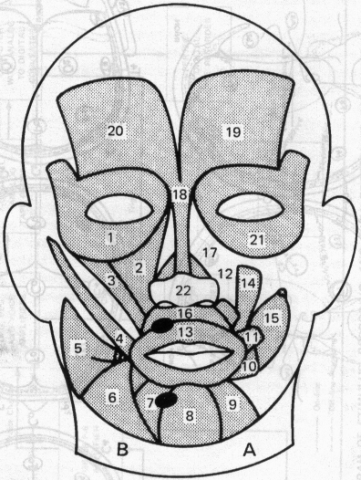

1. Orbicularis oculi m. (right)
2. Quadratus labli superioris m. (right)
3. Zygomatic head of quadratus labii superioris m. (right)
4. Zygomaticus m. (right)
5. Risorius m. (right, cut)
6. Triangularis m. (right)
7. Quadratus labii inferioris m. (right)
8. Mentalis m.
9. Quadratus labii inferioris m. (left)
10. Triangularis m. (left, cut)
11. Zygomaticus m. (left, cut)
12. Quadratus labii superioris m. (left, cut)
13. Orbicularis oris m.
14. Caninus m. (left)
15. Buccinator m. (left)
16. Depressor septi nasi m.
17. Nasalis m. (left)
18. Procerus m.
19. Frontalis m. (left)
20. Frontalis m. (right)
21. Orbicularis oculi m. (left)
22. Nasalis m. (right)

FIGURE 1 MUSCLES OF THE FACE (AFTER VAN RIPER AND IRWIN, 1958)

19

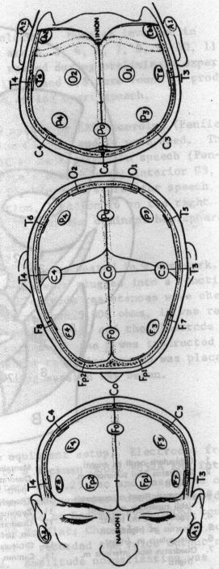
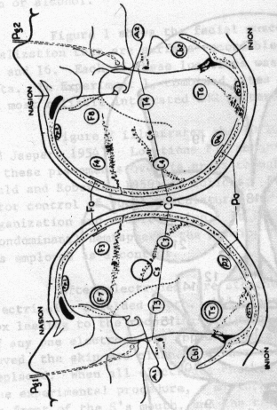

FIGURE 2 ELECTRODE PLACEMENTS FOR 10/20 SYSTEM OF EEC RECORDING (AFTER PENFIELD AND JASPER, 1954)

20

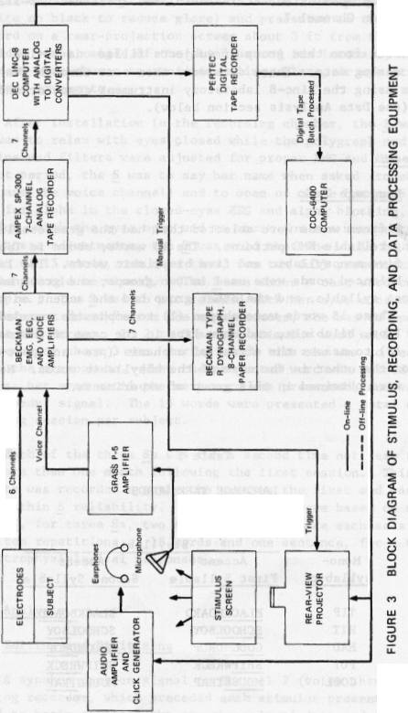

21

amplifiers drove ink—writing galvanometers on chart paper moving at 25 mm! see. EMO and EEG recordings were on Channels 1 through 6 of the Ampex, using frequency modulation, at 1—7/8 in.fsec (pass band dc—312 Hz); voice was recorded on Channel 7.

Data from this group of subjects filled one 10—1/2 in. Ampex tape with analog data. These data were then sent through the data analysis system using the Line—8 laboratory instrument computer and a CDC—6400 computer (see Data Analysis section below).

Procedure

Language Task

Fifteen words were selected that had the greatest likelihood of reproducing reliable EMG patterns. The 15 words, shown in Table 1, consisted of five monosyllabic and five bisyllabic words. The latter phonetically balanced words were used in two groups; one group had the accent on the first syllable, and the other group had the accent on the second syllable. These 15 words were chosen (1) to emphasize rounded lips, spreading lips, bilabials, and open lips in the case of the monosyllabic words and (2) to assess the effect of emphasis (pre— and post—) of one syllable on the other in the case of the bisyllabic words. No covert responses were obtained in this group of experiments.

Table 1
LANGUAGE TASK WORDS

Bisyllabic
Mono— Accent Accent
syllabic First Syllable Second Syllable
TIP BLACKBOARD BLACKBOARD
HIT SCHOOLBOY SCHOOLBOY
HAD COUGHDROP COUGUDROP
PUT SHIPWRECK SHIPWRECK
COOL MOUSETRAP MOUSETRAP

Stimulus Presentation

Each of the individual words in Table 1 was printed on a 35—mm slide (white on black to reduce glare) and presented to the S by projecting the word on a rear-projection screen about 3 ft from the S’s eyes. The subtended visual angle of the stimulus and its intensity in the semi— darkened room were chosen to avoid squinting, glare, or eye strain and to reduce eye movements.

After installation in the recording chamber, the S was instructed that she was to relax with eyes closed while the polygraph and tape recorder gains and filters were adjusted for proper EMG and EEC recordings. During that period, the S was to say her name when asked (to calibrate ENG gains and the voice channel) and to open or close her eyes when asked (to check for alpha in the closed—eyes EEG and alpha blocking, or desyn— chronization, with the eyes open and to check for eye movement artifact). Following these adjustments, the S was told that she would be presented with a list of 15 words, one at a time, for ten full presentations. The. presentations would be visual. (The S was shown a test word on the screen as an example.) The S was to sit relaxed with her eyes closed. On hearing the statement “ready” from the experimenter, she was to open her eyes and look at the screen. In 2 to 3 sec, a stimulus word would be projected on the screen for about 3 sea, during which time she was to read the word aloud into the microphone. When the projected word was turned off, she was to close her eyes until the next word was presented, and wait until the next “ready” signal. The 15 words were presented a total of ten times per recording session per subject.

Each of the three Ss was run a second time not less than one week nor more than one month following the first session. This set of measurements was recorded exactly the same as the first and was run to determine within S reliability. Thus, the data were based on six electrodes per S, for three Ss, two sessions each, where each session consisted of ten repetitions of 15 words and one sentence, for a total of 5,400 electrophysiological responses.

Data Analysis

Editing and Digitizing

A synchronization signal on Channel 7 (voice channel) of the Ampex analog recorder, which preceded each stimulus presentation, caused the Linc—8 to begin sampling the six channels of data and the voice channel through analog—to—digital converters. A total of 7 sec of data were

sampled at 42 samples/sec for each of the seven channels. The seventh second of data was collected for time justification of the electrophyaio— logical response as described below. The data were stored in memory, and on command any two of the six data channels or the voice channel could be displayed on a two—channel, cathode—ray oscilloscope driven by the computer. The display itself consisted of 6 sec of data, or 256 data points. In addition, the scope displayed a vertical cursor that was exactly centered to represent a zero point for time justification of the electro— physiological response.

Figure 4 illustrates the seven—channel dynograph recording of the EMG and EEC for one presentation of the word “COOL” Note the cursor line at the onset of vocalization (Channel 7), which was used to time— justify all electrode responses. Any two of these channels could be displayed on the Linc—scope, as shown in Figure 5. In Figure 5A, an EMG response is shown on the top channel; the voice voltage and the centered cursor are shown on the second channel. Note that the vocal onset is off—centered on the scope, indicating that this particular response was not time justified for vocalization to occur at exactly 3 sec from the onset of the display. By use of a second Linc—8 command, all six channels of data and the voice channel could be rotated simultaneously into and out of memory with the extra seventh second to place the onset of vocalization at any desired point. This feature was used to shift the data and voice channels (to the left in this case) so that the onset of vocalization occurred at the centered, 3—sec cursor, as shown in Figure SB. Thus, after time justification, 3 sec of data were displayed before the onset of vocalization and 3 sec after. On completion of time justification, the six channels of data were stored on Line tape on the computer.

When responses to all 150 word utterances and the 10 sentences for a given subject—session had been stored on Line tape (six channels per word and sentence, for a total of 990 tape blocks), another Linc—8 program was used to transfer this data to the Pertec digital tape recorder in ten files of 101 records per file (255 samples per block were transferred rather than the 256 collected because of an error in the transfer program). The Pertec tape was then unpacked on the CDC-6400 computer, and the data words were reordered in sequence for data processing.

CDC-6400 Response Classification by Averaging

As a first approximation for machine pattern recognition of the six electrophysiological responses for each word utterance, we decided to use a method of averages to construct templates for response—word classification. The data unit of analysis for classification was the individual

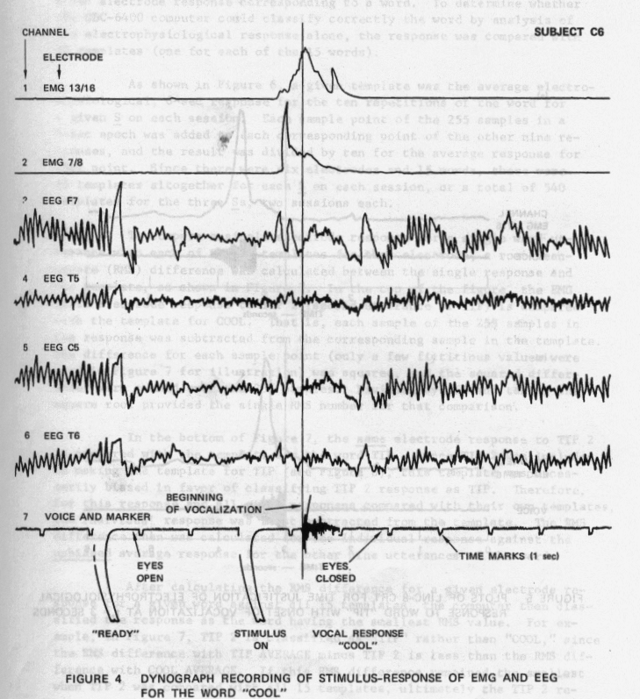

25

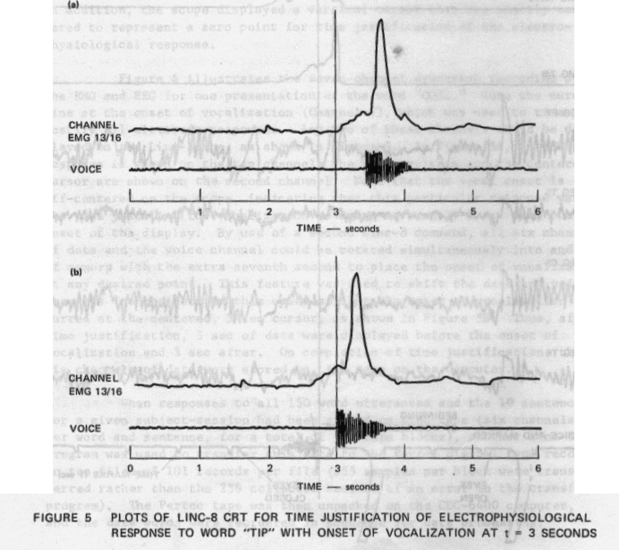

6—sec electrode response corresponding to a word. To determine whether the CDC—6400 computer could classify correctly the word by analysis of the electrophysiological response alone, the response was compared with 15 templates (one for each of the 15 words).

As shown in Figure 6, a given template was the average electro— physiological, 6—sec response for the ten repetitions of the word for a given S on each session. Each sample point of the 255 samples in a 6—sec epoch was added to each corresponding point of the other nine responses, and the result was divided by ten for the average response for that point. Since there were six electrodes and 15 words, there were 90 templates altogether for each S on each session, or a total of 540 templates for the three Ss, two sessions each.

To compare a single electrode response for a single word utterance with each of the 15 templates for that electrode, a root—mean— square (RNS) difference was calculated between the single response and the template, as shown in Figure 7. In the top of the figure, the EMG 13/16 electrode response to TIP 2 (second utterance of TIP) is compared with the template for COOL. That is, each sample of the 255 samples in the response was subtracted from the corresponding sample in the template. The difference for each sample point (only a few fictitious values were used in Figure 7 for illustration) was squared, and the squared differences were summed over the 255 samples. Dividing by 255 and taking the square root provided the single RNS number for that comparison.

In the bottom of Figure 7, the same electrode response to TIP 2 is compared with the template for the word TIP. Since TIP 2 was included in making the template for TIP (see Figure 6), this template was necessarily biased in favor of classifying TIP 2 response as TIP. Therefore, for this response and all other responses compared with their own templates, the individual response was first subtracted from the template. The RNS difference then was calculated for the individual response against the unbiased average response for the other nine utterances of the word.

After calculating the RNS difference for a given electrode response for a given word against all 15 templates, the computer then classified the response as the word having the smallest RMS value. For example, in Figure 7, TIP 2 is classified as “TIP” rather than "COOL," since the RNS difference with TIP AVERAGE minus TIP 2 is less than the RNS difference with COOL AVERAGE. If this RMS difference remained the smallest when TIP 2 was compared with all 15 templates, ultimately the TIP 2 response was classified as TIP.

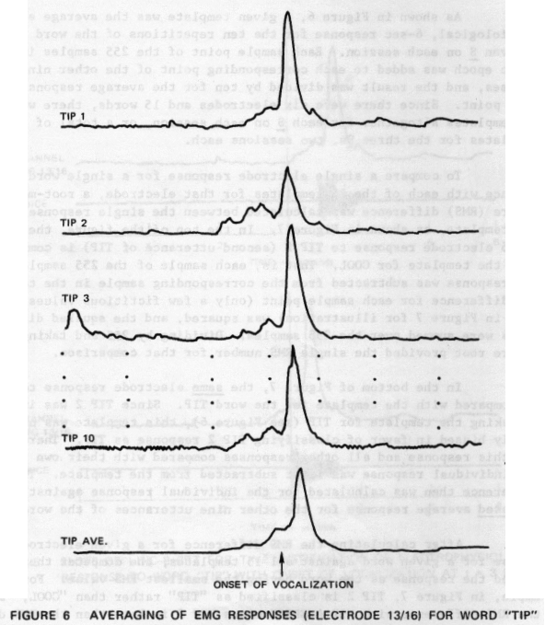

28

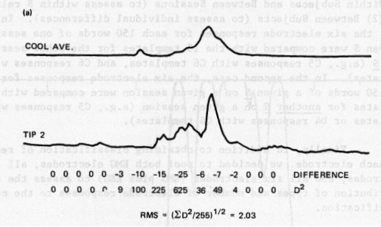
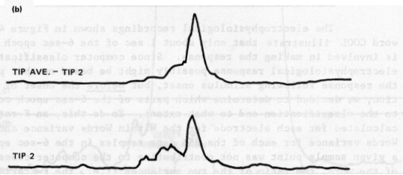
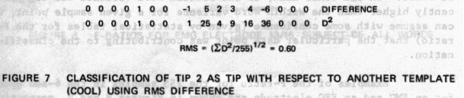

29

In this way, response classifications were made for each of the 150 words per S per session per electrode (Within Subjects, Within Sessions classification). Two additional classifications also were made:
(1) Within Subjects and Between Sessions (to assess within S reliability); and (2) Between Subjects (to assess individual differences). In the first case, the six electrode responses for each 150 words of one session for a given S were compared with the 15 templates for the other session for that S (e.g., CS responses with C6 templates, and C6 responses with C5 templates). In the second case, the six electrode responses for each of the 150 words of a given S on a given session were compared with the 15 templates for another S on a given session (e.g., CS responses with B5 templates or D4 responses with C6 templates).

Finally, in addition to obtaining classification of responses for each electrode, we decided to pooi both EMG electrodes, all four EEC electrodes, and all six electrodes (EMG plus EEG) to assess the relative contribution of types and number of electrode responses to the computer classification.

DetermInation of Critical Classification Period

The electrophysiological recordings shown in Figure 4 to the word COOL illustrate that only about 1 sec of the 6—sec epoch actually is involved in making the response. Since computer classification of an electrophysiological response possibly might be based on that portion of the response following stimulus onset, but before the onset of vocalization, we decided to determine which parts of the 6—sec epoch contributed to the classification and to what extent. To do this, an F—ratio was calculated for each electrode for the Within Words variance and Between Words variance for each of the 255 data samples in the 6—sec epoch. If a given sample point was not contributing to the computer classification of the word, the ratio of the two variances (i.e., the F—statistic) should be small. On the other hand, if the Between Word variance was signif i— cantly higher than the Within Word variance for a given sample point, we can assume with some confidence (given by statistical tables for the F— ratio) that the particular data point was contributing to the classification.

Examples of the F—ratio for the 255 samples in the 6—sec epoch for an EMG and an EEG electrode are shown in Figures 8 and 9, respectively, for S C, Session 5. Note that, in both cases, the F—ratio remains small and statistically insignificant f or about the first 100 samples but becomes and remains significantly large from about Sample 101 to about Sample 200. For the EEG (Figure 9), another portion between about Samples 205 through 230 also reaches significance. This means that, for both EMG and EEG

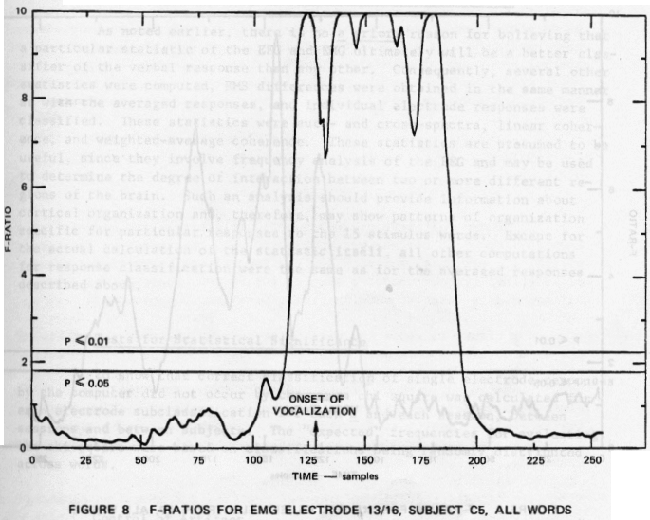

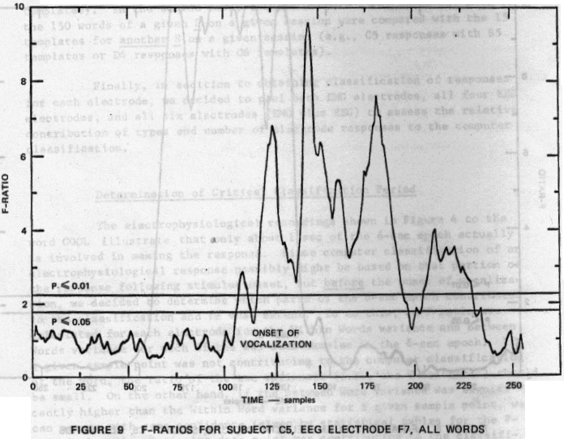

responses taken separately, only that portion of the 6—sec epoch between Samples 101 and 200 probably contributes significantly to classification of the response (that portion of the EEC from 205 to 230 also may contribute but less significantly). F—ratios were calculated for all Ss, sessions, and electrodes with essentially the same results.

CDC—6400 Response Classification by Other Statistics

As noted earlier, there is no a priori reason for believing that a particular statistic of the EEC and EMG ultimately will be a better classifier of the verbal response than any other. Consequently, several other statistics were computed, RNS differences were obtained in the same manner as with the averaged responses, and individual electrode responses were classified. These statistics were auto— and cross—spectra, linear coherence, and weighted—average coherence. These statistics are presumed to be useful, since they involve frequency analysis of the EEC and may be used to determine the degree of interaction between two or more different regions of the brain. Such an analysis should provide information about cortical organization and, therefore, may show patterns of organization specific for particular responses to the 15 stimulus words. Except for the actual calculation of the statistic itself, all other computations for response classification were the same as for the averaged responses described above.

Tests for Statistical Significance

To show that correct classification of single electrode responses by the computer did not occur by chance, a chi square was calculated for each electrode subclassification for each S and each session, between sessions and between subjects. The “expected” frequencies for evaluating the chi square were based on classifications being randomly distributed across words.

Control of Artifact

In a working biocybernetic communication system, constraints on the user against eye or muscle movement may not be effective. Since such movements often produce artifacts in electrophysiological responses (especially in the EEC), it is imperative that a system be designed that is not unduly affected by such artifacts. That is, pattern recognition and classification should be carried out successfully whether or not artifacts are present. For this reason, we decided to analyze these data

without removing those responses with known artifacts present; that is, this was a “worst—case” analysis.

Nevertheless, some effort was devoted to controlling the identifying artifacts and to assessing their contribution to response classification. This was accomplished by obtaining responses in the four EEG electrodes to five words under conditions of both visual and auditory stimuli and with and without known eye movements and movement artifacts. Finally, during data collection, Ss were instructed to remain as relaxed as possible during the response period, with no more eye or body movement than necessary. An analysis of all artifactual data showed that none of the various types of artifact contributed significantly to correct computer classifications, although they did contribute to incorrect classification (i.e., confusion).

Results

Classification by Averages

Individual Responses--Figure 10 illustrates the six electrode templates for S C5 for the word COUGHDROP with the accent on the first syllable. Note that, for both EMG and EEC records, significant changes occur primarily over computer Samples 101 to 200, thus beginning about 0.5 sec before onset of vocalization (arrow at 3.0 sec).

Figure 11 shows the variability around the averages of Figure 10, the upper trace of each pair being the average plus one standard deviation, the lower trace the average minus one standard deviation. Note that the variability of each electrode signal is relatively small. Similar plots were made for all three Ss for the two sessions, each with essentially similar results, indicating that it should be feasible to identify a given spoken word by comparing the electrophysiological response to the templates.

As described in the previous section, for each S on each session the individual electrode response for each of the 150 word utterances was compared with the 15 templates. These comparisons resulted in 15 RNS values, from which the CDC-6400 computer classified the response with the word for which the BMS value was a minimum. Tables of correct responses were then constructed for each S and each session, showing the number of correct classifications for the 150 words for each electrode and each subclassification.

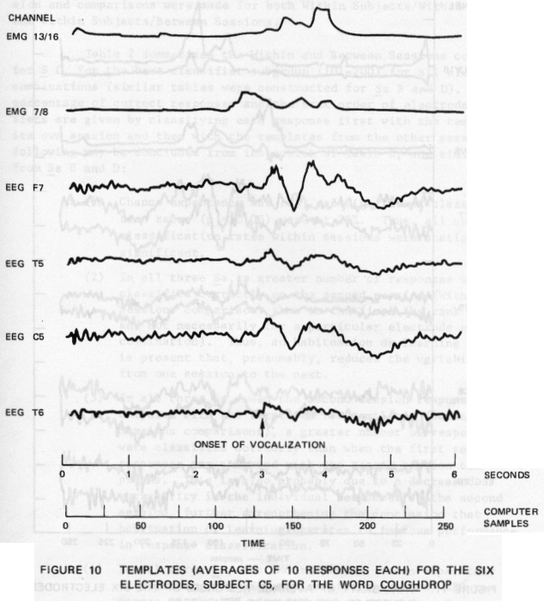

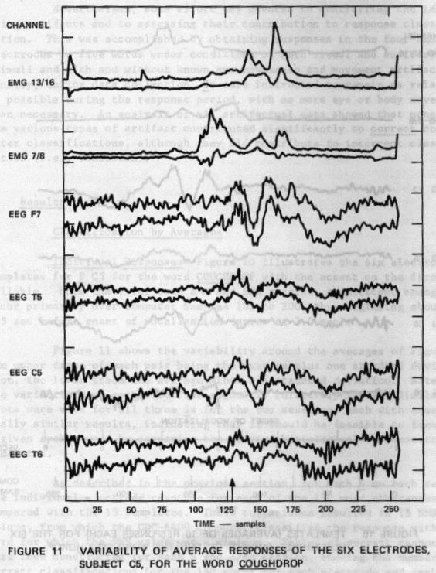

36

Within Subjects Results--To test the reliability of measurements and response classification, all three Ss were run on two sessions each. The sessions were no less than one week and no longer than one month apart. Tables of correct classifications were constructed for each S and each session and comparisons were made for both Within Subjects/Within Sessions, and Within Subjects/Between Sessions.

Table 2 summarizes the Within and Between Sessions comparisons for S C, for the best classifier subgroup (101-200) for all electrode combinations (similar tables were constructed for Ss B and D). The nearest percentage of correct responses and the rank order of electrodes as classifiers are given by classifying each response first with the templates of its own session and then with the templates from the other session. The following may be concluded from inspection of Table 2, and similar results fromSs B and D:

(1) Chance expectancy was 10%, and significant classification rates (p = 0.05) were at 25%. Thus, all correct classification rates within sessions were statistically significant.

(2) In all three Ss, a greater number of responses were classified correctly on the second session (Within Sessions comparison) than on the first (by rank order and not necessarily for a particular electrode or combination). Thus, an habituation or learning effect is present that, presumably, reduces the variability from one session to the next.

(3) In all three Ss, when the second session responses are compared with the first session templates (Between Sessions comparisons), a greater number of responses were classified correctly than when the first session responses are compared with the second session templates. This is also probably due to a decreased variability in the individual responses of the second session, further strengthening the conclusion that habituation or learning operates to improve performance in response classification.

(4) In all three Ss, the EMG responses, taken separately or together, are better classifiers than any EEC response or the EEC responses taken together. However, there appears to be no consistency, either within a S or across Ss, for any particular EEG response being a better classifier than any other.

Within Sessions
C5 with C5* Percent
Channel Correct Rank
C6 with C6
Percent Correct
Between Sessions
C5 with C6†
13/16 1
7/8 2
F7 3
T5 4
C5 5
T6 6
EMG
EEG
All
57%

43
45
47
39
26
63
49
70
3 76%
7 56
6 48
5 46
8 36
9 37
2 79
4 47
1 75
Percent
Rank Correct
2 39%
4 33
5 22
7 31
9 14
8 21
1 42
6 31
3 50
3 53%
4 40
7 15
6 29
9 28
8 25
2 64
5 31
1 65
3
4
9
6
7
8
2
5
1
*

C5 data compared with C5 templates. data compared with C6 templates.

Table 2

NEAREST PERCENTAGE OF CORRECT RESPONSES AND RANK ORDER
OF ELECTRODES AS CLAS S IFIERS, SAMPLE POINTS 101—200,
SUBJECT C, WITHIN AND BETWEEN SESSIONS

C6 with CS
Percent
Rank Correct Rank

(5) The range of percentages of correct classifications across Ss is from 9 to 84%, with both EMG and all six electrodes generally in the higher ranges, EMGs separately and all EEGs in the middle range, and EEGs separately in the lower ranges.

(6) Comparisons among percentages of correct responses among the three Ss indicate that responses from S C are better classifiers, in general, than either B’s or D’s, with B slightly better than D. Examination of either raw data or templates shows that this result is probably due to variability (larger in D, less in B, still less in C).

Between Subjects Results——The results of the EMG analysis showed that an individual’s electrophysiological responses accompanying speech are unique to that individual. Therefore, a comparison was made Between

Subjects for one session for all combinations. The results of this comparison are shown in Table 3, which shows that even though the ENG responses are significant at p < 0.01, the highest frequency (both EMG) is only 39%, compared with 74% Within Subjects/Within Sessions, and 62% Within Subjects/Between Sessions. These results suggest that homologous muscles act more like each other between Ss than homologous brain sites. Table 3 also shows that, although ENGs taken separately or together are better classifiers than the EEGs taken separately or together, no EEC electrode is preferred for classification purposes.

Table 3

NEAREST PERCENTAGE OF CORRECT RESPONSES AND RANK ORDER
OF ELECTRODES AS CLASSIFIERS, SAMPLE POINTS 101—200,
ALL SUBJECTS, ALL SESSIONS

 | Within  Sessions!  Within Subjects | Between  Sessions!  Within Subjects | Between Subjects
 | Percent | Percent | Percent
Channel | Correct Rank | Correct Rank | Correct Rank
1 | 63% 3 | 48% 4 | 27% 2
2 | 59 4 | 51 3 | 24 3
3 | 28 8 | 17 9 | 8 6.5
4 | 35 5 | 22 7.5 | 7 8.5
5 | 30 7 | 22 7.5 | 7 8.5
6 | 28 9 | 24 5 | 8 6.5
EMG | 74 1 | 62 1 | 39 1
EEG | 33 6 | 24 6 | 9 5
All | 65 2 | 58 2 | 22 4

Sources of Error

As indicated under “Data Analysis,” we made no special attempts to remove artifacts or other known sources of error because we wanted to see how well the computer would perform in classifying responses under the “worst—case” condition. Several known sources of error existed, including time and amplitude variations and muscle and eye movement artifacts. Each of these is discussed below, and their relative contribution is evaluated.

Confusion Matrices (Bisyllabic Confusion)——To determine why those responses not correctly classified were confused with other templates, a set of confusion matrices was constructed for each electrode, for each S, and for each session showing how each electrode response was classified. This is shown for all Ss in Table 4. Note that, for computer Samples 1 through 100 and 200 through 255 (left side of table), the rates of correct classifications are quite low and appear to be randomly distributed. This is in contrast with Subgroups 101 through 200 and 1 through 255 (right side of table), where a strong diagonal begins at the upper left, each cell of the diagonal representing the number of correct responses.

There are also two strong subdiagonals in Subgroups 101 through 200 and 1 through 255. The first begins at the junction of SB2 (column) and SB1 (row); the second begins at the junction of SB1 (column) and SB2 (row). These subdiagonals represent a strong confusion by the computer between two identical bisyllabic words with different accents, suggesting that the effect of emphasis on classification is not large. This result further suggests that the percentage of correct classification can be increased materially if emphasis is not taken into account by the computer. That is, we can regard confusions of emphasis not as errors, but as correct classifications of responses. For example, the number of total correct responses in the main diagonals for Subgroups 101 to 200 in Table 4 is 592, or 637g. By disregarding the confusions of emphasis on the bisyl— labic words in classifying responses, this figure increases to 689, or 76%, correctly classified responses.

Time Shift and Amplitude Variation——Two additional sources of error are illustrated in Figure 12. The first, an EMG response to TIP 8, was a slight shifting in time (to the left) of the electrophysiological response with respect to the onset of vocalization. Since the onset of vocalization was taken as the time zero reference, then any such shift would cause an incorrect classification, even though the waveform of the individual response is very similar to. the template. In this case, TIP 8 was confused with COOL. The second source of error was due to amplitude variation, as shown in an ENG response to TIP 9, so that TIP 9 also was confused with COOL (note that although there was also a time shift in TIP 9, it was shifted relative to both templates). However, attempts at machine correction for the first type of error were relatively unsuccessful in improving classification rates, largely because the entire signal had to be time justified, thus producing errors of temporal adjustment in
• one part of the signal while correcting errors in another. Some form of dynamic programming, or perhaps the use of multivariate statistics, may overcome this error.

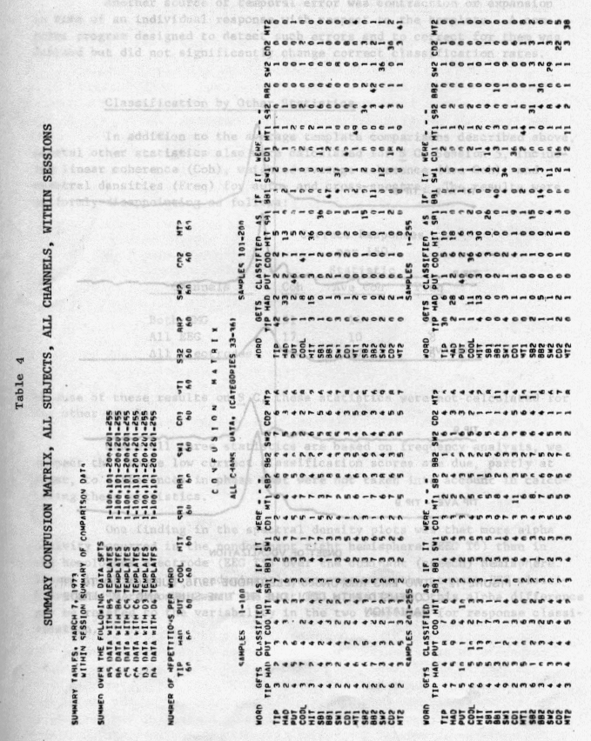

41

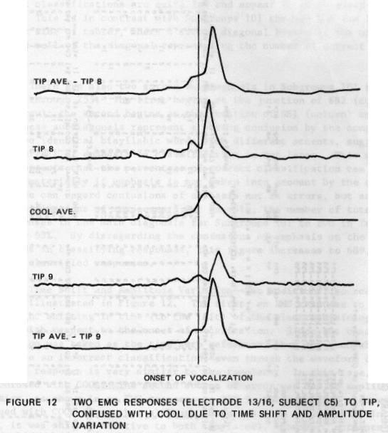

42

Another source of temporal error was contraction or expansion in time of an individual response with respect to the template. A computer program designed to detect such errors and to correct for them was devised but did not significantly change correct classification rates.

Classification by Other Statistics

In addition to the average template comparisons described above, several other statistics also were calculated for S C, Session 5, including linear coherence (Coh), weighted—average coherence (Ave Coh), and spectral densities (Freq) for auto— and cross—spectra. The results were uniformly disappointing as follows:

Correct Responses
per 150
Statistic
Channels Coh Ave Coh Freq
Both EMG 31 14 34
All EEG 17 10 8
All electrodes 25 17 16

Because of these results on S C, these statistics were not calculated for the other two Ss,

Since all three statistics are based on frequency analysis, we suspect that these low correct classification scores are due, partly at least, to differences in phase that were not taken into account in calcu— lating these statistics.

One finding in the spectral density plots was that more alpha activity occurred in the nondominant right hemisphere (EEG T6) than in the homologous electrode (EEC T5) over the dominant (speech) hemisphere. Since, in this S, T6 (nondominant) responses were the poorest EEG classifiers and T5 responses were the best EEG classifiers, this alpha difference may be related to the variability in the two templates for response classi— ficat ion.

Introduction

A primary objective of this research project was to demonstrate the feasibility of man—machine communication through verbal thinking and thus bypass the normal input—output mechanisms. A major operating assumption has been that verbal thinking is nothing more than subvocal speech, and that therefore the electrical activity of the brain during covert speech may be similar to that during overt speech. Our approach the first year was to demonstrate that unique patterns of electrical activity of the brain exist during overt speech, and that a computer pattern recognition technique could be used to identify such activity when it occurs.

It remained to be demonstrated that the electrical activity of the brain during covert speech resembled that of overt speech when the same words were spoken and that the computer pattern recognition technique could equally well classify EEC responses associated with words covertly spoken. The results of experiments demonstrating this effect are presented here.

Covert speech experiments were conducted with two right—handed female volunteers. In both instances, covert speech was defined as silent reading of words visually projected on the rear—vision screen as described under “Methods” below. We recognized that “silent reading” may not be the same thing as “verbal thinking," but decided that it would be best to proceed first in a nonvocal experiment that was as similar to the vocal experiments as possible.

Methods

The procedure was as outlined in "Procedure” (“Off—Line Analysis, Overt Classification”) for both subjects, except that the stimulus words were read silently. For S B7, five words were used both overtly and covertly for comparison purposes, and each word was read five times each in both conditions. The words were: PUT, SCHOOLBOY, COUGHDROP, TIP, and HAD. For S W3, one set of three consonant—vowel--consonant (CVC) words varying only in the first consonant, and one set oE three homonytns (to compare with experiments on overt production of homonyms described in the next section below) were used. Each word was repeated ten times each. The words were: BAN, PAN, MAN, WRITE, RIGHT, AND RITE. For both subjects, no recordable EMG signals could be obtained from the facial muscle electrodes and therefore were not analyzed. Horizontal and vertical eye movements were recorded for S B7 to identify eye—movement artifact in the EEG. For both Ss, the four EEG electrodes described in “Procedure” (F7,

T5, C5, and T6) were employed. For S B7, the Linc-8 computer was used for response classification, whereas for S W3, the CDC-6400 was used initially and the Linc-8 later. In both cases, a correlational time justification technique was employed, since no onset of vocalization could serve as a zero reference.

Results

The initial results were mixed. For S B7, the percentage of correct classifications for the covertly spoken words was about the same as that for overtly spoken words (27% and 29% respectively, for all four EEC electrodes taken together). Furthermore, the pattern of the covert responses strongly resembled the overt responses for the same word and electrode, confirming the assumption that electrical activity of the brain during covert speech (silent reading) is similar to that of overt speech of the same words. This is shown clearly in Figure 13, where single responses by S B7 to the same word in both the overt and covert conditions are illustrated (nontime justified). Since these are not averages, the faster activity of the normal EEC is the predominant potential waveform from all electrodes. Nevertheless, the slow wave component of the response to the unaccented word SCHOOLBOY is readily evident in both the overt and covert responses, especially in electrodes F7, T5, and C5, and cannot be attributed to either eye—movement artifacts, jaw movements, or muscle action potentials. Similar results were obtained for all five words in the covert condition.

Figure 14 illustrates the stability of an EEG—patterned response word within a subject from one occasion to another and from overt to covert conditions. All three traces for S B are the smoothed templates for EEG electrode T5 to the word TIP. The top trace is for overt Session 5, the middle trace on overt Session 6 two weeks later, and the bottom trace is on the covert condition (Session 7) six months after Session 5. The covert response is time justified, and, although there is a fair amount of amplitude variability, the three responses (between the cursors) are almost identical. It should be noted that this is one of our better examples; nevertheless, if classifications are made between the covert responses and overt templates or vice versa, the percentage of correct responses is about the same as for Within Sessions on the overt trials.

For S W3, however, analysis on the CDC-6400 showed the percentages of correct classifications across all electrodes and words to be no greater than chance. Perhaps there was a greater time variation error for S W3 than for S B7, which was amplified by the correlational time justification procedure. For this reason, we reclassified both S B7 and S W3 responses on the Linc—8 after removal of as many sources of error as possible.

46
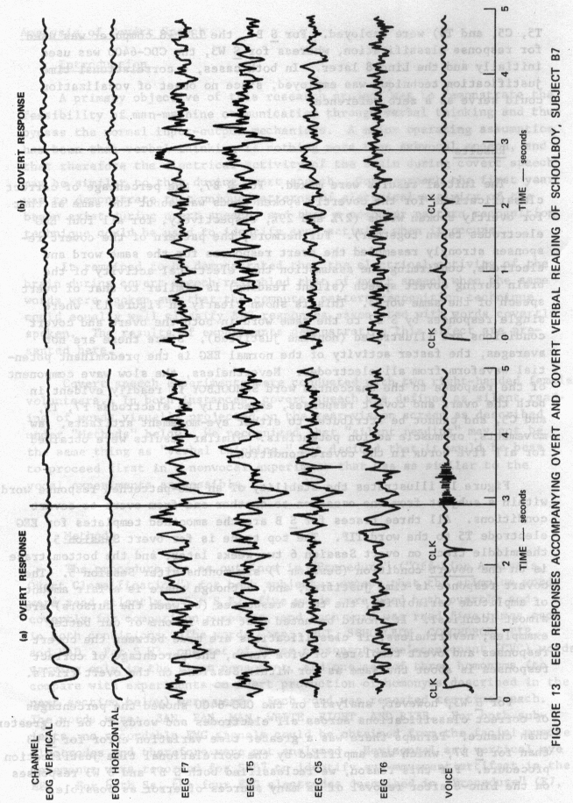

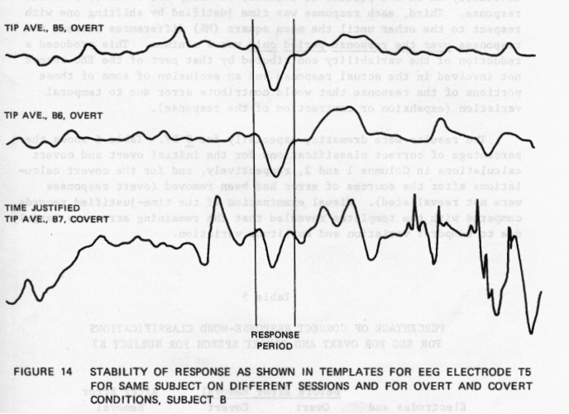

47

To eliminate or reduce error due to amplitude variation, each EEG response for all four electrodes and all words f or both Ss was smoothed twice using a five—point triangulation algorithm. Since the EEG response to overt and covert speech production is a slow wave, the variability of the nonresponse components of the EEG epoch was reduced, and the response itself was enhanced. Second, the smoothed EEG epochs were plotted individually on an X—Y plotter to identify visually the covertly produced response. Third, each response was time justified by shifting one with respect to the other until the mean square (MS) differences between the responses over the response period only was a minimum. This produced a reduction of the variability contributed by that part of the EEG record not involved in the actual response and an exclusion of some of those portions of the response that would contribute error due to temporal variation (expansion or contraction of the response).

The results were dramatic, especially for S B7. Table 5 shows the percentage of correct classifications for the initial overt and covert calculations in Columns 1 and 2, respectively, and for the covert calculations after the sources of error had been removed (overt responses were not reevaluated). Visual examination of the time—justified records compared with the templates revealed that the remaining error was largely due to temporal variation and amplitude variation.

Table 5

PERCENTAGE OF C ORRECT RESPONSE-WORD CLASS IFICATIONS FOR EEG FOR OVERT AND COVERT SPEECH FOR SUBJECT B7
Before Error Removal After Error
Electrodes and Overt Covert - Removal
Combinations Response Response Covert Response
F7 22% 32% 56%
T5 14 18 72
C5 27 14 68
T6 29 28 52
All EEG 29 27 62

Note: All are significant at p < 0.001 by a chi square test.For S W3, electrode F7, the improvement for specific words was BAN:
10%; PAN: 4O%; MAN: 20%; RITE: 20%; RIGHT: 10%; and WRITE: 10%.

Therefore, we can conclude that the EEC reveals similar responses during covert speech (silent reading) to that during overt speech and that these responses may be classified correctly by a computer with a fairly high degree of accuracy, using pattern recognition techniques, when the major sources of error have been removed.

Introduction

Results obtained clearly indicated that overtly or covertly spoken words may be identified by computer analysis of electrophysiological patterns correlated in time with the speech. Our language tasks had involved “discrete” words--that is, words out of context that are semantically different and have no common articulatory components. However, many words in English are either homonyms (words with the same pronunciation but different meanings when spoken in context, such as “write,” “right,” and “rite”), or are very similar, such as words varying only in the initial consonant (for example, “ban,” “pan,” “man,” and “fan”).

Logically, at least some of the biological activity associated with pronunciation of these words is purely “mechanical,” especially in the ENG. That is, it is associated with articulation, the controlling of the vocal musculature for proper pronunciation per se. On the other hand, it is possible that some other components of the biological activity may be associated with the meaning of the word, especially in the EEC. If such components do exist, a biocybernetic communication system must be able to identify them; if they do not exist, some other form of discrimination between similarly articulated but semantically different words must be devised.

To test for possible discriminable articulatory components, a group of CvC monosyllables, in which only the initial consonant differed, was used. Since we also wished to have a source of comparison with the data obtained earlier, we used the same ENG and EEC electrode recording sites. Three bilabials--B, P, and M--and the labio-dental F were chosen as the initial consonants for the CVC group, since maximum EMG responses could be recorded from the lips. The middle vowel chosen was A, and the final consonant was the nasal N. Thus, the four CVC words were BAN, PAN, MAN, and FAN.

Our assumptions were that if there was a nondiscriminable articulatory component, confusion should be a maximum at the level of EMG classification; that B and P should most often be confused with one another, since they differ only in voicing; that N would be confused more with B

This study was carried out as part of a Master’s Thesis by Mrs. Patricia

A. Johnson for the Department of Psychology, San Francisco State University, CA.

and/or P than F; and that F would least likely be confused with either B, P, or N. That is, at the level of ENG classification, the labiodental F should be least likely to be confused with the three bilabials since the overt production of F uses a different muscle configuration than that required for the two bilabial plosives B and P and for the bilabial nasal M. On the other hand, if B and P are not confused, the biological activity may be capable of discriminating voicing (B is voiced, P is unvoiced). The F discrimination would be particularly good at EMG electrode site 13/16 (upper lip) since labio-dental forms involve the teeth and lower lips more than any other part of the facial musculature.

In addition, if there is not a separate articulatory component integral to the EEG pattern associated with a given word during overt speech, the EEG should be as confused as the EMG. However, if the EEC is free of such mechanical constraints, or has specific articulatory components and discriminable contextual components, we would expect the EEG to be the superior classifier.

In the case of the homonyms, the phonetic form Rit (no semantic component), and three of its six possible semantic forms (WRITE, RIGHT, and RITE) were chosen as stimuli. The purpose of this condition was to equate any possible articulatory component, since all four words should be pronounced exactly the same (with possible minor variations) by a given subject. As with the CVC words, there should be a high degree of confusion in the EMG classification among the “Rit” forms. For the EEC, there should be a high degree of correct classification if a semantic component exists in the EEG. If, however, similar levels of confusion exist in both ENG and EEC classification of these words, or if the EMG remains the superior classifier, we may make the following assumptions: The variability in physiological response patterns at our present level of technology is too great to allow for precise classification; we may not be measuring from the correct EEC locations; or we need to determine the interrelationships among patterns from some combination of EEC sites.

Finally, each CVC word and each of the three semantic forms of the homonym “Rit” were put into an identical phrase context. The purpose of this phrasing was to identify the effects of preceding and subsequent words on the CVC words and hotnonyms of interest and to determine whether the computer could classify a word within a phrase context. Our assumpdons were that if no discriminable EMG articulatory component were present, there would be a high degree of confusion among CVC phrases and possibly between a CVC word and that same CVC’s phrase. Similar assumptions were made in terms of the homonyms and homonym phrases.

Subjects were five adult, right-handed human volunteers, two males and three females, ages 18 to 38 years, henceforth designated as U, V, W, Y, and Z. Each subject participated in at least two experimental sessions and two of the Ss (W, Y) participated in three or more sessions, designated 1, 2, 3.... Duration of each session ranged from 1-1/2 to 3 hours, not including pre- and post-session calibration procedures. Before each of the first two sessions, all Ss were given a standard dichotic listening test (see Part II on Hemispheric Differences). Electrode location and equipment setup were similar to the descriptions given in the section on methods.

Language Task

The 14 words and phrases used are shown in Table 6. As a control to ensure that language production is different from simple mechanical movement, Ss also were presented with three control stimuli. The first control required S to make the motor response of pressing a key to the stimulus, “PRESS KEY”; a second control required a swallowing response to the stimulus word “SWALLOW”; and a third control required a verbal response to the phonetic stimulus “Rit” (no semantic component).

Table 6

LIST OF WORDS, PHRASES, AND CONTROLS USED
FOR TESTING ARTICULATORY AND SEMANTIC
COMPONENTS

CVC Words and Phrases
Monosyllabic Words/Phrases
Controls

BAN
PAN
MAN
FAN
THE BAN OF
THE PAN OF
THE MAN OF
THE FAN OF
WRITE
RITE
RIGHT
TO WRITE OF
THE RITE OF
THE RIGHT OF
PRESS KEY
SWALLOW
RIT

Procedure

The section on Methods details the procedures used. Briefly, after electrodes were attached, Ss were comfortably seated in the semi-dark, electrically shielded isolation booth. All electrodes then were attached to the junction box leading to the Beckman Dynograph. When all electrodes were verified as operating properly, the S was carefully instructed as to the general procedure of the experiment and the importance of minimum eye, facial, body, or swallowing movements during a trial interval. A recording session was then begun.

At the sound of the first click in the headset, S was to attend to a green fixation point (5-mm diameter) located in the center of the rear-projection screen. One second later, the stimulus was presented on the screen, at which time S was to continue attending to the stimulus word and to be prepared to respond as soon as the second click sounded. Ss were requested to speak their responses distinctly and normally into the microphone. When a 5-sec trial interval was completed, the projector light illuminating the stimulus was automatically extinguished, and S was instructed to relax and await the beginning of the next trial.

Slides were changed manually during the intervals between each of the 17 stimulus presentations. A single, random presentation of each of the 17 stimuli (7 words, 7 phrases, and 3 controls; see Table 6) constituted one set of trials. Following the presentation of one complete set, the 17 slides were shuffled for random presentation. A second presentation of the same 17 stimuli was conducted in a manner identical to that described above. This procedure was followed for a total of ten trial sets. Thus, for each experimental session, which consisted of the ten trial sets of 17 stimuli each, data were accumulated for 170 stimulus presentations (70 words, 70 phrases, and 30 controls). Each subject participated in at least two experimental sessions. Intervals between sessions were typically two weeks (range--one week to one month). Following each session, the S was given a standard dichotic listening test.

Data Collection and Analyses

A data block comprised the EMG and EEG data collected during a 5-sec trial interval. As described in “Methods,” analog EMG and EEG data obtained during the language tasks were stored on-line by the Linc-8 computer. Thus, all 170 verbal and control responses for a given S for a given session, as well as a set of 20 calibration signals, were stored on Linc tape. These data then were transferred to the Pertec digital

tape recorder, unpacked by the CDC-6400 computer, and the data words, phrases, and controls were reordered in sequence for processing. Data were then time justified using a correlational technique, and all responses were classified.

Response classifications were made for each of the 170 stimuli per subject per session (Within Subjects/Within Sessions classification). As in the earlier data analysis, in addition to the response classifications for each of the six electrodes, we decided to combine (1) the two EMG responses, (2) the four EEG responses, and (3) the six EMG and EEC responses so as to assess the relative contribution of types and number of electrode responses to the computer classification.

Results

General

EEC and EMG templates for the three CVC bilabials BAN, PAN, and MAN, and the labio-dental FAN are illustrated for the second session of S Y in Figures 15 and 16. It is evident that the two EMG channels, although different from each other, are practically identical within each electrode among the three bilabial words BAN, PAN, and MAN. There are equally strong similarities for each EEG electrode among these words during the response period. However, note the very definite differences in both the ENG and EEC patterns for the labio-dental word FAN. Thus, on visual inspection at least, the patterns of muscle contraction and the correlated brain activity for words with very similar articulation of the first sound apparently are nondiscriminable, whereas a similar-sounding word with different articulation of the first sound is discrim inable at both the muscle and brain activity levels. The result of articulatory similarity being reflected in both the EMG and EEC of words sounding alike also was found for the four “Rit” forms, as shown in Figures 17 and 18.

Within Subjects

Table 7 summarizes the percentage of correct response classifications for each channel and combination for both sessions for all subjects. The percentage of correct classifications ranged from 7 to 62%, with the combination of all electrodes being the best classifier in almost all cases. We may conclude the following from Table 7:

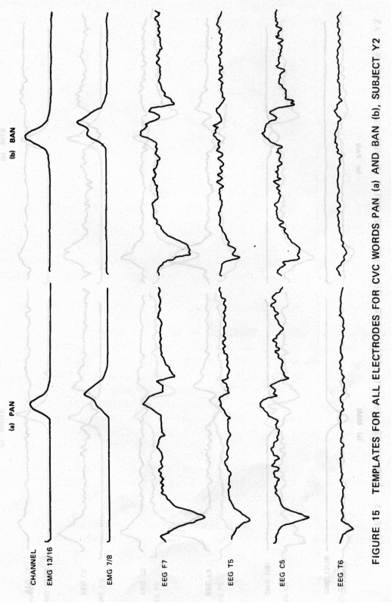

55

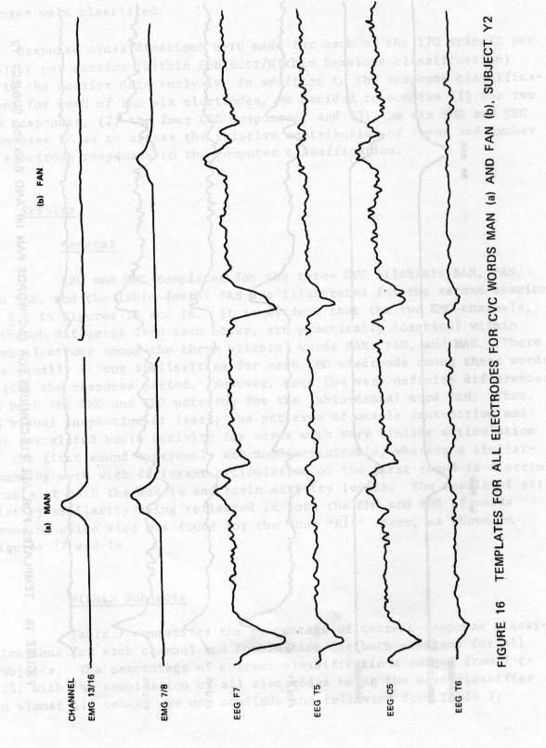

56

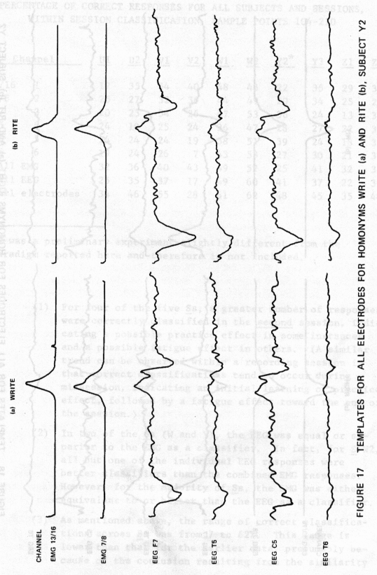

57

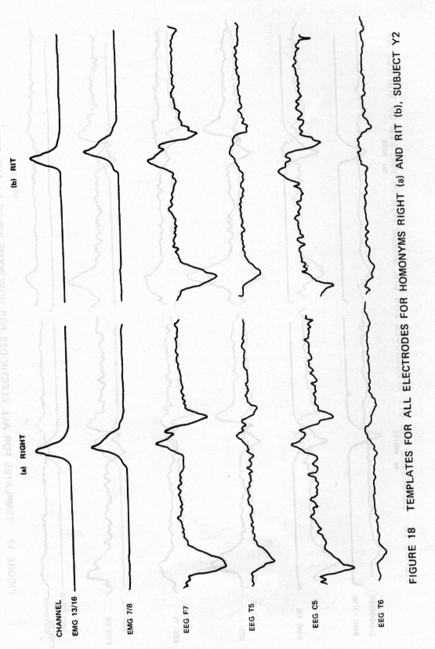

58

Y3 Zl Z2

PERCENTAGE OF CORRECT RESPONSES FOR ALL SUBJECTS AND SESSIONS,
WITHIN SESSION CLASSIFICATION, SAMPLE POINTS 104-210

Channel
U1 U2 V1 V2 W1 W2 Y2*

13/16 1
7/8 2
F7 3
T5 4
CS 5
T6 6
All EMG
All EEC
All electrodes
17 35 34 40 48 48 22 35 29 34
25 27 32 36 44 49 20 34 25 26
20 25 34 26 47 53 36 24 13 33
24 19 25 24 36 47 28 27 22 36
24 24 24 19 38 51 39 24 18 32
19 24 26 7 43 53 27 30 21 37
32 36 40 43 49 52 25 41 32 38
25 35 37 17 49 60 41 37 22 39
34 46 55 28 61 62 48 45 35 48

*Y1 was a preliminary experiment slightly different from the paradigm reported here and therefore is not included.

(1) For four of the five Ss, a greater number of responses were correctly classified in the second session, indicating a possible practice effect in some instances and a possible fatigue effect in others. (A similar trend can be observed within a recording session in that correct classifications tend to occur during midsession, indicating an initial learning or practice effect, followed by a fatigue effect toward the end of the session.)

(2) In two of the Ss (W and Y), the EEC was equal or superior to the EMG as a classifier. In fact, for S W2, all but one of the individual EEC responses were better classifiers than the combined EMG responses. However, for the majority of Ss, the EMG was either equivalent to or better than the EEC as a classifier.

(3) As mentioned above, the range of correct classifications across Ss was from 7 to 62%. This range is lower than that for the earlier data, presumably because of the confusion resulting from the similarity

among the CVC words and the “Rit” forms (as with the bisyllabic words in the earlier data).

(4) Comparisons among subjects indicates that responses from S W were classified correctly more often than those from any of the others in this group of subjects.

When the data from all subjects were grouped together, the resuits were essentially as stated above. That is, the two EMG channels correctly classified 32 to 42% of the responses correctly for all subjects, whereas the EEC ranged from 29 to 327g. For the two EMG channels combined, 39%. of the responses were correctly classified, 37%. for the four EEC channels taken together, and 46% for all six electrodes.

Confusion Matrix

To determine the amount of confusion between computer classification of “like” response-words (CVC words, homonyms, and phrases), sets of confusion matrices were constructed for each electrode and combinations of electrodes for each S on each session. Table 8 shows two summary matrices for all Ss and session for the period of the actual response (computer samples 104 to 210). In Table 8(a), the confusion for both EMG electrodes taken together is shown, and the confusion for all four EEG electrodes taken together is shown in Table 8(b). The diagonals from upper left to lower right give the number of correct classifications out of a possible 100 (and thus the percentage of correct classifications), and the outlined confusion blocks illustrate the confusion between like words. Conclusions from Table 8 may be summarized as follows:

(1) In both the ENG and EEG responses, the major confusion existed only between like forms, whether they be CVC words, homonyms, CVC or homonym phrases, or mechanical controls. Thus, individual response-words were successfully discriminated from phrases containing that word, from words or phrases of discretely different articulatory production, and from the mechanical control responses.

(2) The control responses PRESS KEY and SWALLOW were not confused with each other or with any language task, showing that the language components of each response were discriminable as such.

(3) The mechanically similar bilabials BAN, PAN, and WLN were confused with each other in both the EMG and EEC from one-tenth to one-third of the time. On the other hand, the mechanically different labio-dentai

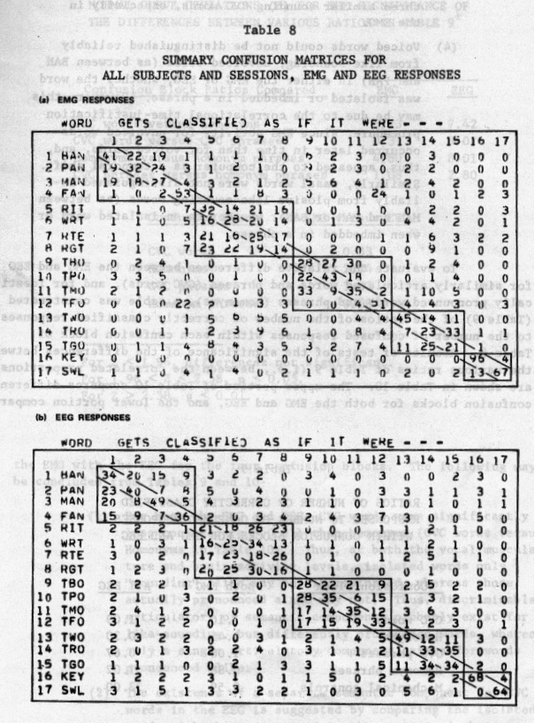

61

FAN was discriminated successfully from the other three similar sounding CVC words, especially in the EMG.

(4) Voiced words could not be distinguished reliably from like-sounding, unvoiced words (as between BAN and PAN) in either the EMG or EEC, whether the word was isolated or imbedded in a phrase. However, this may be due to the correlational time-justification procedure, since EMG activity for unvoiced words occurred later in time than for voiced words, and, thus, appeared to the computer as a temporal shift. Similarly, nasal words were not distinguished reliably from plosive like-sounding words (as between MAN and PAN or BAN), whether as an isolated word or when imbedded in a phrase.

To evaluate the relative differences between the EMG and EEC for similarly articulated words and phrases (CVC words), and for identically pronounced words and phrases (hotnonyms), a table was constructed (Table 9) of the ratios of the number of correctly classified responses to the number of confused responses within each confusion block of Table 8. Results of tests of the significance of the differences between the various ratios of Table 9 (i.e., between the correlated proportions) areshown in Table 10. The upper portion of Table 10 compares different confusion blocks for both the EMG and EEG, and the lower portion compares

Table 9

RATIOS OF NUMBER OF CORRECTLY CLASSIFIED
RESPONSES TO NUMBER OF CONFUSED RESPONSES
WITHIN CONFUSION BLOCKS FOR EMG AND EEC
Confusion Block Both ENG All EEC
CVC words 1.16 1.09
Hotnonyms 0.45 0.30
CVC phrases 1.08 0.67
Homonym phrases 0. 88 1.02
Mechanical controls 9.59 33.00

NORMAL CURVE DEVIATIONS (Z) FOR THE SIGNIFICANCE OF
THE DIFFERENCES BETWEEN VARIOUS RATIOS IN TABLE 9*

Z-Scores
Confusion Block Ratios Compared EMG EEC
CVC words versus homonyins 5. 73 7.42
CVC words versus CVC phrases 0.37 307
Homonyms versus homonym phrases 4.80 8.01
CVC phrases versus homonym phrases 1.08 2.80
Confusion Block ENG versus EEG
CVC words 0.33
Homonyms 2.74
CVC phrases 3.03
Homonym phrases 0.68

For Z < 1.96, differences not significant.
For 1.96 < Z < 2.58, p < 0.05.
For Z > 2.58, p < 0.01.

the EMG with the EEC for the four confusion blocks. The toilowing may be concluded from Tables 9 and 10:

(1) For both the EMG and EEC, CVC words were significantly less confused (p < 0.01) than homonyms (CVC words versus Homonyms in Table 10). Thus, at both the vocal musculature and brain activity levels, isolated words only “sounding” alike may be discriminated, whereas those actually pronounced alike may not. Thus, discriminable articulatory or semantic components probably exist for like-sounding, but differently pronounced words, whereas only a single articulatory component exists for words pronounced alike.

(2) The existence of a separate semantic component for CVC words in the EEC is suggested by comparing the isolated words with those contained in the contextual phrase (CVC Words versus CVC Phrases in Table 10, p < 0.01). Thus, the EEC is capable of discriminating similarly
63

articulated words in context when there is no significant difference in the actual articulation of these words in context (contrast with EMG).

(3) Even homonyms are more likely to be classified correctly if they are contained in a contextual phrase than when isolated (Homonyms versus Homonym Phrases in Table 10). This difference is significant at p < 0.01 for both EMG and EEC, but especially for the EEC. This suggests that Ss can evoke only distinctive semantic aspects of a lexical item with only one pronunciation but can evoke several semantic interpretations when that item is placed in a context.

(4) Whereas, for the EMG, CVC words are less confused than homonyms, CVC phrases are only slightly less confused than homonym phrases (CVC Phrases versus Homonym Phrases in Table 10), but not significantly so. For the EEC, however, CvC phrases are significantly more confused than homonyms (p < 0.01). Again, this may reflect the differences in correct classification when words are used in context rather than when they are isolated, with identically pronounced words being more discriminable than “like-sounding” words.

(5) Over all, ENGs tend to be less confused than EEGs (lower portion of Table 10), but significantly so only for homonyms and CVC phrases (p < 0.01). We can account for this only in terms of higher EEC variability. In Table 9, the EEG does have a higher percentage of correct classifications for homonyms than the EMG, but this difference is not significant.

(6) The mechanical controls are completely discriminated from all language tasks and vice versa at p < 0.0001. Therefore, we can conclude that all results with the language tasks were related to language function and not to any confusion from mechanical interference.

On-Line Analysis

Introduction

The results from the off-line computer analysis of the EEC coincident with overt and covert speech described in the preceding sections were
sufficiently above chance expectation (on the average statistically

significant at p < 0.001) to conclude that a biocybernetic communication system as originally proposed is feasible. However, to be useful, such a communication system should be employable in real-time, with on-line communication between the brain of a man and a computer. This last section of Part I describes our efforts in this direction.

On-line analysis was carried out over a period of 1-1/2 years in a generally dynamic fashion. That is, no single set of experiments was conducted with a large number of subjects to investigate a given parameter. Rather, a basic paradigm was formulated for the on-line analysis and then variations were made in this paradigm for exploration of several important features. For example, single electrode responses were compared with responses averaged across several electrodes; various EEC recording sites were compared for maximum correct computer classification; left hemisphere electrode responses were averaged together and compared with averaged right hemisphere electrode responses, and both sets of responses were compared with the average of electrodes from both hemispheres taken together; several types of computer algrorithms were compared with each other, and attempts were made to correct for temporal variation by computer modification so as to improve correct classification rates; different amounts of EEC data were compared (i.e., larger or smaller epochs), as well as different periods (i.e., EEC data collected during and after the actual response of S to the stimulus word); trained subjects were compared to naive subjects; and repetitive (fixed-serial-order) presentations of stimuli were compared with random presentations. For most of these parameters, overt speech was compared with covert speech.

Because of the volume of results obtained from this procedure (described in detail in Semi-Annual Technical Progress Report Nos. 4, 5, and 6), this section is limited to a description of the basic paradigm and summarizes the results of the various comparisons described above. A concluding statement is given at the end of this section regarding the most feasible on-line technique as determined from our results.

Methods and Procedures

A total of 31 Ss were run on the on-line experiments for a total of 140 experimental sessions. Ss were both male and female volunteers, ranging in age from 21 to 50 years. Sessions lasted from two to six hours (mean of three hours each).

One major set of seven words was used, with minor variations. In these experiments, we were preparing for a demonstration of our procedures

as well as assessing and improving our computer techniques for on-line classification. Therefore, words were chosen on the basis of two practical demonstrations. The first set of words was chosen in conjunction with a demonstration for EEG-computer control of an in-lab video camera used to observe a free-living group of adolescent chimpanzees. The seven words in this instance were chosen on the basis of the video camera capability, including movement to the right, left, up, and down, and movement via the zoom lens to far and near. Thus, the words to be classified by the computer on the basis of the EEC responses were RIGHT, LEFT, UP, DOWN, NEAR, and FAR. The seventh word, STOP, was used in interaction with the other six words in controlling the video camera. For an alternate demonstration, the movement of a dot on a video monitor to the right, left, up, or down, as well as the fast or slow movement in any of the directions, was chosen. Thus, the words used were RIGHT, LEFT, UP, DOWN, FAST, and SLOW. Again, the seventh word was STOP.

Details of the general procedures for electrode preparation and attachment were given earlier. However, certain changes were made in the experimental design for these studies, including elimination of the EMG, and recording of the EEC from eight electrodes (four over each hemisphere from homologous leads: F7, C5, T3, and T5 for the left hemisphere, and F8, C6, T4, and T6 for the right hemisphere; all EEC leads were referenced to the vertex).

After electrodes were attached, the S was seated in a semidark, electrically shielded booth, and the electrodes were plugged into a junction box attached to the recording equipment. When all electrodes were verified for adequate resistance (typically under 1K-ohm) and optimal electrophysiological recording, an experimental session was begun. The session consisted of a visual presentation (on a Conrac video monitor) of the set of seven words once every 5 sec for periods of 1 sec each. Stimulus cues and presentation, as well as onset of data collection, analysis, classification, and feedback, were controlled by the DEC Linc-8 computer.

When a S was ready, the computer automatically initiated a template-building phase of the experiment. One second after an initial warning click in the earphones, a word was automatically presented on the video screen for 1 sec. The S was instructed to attend to the video screen at the presentation of the warning click and to read the word aloud (overt condition) or read the word silently (covert condition) as soon as the word appeared on the screen. Data were collected only during the 1 sec that the stimulus was present on the screen, commencing 180 msec after the onset of the word and ending 180 msec before the word ended. At a sampling rate of lOO/sec, this resulted in 64 10 samples per trial

per electrode. After the first presentation of each word (i.e., on the second and subsequent presentations), the computer would present the classification results to the S after each trial, until all words had been presented ten times each (70 presentations in all). This usually constituted an experimental session.

General

Table 11 presents a typical on-line classification data sheet, in this case for S 3, Session B, overt condition. Similar data sheets were completed for each subject for each condition per experimental session. Across the top and down the left side of the data sheet are listed the seven stimulus words. The 49 individual boxes were used for entry of data, i.e., which repetition of the stimulus word (to the left) was classified as the word printed above each column. For example, the third repetition of the word RIGHT was classified as FAR, whereas the fourth and seventh repetitions were classified as STOP. Thus, the seven boxes along the diagonal (within word boxes) list the correct classification instances for each of the seven words. The seven rows and columns (minus the within word boxes) indicate the incorrect classification instances (i.e., confusions) for each word across the horizontal axis with the word to the left.

In addition, the column on the far right side of Table 11 gives correct classification percentages for each individual word, as well as the overall percentage of correct classification (in this instance 44%). Note that, for this S, in this condition, UP was the word most often classified correctly (707.); it was followed closely by LEFT (60%) and by RIGHT and FAR (50%), but DOWN was never classified correctly. Note also the general tendency for correct classifications to be grouped (such as 8, 9, 10 for RIGHT; 4, 5, 6, 7 for LEFT and so on). This tendency was observed consistently in all Ss and in all sessions. Finally, Table 11 shows that correct classifications are more likely to occur after the first three or four presentations. This tendency may indicate a “practice” effect, whereas another consistently observed effect, a slight decrease in correct classification during the last few presentations, may indicate a “fatigue” effect. This apparent fatigue effect also is observed during extended sessions; general classification percentages begin to decrease after the first four or five presentations in a single session.

Results

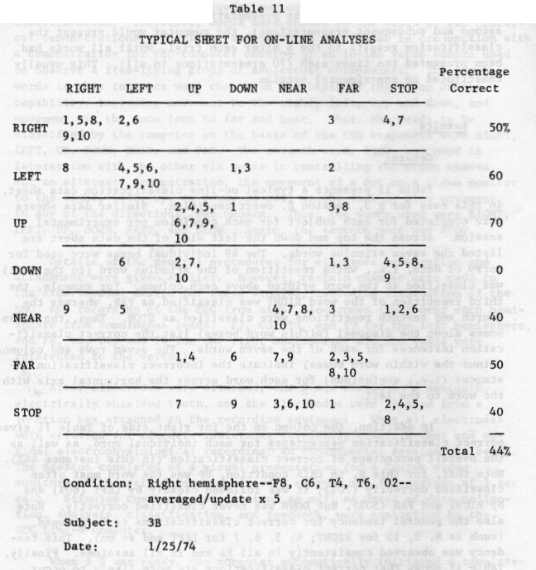

initial On-Line ResuIts

To compare the results of the various on-line classification procedures of EEG, we developed a new format of data presentation. This format is illustrated in Table 12, which presents results for seven Ss from the initial on-line experiments for both overt and covert speech over a number of sessions for each subject. The results are divided

68

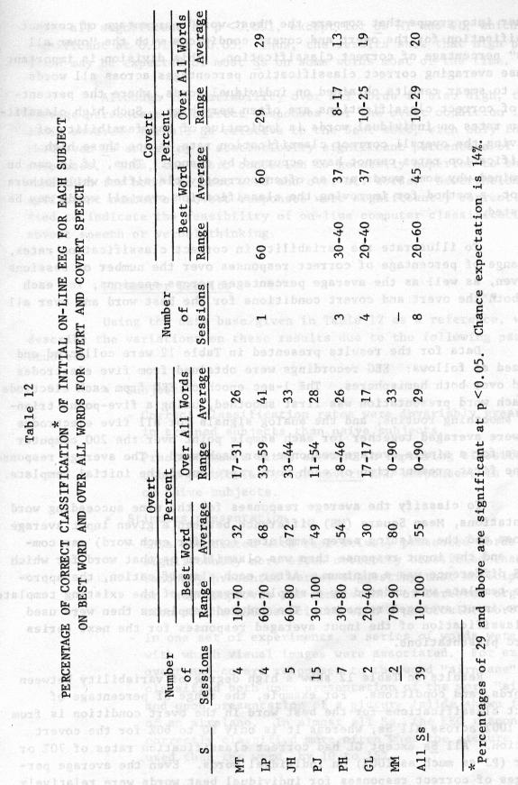

69

further into groups that compare the “best word” percentage of correct classification for the overt and covert conditions with the “over all words” percentage of correct classification. This division is important because averaging correct classification percentages across all words tends to smear results obtained on individual words, where the percentages of correct classifications are often very high. Such high classification rates on individual words is indicative of the feasibility of improving the overall correct classification rate, since these high classification rates cannot have occurred by chance. Thus, if it can be determined why some words are so often correctly classified while others are not, a method for improving the classification over all words may be suggested.

To illustrate the variability in correct classification rates, the range of percentage of correct responses over the number of sessions is given, as well as the average percentages across sessions, for each S on both the overt and covert conditions for the best word and over all words.

Data for the results presented in Table 12 were collected and analyzed as follows: EEG recordings were obtained from five electrodes placed over both hemispheres. The 1-sec epoch of EEG from each electrode for each word presentation was first smoothed, using a five-point triangular smoothing routine, and the analog signals for all five electrodes then were averaged together for each sample point over the 200 computer samples for a single average response for each word. The average response for the first presentation of each word represented the initial template.

To classify the average responses for the nine succeeding word presentations, Mean Square (MS) Difference between a given input average response and the existing seven templates (one for each word) was computed, and the input response then was classified as that word for which the MS difference was a minimum. After each classification, the appropriate template was updated by a simple averaging of the existing template and the input averaged response. The updated templates then were used for classification of the input averaged responses for the next series of word presentations.

Results in Table 12 show a high degree of variability between Ss, words, and conditions. For example, the range of percentage of correct classifications for the best word in the overt condition is from 10 to 1OO% across all Ss, whereas it is only 20 to 6O% for the covert condition. All Ss except GL had correct classification rates of 7O% or higher (PJ as much as 1OO%) on individual words. Even the average percentages of correct responses for individual best words were relatively

high, all significant at p<O.OO1, except for Ss MT and CL, which were significant at O.O1<p<O.O5. Thus, the results show that high performance may be expected of most Ss on some words most of the time.

Although the variability over all words is also high, the average percentage of correct responses for the overt condition is reduced severely for all Ss relative to the best word, with only four of the seven Ss achieving a statistically significant percentage of correct responses. Thus, the overt condition is generally superior to the covert condition for both the best word and over all words. Nevertheless, a sufficient number of covert responses were significantly correctly classified to indicate the feasibility of on-line computer classification of covert speech or verbal thinking.

Parameter Results

Using the data base given in Table 12 as a reference, we now describe the variations on these results due to the following parameters studied:

• Subjects

Correct classification rates were invariably greater in trained subjects than naive subjects.

Practice was a vital element in improving classification, particularly for covert EEG responses, in trained or naive subjects.

• Stimulus presentation

EEGs associated with repetitively presented words were significantly more often correctly classified than randomly presented words, suggesting that anticipation or “set” improves the consistency of cerebral organization of the EEG associated with a particular word.

In one set of experiments, a series of words were used with which visual images were associated. For example, overt and covert responses to the word “airplane” were classified both upon presentation of the word “airplane” and upon presentation of a picture (slide shown for 1 sec) of an airplane. In almost all Ss, the EEC response was correctly classified more often when the picture was used than the word, by 10 to 157g.

• Responses

- EEGs associated with overt speech had higher percentages of correct classification than those associated with covert speech. This result, in large part, is due to the difficulty in reproducing a word silently in the same way and at the same time relative to the presentation of the stimulus without the audio feedback present when reading a word aloud, since highly trained Ss did as well with covert words as overt words.

- Single “best words” usually were classified correctly a high percentage of the time (70 to 100%), indicating the strong feasibility of improving overall correct classification rates. This may be contrasted with the average correct classification rate across all words of 20 to 29% (though one of our Ss typically performed in the high 70s and 80s).

• Recording

- Multiple EEG recording sites are superior as classifier locations, when taken together either as averaged responses or strung “in-line” as a single response, than any single electrode. This is due, no doubt, to the variability within and between Ss at a given recording site.

- No single electrode site appears to be superior to any other; however, over all subjects and sessions, temporal sites (T3, T4, or T5, T6) are superior to frontal or central sites. Occipital and parietal areas give no better than chance correct classifications.

- Generally, averaged left hemisphere EEGs were classified correctly more often than averaged right hemisphere EEGs, and more than the EEG averaged over both hemispheres.

- A group of EEG electrode responses can be classified as one response by either averaging all individual responses together or by leaving the individual responses alone but stringing them together as a single response. The latter method is far superior to the averaged method in that, for both overt and covert responses, the correct classification rate for the averaged method is about 20 to 297%, whereas for in-line responses the rate is typically above 50% correct responses, even across all words.

- Signal smoothing (a low-pass filter) provides significantly higher classifications than no smoothing, indicating that the information for classification is in the low-frequency range of the EEC.

- Exponential decay updating of templates with new input signals is superior to no updating or updating by simple averaging.

- A short EEC epoch of about 500 msec provides a higher rate of correct classifications than do other epochs collected before or later than 200 msec after the stimulus presentation.

- Mean-square or root-mean-square classification of EEC responses is slightly superior to correlational
analysis.

- Machine time justification of responses, to correct for temporal variation, provides fewer correct classifications than no time justification at all and significantly fewer than if individual signals are time justified by visual means. For example, the data in Figure 19 are overlays of separate EEC responses at each electrode site for each of the seven words. Each response has been time justified to all other responses of a group by visual pattern recognition. The percentages of correct responses for this group of data increased from an average of 29% for machine time justification toan average of 61% after visual time justification.

Concluding Statement About On-Line Analysis

On-line, real-time computer analysis of the EEG coincident with overt and covert speech is entirely feasible, although it is not yet sufficiently reliable to be used in a practical system. Examination of Figure 19 shows that each EEC signal pattern is unique relative to individual words, and most of the relevant parameters for optimum computer classification are evident in the figure:

(1) EEC epochs must be as short as the verbal response itself and must be collected during the period of the verbal response.

73

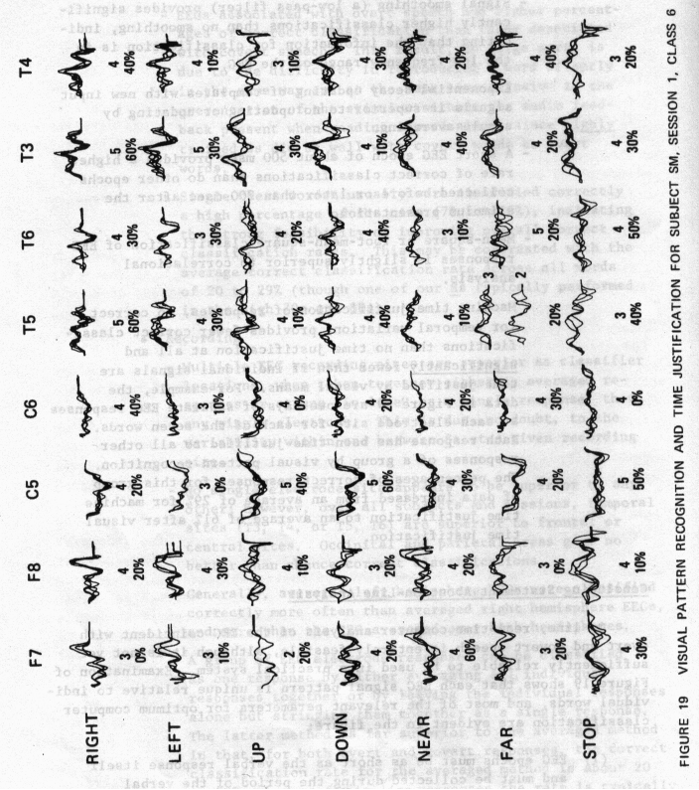

74

(2) More than one electrode should be included in the analysis, and all EEC signals analyzed “in line” as though they were one response.

(3) Time justification by machine must use similar pattern recognition techniques as the human eye.

(4) Signals should be smoothed to eliminate higher frequency “noise.”

(5) Templates should be updated with new, incoming signals, using an exponential decay method.

(6) A time-series analysis using a mean-square or root-mean-square difference algorithm is preferred over either a correlational technique or a frequency-domain analysis.

(7) Subjects should be trained, should be practiced, and should have a “set,” or anticipation of what they are to say or verbally think.

(8) For some forms of biocybernetic communication, pictures or visual images might be used to good advantage along with the uttered or thought word.

DISCUSSION OF BIOCYBERNETIC COMMUNICATION

The purpose of this project was to test the feasibility of designing a biocybernetic communication system, whereby the human brain is closely coupled to a computer for direct, real-time, man-machine interaction. We conclude from our results that it is feasible to use the human EEG coincident with overt and covert speech as inputs to a computer for such communication. However, we also conclude that, without additional research, the EEG is not adequate for the design of a practical operating system; indeed, other methods than those employed here may prove superior.

Nevertheless, enough information has been obtained during this project to specify the optimum parameters to use for an EEG-operatirig system and to suggest future research toward that end. Our results show conclusively that consistent, repeatable patterns exist in the EEG during overt speech (for example, see Figure 19) and covert speech (Figures 13 and 14) and that a computer can recognize these patterns a statistically significant percentage of the time.

The major problems to be solved in using the approach used for this project are those of variability. For example, some subjects consistently have high percentages of correct computer classification of their EEG during both overt and covert speech, as high as 85% over all words overtly spoken and as high as 72% over all words covertly spoken. In these same individuals, EEGs associated with individual words frequently are classified correctly 100% of the time, regardless of the number of times repeated (as many as 25 times in one S). In these individuals, the patterns of EEG activity are consistent over time--in fact as much as 18 months--so that EEGs obtained today may be caissified correctly against templates obtained a year-and-a-half ago.

As described in Part II, these individuals also appear to have a strong hemispheric lateralizatiort for speech, suggesting that they possess a more consistent pattern of cerebral organization than others who do not have strong hemispheric lateralization for speech (for example, stutterers) and whose EEGs frequently are classified correctly by the computer at no better than chance expectancy. The latter group of individuals represent the other extreme of our subjects--those showing pronounced variability in the EEG in time and amplitude. Occasionally the EEGs of these individuals have consistent patterns; and, during these

periods, computer classification improves, as when actual pictures of objects are used as stimuli rather than a word representing the object. However, these patterns do not persist, so that during a given experimental session there may be a high percentage of correct classifications for a time, followed by a decline, suggesting that the pattern of cerebral organization has shifted or drifted. Some evidence exists in our data to suggest that, for these individuals, a repeatable pattern will occur when the stimulus word has some significance to the S.

In between these two extremes are other individuals who show fairly consistent EEG patterns that are classified correctly by the computer on some words but not on others, on some days but not on others. When the data of all three groups are combined, it is not surprising that the overall classification rates are not as high as desired--on the average, about 35% correct classifications on overt data and 27% on covert data. Both sets of data are statistically significant (at the 0.01 and 0.05 levels, respectively), but they are hardly significant enough to serve as a basis for design of a practical operating system.

It would be a serious error, however, to discount the possibilities of a biocybernetic communication system based on these combined scores, since there are more individuals with scores in the 70 to 9O% correct classification rates than in the 10 to 15% range. Rather, we need to determine why some individuals have more consistent patterns, why some do not, and how consistent patterns might be obtained or even induced in those who do not. The studies on hemispheric laterality described in Part II point to ways for resolving this problem.

Given consistent EEG patterns, a persistent, almost constant error remains in machine classification of the EEG. Much of this might be due to the methods we used in pattern recognition or to the amount of data provided to the computer. For example, we know that if six to eight electrodes are employed, and their EEG responses are strung together in line as a single response six to eight times as long as a single response, significantly higher correct classification rates are obtained than when either a single electrode is used or when all electrode responses are averaged together as a single response of unit length. This “in-line” procedure essentially increases the number of variables employed in the classification, giving equal weight to all variables, thus suggesting that a multivariate approach may be more successful than the approach used here. Also, we have improved correct computer classification rates significantly by using human visual pattern recognition to time-justify signals. Thus, if machine time justification could mimic the human pattern recognition algorithm, much of our present variability would be reduced.

Another major source of variability, especially in the covert responses, is the naivete and training of the Ss and their “set” to respond. That is, sophisticated Ss with considerable training have consistently higher correct computer classifications scores than naive, untrained subjects. Furthermore, when the Ss know in advance what word they are to speak or think, correct classification rates are higher. This cortical organization for saying or thinking a word, as reflected in the Ss’ EEG pattemns, is more consistently evoked when sufficient time exists for that organization to occur, and the Ss’ “set” to respond is well formed.

These observations indicate that the optimum parameters required for a consistently accurate computer-brain intercommunication system are as follows:

(1) Ss who have strong hemispheric lateralization for language should be chosen. This may be predetermined by dichotic listening tests (see Part II).

(2) As many as six to eight electrodes should be used on the side of cerebral dominance for language, with emphasis on cortical areas involved in speech-, word-, and auditory-association areas.

(3) Ss should be trained in the operating system, especially temporal training for covert responses, to speak or think words as consistently as possible.

(4) Ss should know what word will be said or thought next; i.e., they should have a set to respond.

(5) Words for speaking or thinking should have some meaning for the S, or should be used in a meaningful context.

(6) Data collected from each EEG electrode should be limited as nearly as possible to the period of time required for actual utterance or thought.

(7) Data from all EEGs should be strung together in-line, as a single response, and should be smoothed sufficiently to eliminate high-frequency components.

(8) Pattern recognition algorithms the computer employs should time-justify the single, combined response, much as a human observer would do with visual pattern recognition.

(9) Stored patterns should be “refreshed” from time to time (i.e., new templates should be formed and updated) to take account of “drifting” cortical organization.

PART Il--HEMISPHERIC LATERALITY

Introduction

As indicated in the General Introductioa, we have no a priori evidence that cortical organization for language production or verbal thinking resides only in the sites we have chosen to place our EEG electrodes. Indeed, evidence of other investigators shows that, in some people, cortical organization for speech may occur in locations different from those we have investigated. Therefore, assuming that the best electrode placement for EEG word-classification will be located over that cortical area more actively engaged in producing the word, it is important to be able to predict, for a given subject, in which hemisphere verbal functions are most likely processed. Also, if different hemispheres process language function in different individuals, does the processing itself have a different form? Finally, in those individuals in whom speech is processed bilaterally, may we expect to find similar measures for biocybernetic communication as in individuals in whom speech is processed unilaterally?

Traditionally, speech localization (i.e., hemispheric asymmetry) has been assigned to that hemisphere opposite to the handedness of the individual involved. Since there are more right-handed people than left, it has been assumed that the left hemisphere is predominantly used for speech production. This concept has been based primarily on clinical evidence from neurosurgically lesioned, brain-damaged, or electrically stimulated patients. That functional brain asymmetries exist has been well documented in animals (Rosensweig, 1951; Hall and Goldstein, 1968), and clinically in split-brain human patients (see Bogen 1969a and b, for an extended review and bibliography), whereas anatomical and pathological verification of brain asymmetries has been demonstrated in over 200 humans (Geschwind and Levitsky, 1968; Glonig et al., 1969). In addition, the perception of language also appears to be lateralized, as revealed by dichotic listening tests (Kimura, 1961, 1967). “Dichotic listening” refers to the simultaneous, bilateral presentation of two different auditory stimuli to determine performance differences between the two ears and, consequently, to demonstrate lateralization of function.

Accordingly, three studies were conducted to determine the effects of laterality in language and nonlariguage tasks. The first, on the

correlation between dichotic listening and correct computer classification of the EEG during overt speech, used data previously reported in these pages. The last two studies on EEG asymmetry and word classification and target recognition and EEC alpha asymmetry, were extensive studies in their own right.

Dichotic Correlations

Ss for correlation of percentage of correct classification of EEC response words with dichotic listening scores were the three used in the off-line experiments (B, C, and D) and the five used for the Articulatory, Semantic, and Contextual study (U, V, W, Y and Z).

Each subject was given the dichotic listening tëst’twice. Percentages of correct responses on the dichotic tests were obtained by dividing the number of correct left and right ear responses by the total number of stimuli. Arbitrarily, for each of the two dichotic tests, left ear scores were subtracted from right ear scores, and the two differences were averaged for each subject. Thus, a positive average difference for a subject indicated right ear dominance, whereas a negative average difference for a subject indicated a left ear dominance. According to past research with dichotic listening (see discussion avove), right ear dominance signifies left cerebral dominance for language and vice versa.

The percentage of correct classifications of EEG responses for the right and left hemispheres (electrodes T6 and T5 respectively) for all Ss on the two language recording sessions were treated similarly. That is, computer classifications for EEG responses during language tasks were obtained for each of the eight Ss on two separate sessions. The percentages of correct responses for the right hemisphere electrode (T6) were subtracted from the percentage of correct responses for the left hemisphere electrode (T5) for each session, and the differences were averaged for each S. Thus, a positive average difference for a subject indicated a left hemisphere dominance for correct classification of EEG responses during the language task and vice versa.

The results are given in Table 13. Ss (first column) were ranked from the maximum left hemisphere EEG dominance to the maximum right hemisphere EEG dominance. A score of zero indicates equality. Average difference scores for EEC dominance for each S are given in the second column, and the corresponding average difference scores from the dichotic listening tests for ear dominance are given in the third column. As indicated, three of the eight Ss were left EEC hemisphere dominant (and right eared), one was bilateral (and equal eared), and four were right EEC hemisphere dominant (left eared).

82

RANK ORDER COMPARISON
BETWEEN HEMISPHERIC EEC DOMINANCE
AND EAR DOMINANCE*

Rank Order Correlation
0.786, 0.01 < p < 0.05
Average Difference
Subject EEG Dominance Ear Dominance
C +15.0 +11.5
V +11.5 +7.5
D +9.5 +5.0
U +0.0 +0.0
Y -2.0 -11.5
W -11.0 -1.5
B -12.0 -11.0
Z -15.0 -1.5

*
See text for definitions.

A rank order correlation was calculated between EEC and ear dominance, with a significant Rho of 0.786 (0.01 <p < 0.05). Thus, if the dichotic tests actually measure laterality of language function, low computer classification scores on a given electrode may simply mean that language is not processed under that electrode. Conversely, these resuits confirm that a dichotic test is the simplest way of determinthg placement of EEC electrodes for biocybernetic communication. These resuits are also significant in view of the fact that all eight Ss were chosen because they were right-handed and, therefore, presumably left hemisphere dominant for speech. Had electrodes been used more extensively over the right hemisphere of the Ss with left ear dominance, the percentage of correct EEG response classifications probably would have been higher than those obtained.

Introduction

About 80 to 9O% of right-handed individuals process language in their left cerebral hemispheres and music and spatial tasks in their right hemispheres (Wada, 1949; Bogen and Bogen, 1969). The remaining 10 to 2O% of dextrals and 40 to 5O% of sinistrals seem to have the reverse of this pattern of organization or have these functions more bilaterally represented in both hemispheres (Branch et al., 1964; Goodgiass, 1972; Glonig et al., 1969). Verbal and nonverbal functions may have become represented in opposite hemispheres through evolution to reduce the interference of one cognitive system with the other (Levy, 1969). Levy arid others have suggested that variations in the laterality patterns of these processes, such as bilaterality, may result in inefficient processing (Levy, 1969; Laridsell, 1969; Miller, 1971; Galin, 1973). One way to test this hypothesis is to compare the pattern of laterality in normal right-handed Ss with the patters in Ss who have a known inefficiency of function, such as stuttering, that may be related to inadequately established hemispheric specialization (Orton, 1927; Travis, 1931; Bryngelson and Rutherford, 1937; Jones, 1966; Van Riper, 1971).

Although stuttering does diminish with some psychological therapies, to view it in purely psychological terms is to disregard much evidence of organic etiology. For example, there are many indications of a hereditary factor. Stuttering is known to run in families (especially those with left-handed members) and is four times as prevalent among males as females. Also, it is insidious in onset, occurring between the ages of two and five when a child is first learning language and is rarely reported as originating at any other age unless as a result of frank brain injury.

There are essentially two schools of thought: one considers stuttering a psychological problem and one regards it as an organically based disability. In the 1930s, a great deal of attention was directed toward a theory advanced by Orton (1927) and Travis (1931) that stuttering was caused by a lack of cerebral dominance, resulting in a rivalry between the two hemispheres for the control of the bilateral musculature involved in speech. Evidence supporting this theory came from many sources. A change of handedness sometimes is accompanied by the onset of stuttering in very young children, whereas reverting to the original hand has been

*

This study was carried out as part of a Ph.D. thesis by Dr. Jearinine Herron for the Department of Anatomy, Tulane University, New Orleans, LA.

known to alleviate it. Tests of peripheral preferences (eye, hand, foot) frequently have indicated some lack of hemispheric lateralizatiort in stutterers. Bryngelson arid Rutherford (1937) reported that, in a normal population, they found 75% right handed, 16% left handed, and 8% ambidextrous. However, in a stuttering population, the distribution was 61% right handed, 4% left handed, and 34% ambidextrous.

Studies that indicate some degree of incomplete lateralization in stutterers are numerous and conflicting. To resolve this problem, it is necessary to be able to determine safely and reliably the location of functions known to be asymmetrically organized in the cortex.

Recent studies have shown that the EEG can be used for this purpose. Power in the alpha frequency band of the EEG (8 to 12 Hz) attenuates during cognitive tasks such as mental arithmetic (Glass, 1964, 1970; Berger,, 1929; Adrian and Matthews, 1934). Other investigators have demonstrated that variations in alpha activity during hemisphere-related tasks can be used to analyze asymmetry of cortical function (Galin and Orustein, 1972; Morgan et al., 1971; McKee et al., 1973).

Another technique for assessing language and music laterality is the simultaneous presentation of competing verbal or musical signals to both ears (dichotic listening). Normal right-handed Ss prefer their right ear for speech stimuli (Broadbent, 1954) and their left ear for music stimuli (Kimura, 1963). Right-ear preference for language is interpreted as reflecting verbal processing in the left hemisphere. More stutterers have been found to have a left ear preference for verbal material than controls on dichotic listening tests (Curry, 1967; Perrin, 1969; Quinn, 1972), but this finding was not confirmed by Sussinan and MacNeilage (1974).

This experiment was designed to compare the lateralization of language and music abilities in the cortical hemispheres of stutterers and nonstutters and to use the resulting relationships in computer classification of the EEC during speech. Hemispheric asymmetry for these functions was measured by analyses of EEG activity in the 8- to 12-Hz frequency band from bilaterally placed homologous leads, and these measures were correlated with behavioral scores of the same subjects during a speech-related dichotic listening task. EEG classification then was obtained using the off-line, root-mean-square method described in the econd and Third Semi-Annual Technical Progress Reports.

Methods

Subjects

Ss ‘were six adult, right-handed stutterers and eight adult, right-handed nonstutterers, all of whom were male, except the eighth nonstutterer, BA. Ages ranged from 18 to 37 years. Histories of each S were taken which included a handedness questionnaire and information about incidence of familial sinistrality and S’s preferred foot, ear, and sighting eye. No S was admitted to the study who had any history of severe anoxia or febrile disease or brain injury.

EEC Experiment

Electrodes and Electrode Placements--Scalp, reterence, and ground electrodes were Beckman silver, silver-chloride standard disk skin electrodes. Locations T3, T4, T5, and T6 of the 10/20 system of EEC recording (Penfield and Jasper, 1954) were used with the reference electrode at the vertex at Cz, and the ground was over the right mastoid process.

EEG signals were recorded on a Beckman Type R Dynograph. Amplitude was normalized by setting all channels to the same gain. The time constant throughout all sessions was 0.1 Sec. These data also were recorded on an Ampex SP-300 analog tape recorder and then sent through the data analysis system using a Digital Equipment Corporation Linc-8 1aboratory instrument computer with analog to digital converters, a Pertec digital tape recorder, and a CDC-6400 computer (see data analysis section below). Calibration procedures to ensure equality of each channel were run before and after each session.

Stimulus Materials--Cognitive tasks designed to activate cortical areas in left and right hemispheres were presented on 15 slides as follows:

(1) Five verbal tasks—-HIT, COOL, TIP, HAD, PUT.

(2) Five music tasks--illustrated in Figure 20, pronounced with neutral “uh.”

(3) Five combined music and verbal tasks--same music tasks as above in (2) pronounced with the words in (1) instead of with the neutral sound "uh," illustrated in Figure 20.

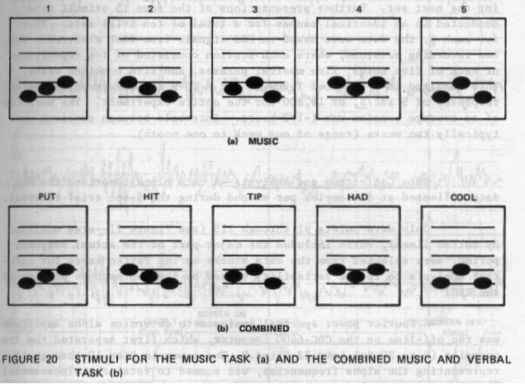

87

Stimulus Presentation--Initiation and maintenance ot a s-sec trial interval, as well as on-line storage of each trial interval, were provided by a Linc-8 program (CNTLSTIM). Figure 21 illustrates an actual chart page with the CNTLSTIM interval on Channel 7 and the voice response on Channel 8.

Slides were changed manually during the intervals between each of the 15 stimulus presentations. A single random presentation of each of the 15 stimuli constituted one set of trials. Following the presentation of one complete set, the 15 slides were randomized and made ready for the next set. Further presentations of the same 15 stimuli were conducted in an identical manner for a total of ten trial sets. Thus, for each S, the data were based on EEG signals from four electrodes for two recording sessions, where each session consisted of ten repetitions of each of five words, five musical phrases, and five combined tasks. This resulted in a total of 1,200 (4 X 2 X 10 x 15) electrophysiological responses of 5 sectS, or 16,800 for the entire experiment. The duration of an average session was 1-1/2 hours. Intervals between sessions were typically two weeks (range of one week to one month).

Data Collection and Analysis--A data block comprised the EEC data collected at 51 samples per second during the 5-sec trial interval.

Only data points 91 through 218 (see Figure 21--area outlined by dotted lines), which included the major part of the actual response period, were selected from the data blocks on the Pertec tapes for spectral analysis to reduce variability caused by the nonresponse portion of the EEC.

A Fourier power spectral analysis to determine alpha amplitudes was run off-line on the CDC-6400 computer, which first separated the frequencies (0 to 20 Hz) into 33 “bins.” The power in Bins 10 through 15, representing the alpha frequencies, was summed to total the alpha activity in one response period at one electrode site. The totals for the ten utterances of a given response were then averaged. All 50 verbal responses were averaged, all 50 music responses were averaged, and all 50 combined responses were averaged. Thus, there were three scores--music, verbal and combined “average alpha amplitude” (AAA) computed for each electrode site. Verbal to music (V/M) ratios also were computed for each electrode site using the verbal/music AAAs.

Artifact Contamination--The computation of AAAs was performed without any editing of artifact. It was assumed that:

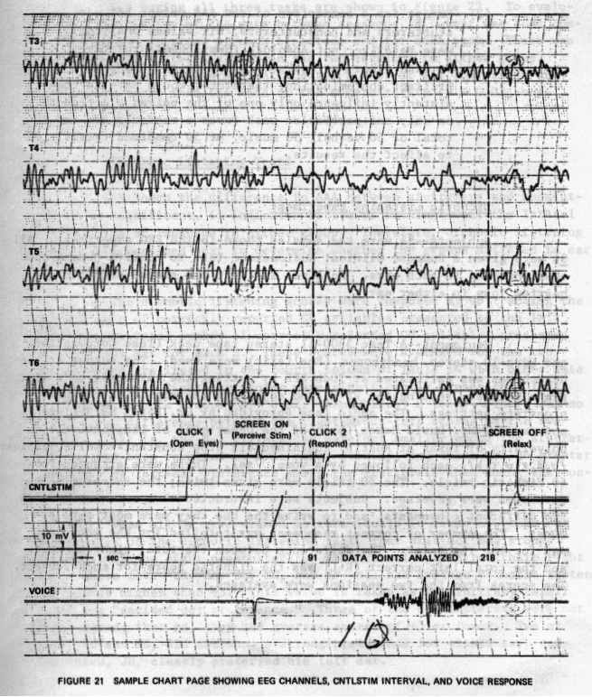
89

(1) High-frequency contamination, slow high-amplitude muscle artifacts, and eye-movement potentials largely would be eliminated by the fact that only alpha frequencies were analyzed which exclude all frequencies outside 7.7 to 12.0 cps.

(2) Except for a comparison of raw AAA values between stutterers and nonstutterers, all values analyzed were relative, not absolute (hemispheres relative to each other, or tasks relative to each other). Artifact contamination, therefore, would have to consistently influence only one of the paired electrodes, on only one particular task (over a randomly ordered total of 50 verbal, 50 music, or 50 combined trials) to affect the results.

Dichotic Listening Experiment

Sub jects--Ss were the same as those in the EEC experiment. All Ss were given a Rudmose Clinical Audiometric test to confirm normal and equal hearing in both ears. No S was included who showed significant hearing loss in either ear.

Equipment--A Teac 3300-11 stereo tape deck (Teac Corporation) and Nova-lO stereo headphones (Realistic) were used. The output at the headphones was calibrated at 70db SPL by putting the earphones on a flat plane coupler, reading the VTVM, and adjusting the amplifier to the appropriate settings. The audio tape (provided by Dr. Peter MacNeilage and made by Mr. David Hakes, both of the Department of Linguistics, University of Texas at Austin) contained six stop constant-vowel syllables:
/b,d,g,p,t,k/, each followed by a vowel /ae/. These were arranged for 60 dichotic trials. The 60 trials were given twice; the second time the earphones were reversed. Subjects were instructed always to answer with two different consonants, and to write the one they were most sure of first. The number of correct responses was totalled for the left ear and for the right ear. The difference between the total right correct and the total left correct (R-L) was the dichotic score for each subject. The scores from the two sessions were averaged.

Results

Average Alpha Amplitude

The mean AAA values (in arbitrary units) for stutterers and nonstutterers during all three tasks are shown in Figure 22. To evaluate the reliability of the data between sessions, a t-test was done comparing the two sessions at each electrode and for each task. There was no significant difference between the two sessions in either group. The AAAs of stutterers are significantly higher at all four sites and during both tasks than the AAAs of the nonstutterers (p < 0.02, one-tailed t—test)

Dichotic Listening Tests

Although the difference in AAA between stutterers and nonstutterers is significant, it indicates little or nothing about the lateral organization of language in either group. Therefore, dichotic listening scores were examined next to determine whether the groups differed in ear preference.

The dichotic listening scores were computed by subtracting the total number of correctly reported CV syllables presented to the left ear from the total number of correctly reported CV syllables presented to the right ear for each S. These scores were averaged for the two sessions and are listed in the fourth column of Table 14 with other data reported below. Right-ear scores were significantly higher than left-ear scores in both groups (p < 0.02, Mann Whitney U test). There was no significant difference between the right-minus-left scores of the two groups. That is, the R-L differences were not smaller among the stutterers, as has been reported by some other studies; and there was no greater incidence of left-ear preference among the stutterers than among the nonstutterers.

When all Ss were viewed as individuals in terms of their ear preferences on the dichotic listening test, four distinct new groups emerged. Of the eight nonstutterers, five clearly preferred their right ear. These five--LR, BA, BL, NC, and MP--all had average dichotic listening scores higher than +3. This value is taken as an arbitrary cutoff point for “decided ear preference.” Three of the nonstutterers were not right-eared; that is, they had average scores of +3 or lower. Two of them, JD and PC, did not show a strong preference for either ear, and the third, JH, clearly preferred his left ear.

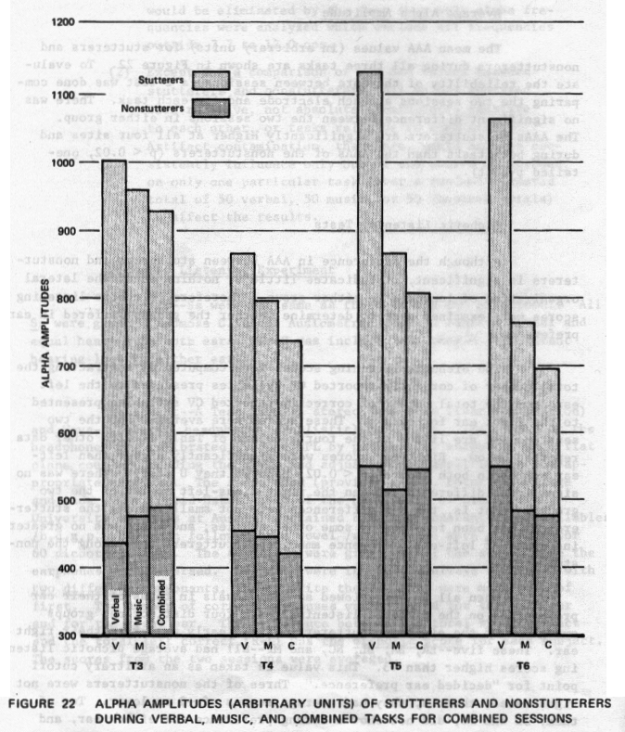

92

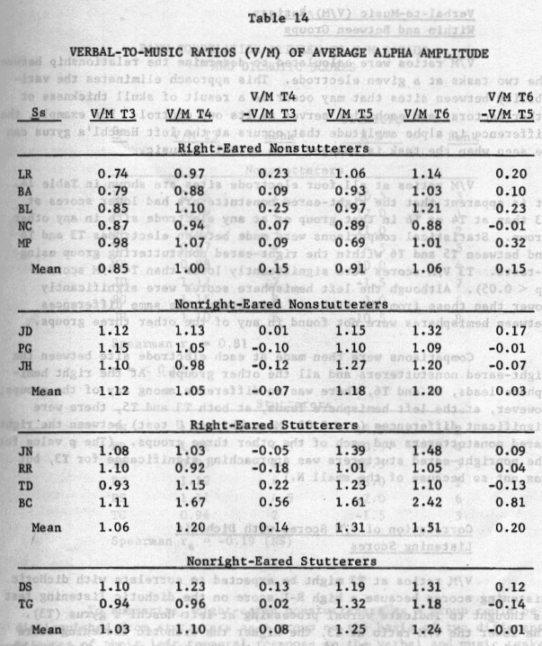

Among the six stutterers, four strongly preferred their right ear (JN, RR, TD, and BC), two showed nonright-ear preference (DS and TG), and none showed a decided left-ear preference. Since all Ss were selected on the basis of right-handedness to achieve homogeneity of laterality within groups, a further selection was made on the basis of ear preference. Both stutterers and nonstutterers were separated into two subgroups, “right-eared” and “nonright-eared.”

93

Verbal-to-Music (V/M) Ratios
Within and Between Groups

VIM ratios were calculated to determine the relationship between the two tasks at a given electrode. This approach eliminates the variability between sites that may occur as. a result of skull thickness or other factors, and each site serves as its own control. For example, the difference in alpha amplitude that occurs at the left Heschl’s gyrus can be seen when the task is changed from verbal to music.

V/N ratios at all four electrode sites are shown in Table 14. It is apparent that the right-eared nonstutterers had lower scores at T3 than at T4 or T6 in that group or at any electrode site in any other group. Statistical comparisons were made between electrodes T3 and T4 and between T5 and T6 within the right-eared nonstuttering group using t-tests. T3 V/M scores were significantly lower than T4 V/M scores (p < 0.05). Although the left hemisphere scores were significantly lower than those from the right in this group, the same differences between hemispheres were not found in any of the other three groups.

Comparisons were then made at each electrode site between the right-eared nonstutterers and all the other groups. At the right hemisphere leads, T4 and T6, there was no difference among any of the groups; however, at the left hemisphere leads, at both T3 and T5, there were significant differences (p < 0.02, Mann Whitney U test) between the right-eared nonstutterers and each of the other three groups. (The p value for the nonright-eared stutterers was approaching significance for T3, but was not so because of the small N.)

Correlation of V/M Scores with Dichotic
Listening Scores

V/M ratios at T3 might be expected to correlate with dichotic listening scores because a high R-L score on the dichotic listening test is thought to indicate verbal processing at left Heschl’s gyrus (T3). The lower the V/M ratio at T3, the higher the dichotic listening score should be; and, conversely, the higher the V/N ratio at T3, the more negative the dichotic listening score should be. V/M scores at T3 (ranked from lowest to highest) and dichotic listening scores (ranked from positive to negative) were correlated for stutterers and nonstutterers using the Spearman Rank Correlation Test. These scores and their ranks for the two measures are shown in Table 15. A +0.81 correlation (p = < 0.01) was found between V/M ratios at T3 and dichotic listening for nonstutterers, but a slightly negative, nonsignificant correlation was found for the stutterers.

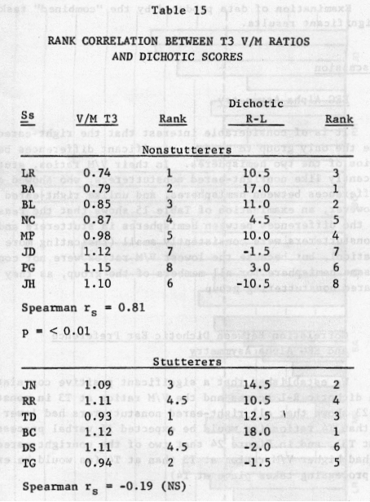

To summarize, right-eared nonstutterers as a group could be distinguished from stutterers as a group on the basis of two different measures of their left temporal response to the verbal and music tasks:
(1) they had lower V/M ratios at T3 and T5, and (2) their rank correlation between T3 V/M scores and dichotic ear preference was positive and significant, whereas no such correlation was found with the stutterers. However, nonright-eared nonstutterers could not be distinguished from stutterers. on the basis of any results shown so far. In other words, no obvious differences existed between the two that might explain stuttering in one group and not in the other.

95

Examination of data produced by the “combined” task did not yield significant results.

Discussion

EEG Alpha Asymmetry

It is of considerable interest that the right-eared nonstutterers were the only group to produce significant differences between the V/N ratios of the two hemispheres. In their V/M ratios, stutterers were significantly like nonright-eared nonstutterers, who showed no signif icant differences between hemispheres, and unlike right-eared nonstutterers. However, an examination of Table 15 shows that the reason was not because the differences between hemispheres in stutterers and nonrighteared nonstutterers were consistently small (indicating more “bilateral” organization), but because the lowest VIM ratios were not consistently in the same hemisphere for all members of the group, as they were in the right-eared nonstuttering group.

Correlation Between Dichotic Ear Preference
and EEG Alpha Asymmetry

We established that a significant positive correlation exists between dichotic R-L scores and the V/M ratios at T3 in nonstutterers. Figure 23 shows that all right-eared nonstutterers had lower T3 V/M ratios than T4 ratios (as would be expected if verbal processing takes place at T3), and in Figure 24 that two of the nonright-eared rionstutterers had higher V/M ratios at T3 than at T4 (as would be expected if verbal processing takes place at T4).

EEG alpha during hemisphere-related tasks previously has not been correlated with dichotic listening scores in “normals” or in any other groups. The significance of the rank correlation makes this one of the most important findings of this research. It was reasonable to expect that a right-ear preference would correlate with left hemisphere verbal processing and, conversely, that a left-ear preference would correspond to right hemisphere verbal processing. But finding a significant rank correlation was surprising. The indication from these results is that the amount of alpha asymmetry correlates with the extent of our preference. The fact that these measures separated “normal” Ss with “typical” lateral organization from those with “reversed” organization make a powerful diagnostic tool--if their correlation remains constant in future studies, and if they can predict correctly lateral organization in patients tested with sodium amytal.

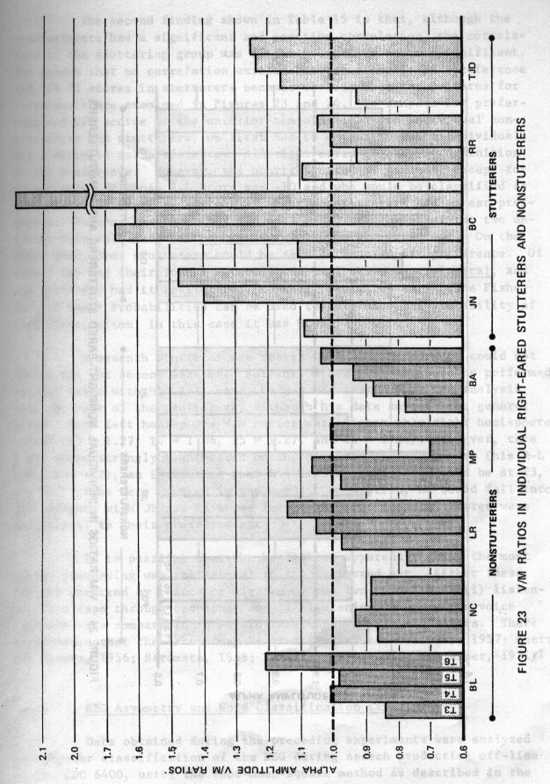
97

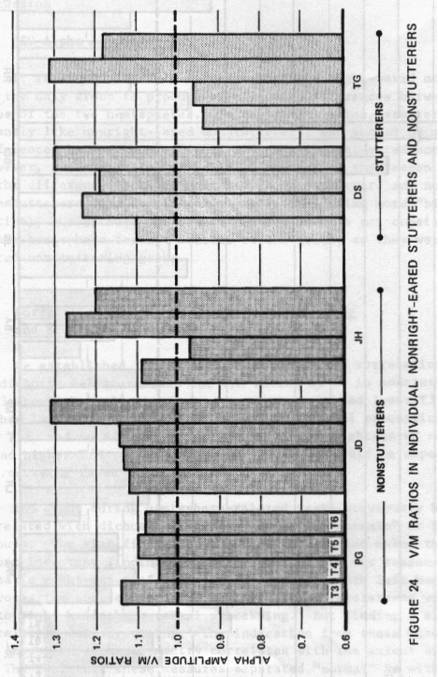

98

The second finding shown in Table 15 is that, although the nonstutterers had a significant and positive correlation, the correladon in the stuttering group was slightly negative arid nonsignificant. The reason that no correlation existed between dichotic ear preference and VIM T3 scores in stutterers becomes obvious when the patterns for individuals are examined in Figures 23 and 24. To compare ear preference and V/M scores at the anterior temporal leads in individual nonstutterers and stutterers, we first had to establish which individuals had a definite ear preference. All right-eared Ss had, by definition, an ear preference. However, the nonright-eared Ss did not, except for nonstutterer JH whose R-L score was -10 and who would be classified as left-eared. Therefore, six out of eight nonstutterers had an ear preference. Figure 23 shows that, in each case, the lowest of the two anterior temporal leads was contralateral to the preferred ear. On the other hand, four stutterers could be said to have an ear preference. Of these, two had their lowest anterior temporal score contralateral, and the other two had it ipsilateral, to their preferred ear. (The Fisher Test of Exact Probabilities can be used to determine the probability of this distribution; in this case it was 0.05.)

A seventh stutterer was tested only once because he could not return for the second session. For this reason, and because he performed several tasks with his left hand, he was not included in the analysis with the rest of the stutterers, although his data support the general trend. Both left hemisphere V/M ratios were higher than right hemisphere
ratios (T3 1.27, T4 1.06, T5 = 1.27, and T6 = 1.24). However, this
S was quite strongly right-eared on the dichotic listening test (his R-L score was +22), an indication that his lowest V/M score should be at T3, not T4. If he were counted in the subject population, he would fall into the category with JN and RR whose lowest anterior temporal scores were ipsilateral to their preferred ear.

It is puzzling that the hemisphere apparently doing the most verbal processing was ipsilateral to the preferred ear. Either these results occurred by chance or mistake or the two conditions--(1) listening to a tape through earphones and (2) listening to one’s own voice feedback--are comparable in noristutterers but not in stutterers. There is evidence that the latter may be true (Butler arid Galloway, 1957; Cherry and Sayers, 1956; Stromsta, 1958; Tomatis, 1954, 1963; Van Riper, 1971).

EEC Asymmetry and Word Classification Experiment

Data obtained during the preceding experiments were analyzed by computer classification of the EEG during speech production off-line on the CDC 6400, using the root-mean-square method as describedin the

Third Semi-Annual Technical Progr€ss Report (September 1973). Subjects
then were grouped according to their dichotic listening tests, as described above, and group comparisons were made between alpha asymmetries and percentage of correct classification.

Percentage of Correct Classification Scores at Known SpeechProcessing Sites Versus Those at Other Sites--We expected that the percentage of classification scores would be higher from electrode sites over known speech-processing centers than from other cortical sites. In previous experiments, all available EEG channels had been used to collect data from these centers. In this experiment, two parietal sites also were used (P3 and P4), which probably were active in the processing of the visually presented stimulus but not in the production of speech. Table 16 shows the percentage of classification scores from temporal and parietal leads in four groups of Ss: (1) right-eared nonstutterers, (2)nonright-eared nonstutterers, (3) right-eared stutterers, and (4) nonright-eared stutterers. The parietal sites produced mean percentage of classification scores at chance levels only (chance = 2O%), whereas the means for T3, T4, T5, and T6 of the right-eared nonstutterers were higher than chance and significant for all temporal leads (Column “All Ts”). Dichotic scores and R/L AAAs obtained previously for each subject are also shown in Table 16 for comparison. No correlation appears to exist between mean dichotic scores or R/L AAAs and mean percentage of correct classifications.

Percentage of Correct Classification Scores at Left Hemisphere Compared with Right--Our previous results would indicate that percentage of classification scores would be higher at left hemisphere leads than at the right in right-eared subjects. This was not the case, as can be seen in Table 16. From the percentage of classification scores of the first group of right-eared rionstutterers, T3 scores were not consistently higher than T4 scores, nor were T5 scores higher than T6 scores. However, in the next group, nonright-eared nonstutterers, and in aonrighteared stutterers, and in nonright-eared stutterers, T4 scores were as high as or higher than T3 scores, which would be expected if the lack of a strong right ear preference were an indication of verbal processing in the right hemisphere rather than the left.

Percentage of Correct Classification Scores of Right-Eared Nonstutterers Versus All Other Groups--No significant differences existed between percentage of classification scores of right-eared nonstutterers and the other groups (as there were when V/M ratios of R/L ratios were

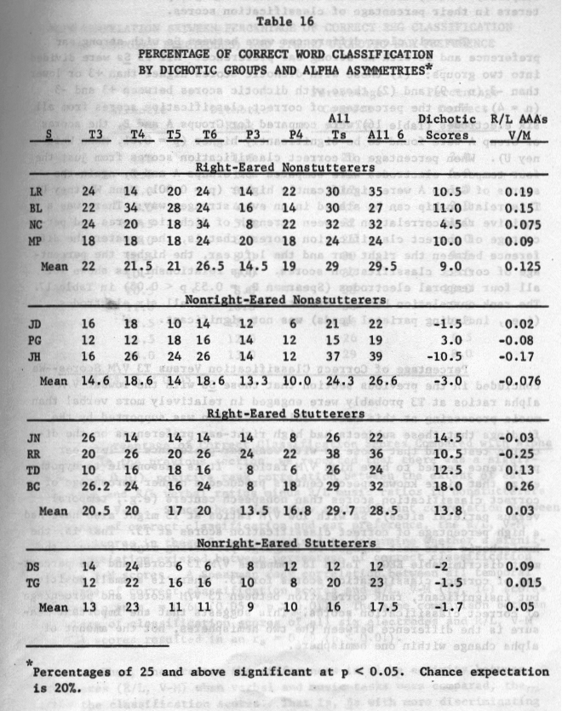

101

compared). Also, the stutterers differed as a group from the nonstutterers in their percentage of classification scores.

The only clear differences were between Ss with strong ear preference and Ss with no strong ear preference. All 13 Ss were divided into two groups: (1) those with dichotic scores higher than +3 or lower than -3 (n = 9) and (2) those with dichotic scores betweeti +3 and -3 (n = 4). When the percentage of correct classification scores from all six electrodes (Table 16) were compared for Groups A arid B, the scores of Group A were found to be significantly higher (p = 0.01, Mann Whitney U). When percentage of correct classification scores from just the four temporal electrodes were compared for Groups A and B, again the scores of Group A were significantly higher (p 0.001, Mann Whitney U). This relationship can be stated in an even stronger way: There was a positive rank correlation between strength of dichotic scores and percentage of correct classification scores; that is, the greater the difference between the right ear and the left ear, the higher the percentage of correct classification scores. This relationship is shown for all four temporal electrodes (Spearman Rs = 0.53, p < 0.05) in Table 17. The rank correlation between dichotic scores and all six electrodes (i.e., including parietal leads) was not significant.

Percentage of Correct Classification Versus T3 V/M Scores--We concluded in the previous section that those Ss with the lowest V/M alpha ratios at T3 probably were engaged in relatively more verbal than music processing at this site. This conclusion was supported by the findings that these subjects had high right-ear preferences on the dichotic test, and that those Ss with weak ear preference or left ear preference tended to have high V/M ratios. It is reasonable to hypothesize that since known speech centers produced a higher percentage of correct classification scores than nonspeech centers (e.g., temporal versus parietal sites), Ss with low V/M ratios at T3 might also have had a high percentage of correct classification scores at T3. That is, the hemispheric site most engaged in language processing might produce the most discriminable EEG. Table 18 compares V/M T3 scores and the percentage of correct classification scores for T3. There is a small positive, but insignificant, rank correlation between T3 VIM scores and percentage of correct classification scores. This suggests that the important measure is the difference between the two hemispheres, not the amount of alpha change within one hemisphere.

RANK CORRELATION BETWEEN PERCENTAGE OF CORRECT EEC CLASSIFICATION
(ALL TEMPORAL ELECTRODES) AND STRONG DICHOTIC EAR PREFERENCE
Percentage Percentage
Dichotic Dichotic Correct Correct
Score Rank All Ts Rank
TG 1.5 1.5 20 3.0
JD 1.5 1.5 21 4.0
DS 2.0 3.0 12 1.0
PG 3.0 4.0 15 2.0
NC 4.5 5.0 32 11.0
MP 10.0 6.0 24 5.0
LR 10.5 8.0 30 9.5
311 10.5 8.0 37 12.0
RR 10.5 8.0 38 13.0
BL 11.0 100 30 9.5
TD 12.5 11.0 26 6.5
JN 14.5 12.0 26 6.5
BC 18.0 13.0 29 80

= 0.53, p < 0.05

Percentage of Correct Classification Scores Compared with Alpha Measures--In the previous section, we reported that there was a significant (p < 0.01) positive rank correlation between the extent of ear preference and R/L verbal ratios minus R/L music ratios in nonstutterers (i.e., R/L, V-M). Since these data show a significant correlation between percentage of correct classification and ear preference, the R/L, V-M (T3, T4) scores in these Ss were examined to determine whether a significant correlation existed between percentage of correct classification and R/L, V-M scores. A Spearman rank correlation between all temporal percentage of correct classification scores and R/L, V-M (T3, T4) scores resulted in an = 060 (0.05 > p > 0.01). The same comparison between percentage of classification scores of all six electrodes arid R/L, V-M (T4, T3) scores resulted in an rs = 0.69 (p < 0.01).

Thus, the greater the differences in alpha activity between hemispheres (R/L, V-M) when verbal and music tasks were compared, the higher the classification scores. That is, Ss with more discriminating hemispheres (greater response to tasks) have higher classification scores.

CORRELATION BETWEEN PERCENTAGE
OF CLASSIFICATION AND VIM RATIO AT T3
V/Ma~T3 Rank T3 Rank
LR 0.74 1 24 3.5
BL 0.85 2 22 5
NC 0.87 3 24 3.5
MP 0.98 6.5 18 7
JD 1.12 12 16 8.5
PC 1.15 13 12 11.5
JH 1.10 8 16 8.5
JN 1.09 6.5 26 1.5
RR 1.11 9.5 20 6
TD 0.93 4 10 13
BC 1.12 11 26 1.5
DS 1.11 9.5 14 10
TG 0.94 5 12 11.5

r = 0.23

Discussion--The Ss of these experiments were divided into the four groups showing significant laterality differences according to language and nonlanguage tasks (i.e., right-eared nonstutterers, nonrighteared nonstutterers, right-eared stutterers, and nonright-eared stutterers), on the logical grounds that these hemispheric differences would correlate with computer classification of the EEG with speech production. However, this correlation was not found, nor were any significant correlations obtained between dichotic listening scores (relative to hemispheric laterality) and “best classification hemisphere” as obtained with other subjects. These results might be explained on the basis that the groups were too heterogeneous, that the N was too small, or that the tasks were not sufficiently discriminable.

A more plausible explanation, however, is to be found in the results showing a significant positive correlation between the amount of ear preference and the percentage of correct classification scores. If it is assumed that the difference between laterality measures is a measure of cortical organization during speech tasks (the greater the difference, the greater the cortical organization f or language), correct computer classification scores should be expected to improve with greater

cortical organization for language. This was found and was supported further by the finding that, when nonlanguage tasks were included in the ranking of cortical organization, a higher percentage of computer classification scores were obtained.

Thus, we can conclude that, when there is a strong laterality difference between language and nonlanguage tasks, and when language is strongly organized in one hemisphere, then the EEG will reveal more consistently a unique pattern associated with specific word production that may be recognized by a computer.

Introduction

The main objective of the experiments reported here was to determine whether the pattern of arousal in the right and left hemispheres of the human brain influenced the efficiency with which perceptual-motor tasks were executed. The study was predicated on a substantial number of publications indicating that the hemispheres are specialized for different modes of functioning and that cerebral dominance in particular situations can be assessed through EEG analysis.

Marc Dax in 1836 and Paul Broca in 1865 (Benton and Joynt, 1960) noted that cerebral damage to the left hemisphere frequently is followed by aphasia, whereas right hemisphere damage usually has no such effect. More recent data confirm that view. Reversible chemical block of one hemisphere may prevent speech, whereas the other does not (Wacda, 1949). Damage or block of the nonspeech hemisphere selectively impairs visual maze performance, face recognition, recall of geometric figures, and so on (Teuber, 1962; Milner, 1971). Disconnection of the two hemispheres through coinmissurotomy revealed that the hemispheres are specialized in terms of two general modes of functioning--one variously described as a linear, analytic, serial, logical, or propositional mode; and the other as a nonlinear, synthetic, parallel, appositional, or Gestalt mode (Bogen, 1969a,b; Bogen and Bogen, 1969).

Electrical responses of the brain--sensory evoked potentials (EP), contingent negative variation (CNV), and the spontaneous EEG--also indicate a lateralization of function. Presentation of visual patterns representing words or random dot designs produce different EP waveforms, and the forms are most different in the language hemisphere (Buchsbaum and Fedio, 1969, 1970). Natural speech stimuli produce larger EPs in the language hemisphere, especially in the tempo-parietal region (Morrell and Salamy, 1971), and the processing of speech can be differentiated, in terms of EP waveforms, from the analysis of nonspeech acoustic parameters (Wood et al., 1971). The amount of asymmetry in the auditory EP is, furthermore, a function of the meaningfulness of auditory stimuli as well as of the mere verbal or nonverbal categorization of materials (Matsumiya et al., 1972).

The meaning also can be in terms of verbs or nouns. Evoked responses to clicks that cue a verbal response differ as a function of the

*
Work carried out and reported by Dr. Charles S. Rebert.

S's set to interpret the word as a verb or noun, and the EPs associated with verb sets are of shorter latency than those in noun sets (Teyler et al., 1973). EPs produced by brief flashes are altered as a function of a S's engagement in verbal or nonverbal tasks, EP power in the right hemisphere being largest during performance of a right hemisphere task (Calm and Ellis, 1975). Somewhat complicating this literature are several findings indicating that asymmetric EPs are produced by unstructured, nonverbal, nonmeaningful stimuli such as tones, light spots, clicks, and so on (Ruhm, 1971; Eason et al. , 1967; Gott and Boyarsky, 1972; Davis and Wada, 1974). The relationship of these asymmetries to hemispheric specialization is not entirely clear but may relate to the primary auditory nature of language and visuo-spatial processing in the nondominant hemisphere. Many of the EP studies have been criticized as methodologically unsound (Friedman et al., 1975).

Oscillatory EEG activity in the two hemispheres has been found to differ as a function of the type of tasks in which Ss are engaged. Morgan et al. (1971) induced asymmetry in the alpha band by requiring Ss to respond to questions requiring either analytic (verbal, mathematical) or synthetic (visuo-imaginative) activity. Although the right hemisphere had more alpha activity in general than did the left, the proportion of alpha in the right hemisphere decreased during the spatial tasks, whereas that in the left decreased during the analytic tasks. Galin and Ornstein (197.2) confirmed Morgan’s findings using different tasks such as writing or mentally composing a letter or forming geometrical designs, either actually or imaginatively. In a more detailed analysis of the Calm and Ornstein data, Doyle et al. (1974) found that the requirement for motor output increased the degree of asymmetry in verbal and spatial tasks. Morgan et al. (1974) confirmed their previous findings by inducing EEC asymmetry with verbal or spatial imaginative tasks, and Butler and Glass (1974) observed relative alpha suppression in the left hemisphere when right-handed Ss engaged in mental arithmetic. Robbins and McAdam (1974) also observed alpha asymmetry when their Ss used different cognitive modes in processing information, even though the information used (picture postcards) was the same for each task. Only instructions to the Ss were varied. Alpha asymmetry in a task using both verbal and spatial imagery was intermediate to that associated with use of only one mode or the other. McKee et al. (1973) showed that the degree of asymmetry was a function of task difficulty--becoming greater with increasing difficulty of a linguistic task. Herron (1974) showed that asymmetry occurred in normal right-eared Ss (defined with a dichotic listening task) but not in Ss with no ear preference or left-ear dominance. Stutterers exhibited less asymmetry than normals. Schwartz et al. (1973) observed right alpha suppression when Ss whistled a song and left alpha suppression with recitation of lyrics No asymmetry was observed during singing (a presumed

dual-hemisphere task). Increasing the difficulty of the tasks enhanced the degree of asymmetry originally seen.

The foregoing literature survey indicates that asymmetric functioning of the two hemispheres occurs in normal human subjects during performance of different tasks and shows that the asymmetry can be monitored by recording several types of gross electrical events. Because of the ease of EEC recording, the lack of necessity for time-locking of responses, and the continuous nature of the EEG, this technique of electrophysiological monitoring has the most promise as a tool for determining the role of hemispheric dominance in a variety of tasks, so it was used in the experiment reported here.

Although several investigators have shown that EEG asymmetry is induced by engagement in a task, there have been no reports that the degree of asymmetry influences the efficiency with which tasks are performed. If EEC asymmetry is a functionally relevant event, a relationship to performance should be demonstrable. Assuming that such asymmetry reflects a direction of attention to one or the other processing modes, it would be expected that the perception of stimuli relevant to that mode would be enhanced, and perception of irrelevant stimuli would be retarded. Verbal and nonverbal target-recognition tasks were designed to test that expectation.

Experiment 1 - EEC Asymmetry and Performance

Methods

Subjects

Thirty-three adult male or female Ss were tested for handedness using the following tests:

(1) Handwriting
(2) Reaching for small objects
(3) Simulated quick draw of pistol
(4) Rifle aiming
(5) Paper sighting
(6) Ball kicking
(7) Family history
(8) Written questionnaire.

A score of 0 was given for left-handed responses, 1 for mixed responses, and 2 for right-handed responses on the manipulative tasks. The number

of right-handed responses was cumulated from the questionnaire and added to the performance score. Only clearly right-handed Ss (those with scores greater than 22 out of a total of 29 and no family history of left-handedness) were to be used in the experiment. Ninety percent of right-handed individuals have language localized in the left hemisphere.

Twenty-three Ss also were given a preliminary EEC screening to familiarize them with the experimental environment and to narrow the selection of Ss. The initial aim was to select 16 Ss, 8 male and 8 female. From those 23 Ss, the final subject group was selected on the basis of highest handedness scores and absence of EEG peculiarities (e.g., persistent alpha at a single lead).

Task Development

Tasks were developed that presumably would differentially engage the two hemispheres and allow quantitative analysis of performance. A target detection design was thought to be appropriate to these aims.

The verbal task consisted of recognizing briefly presented words (50-msec exposure) that were members of a designated word category (animals, verbs, size, etc.; see Table 19). Similarly, prememorized subsets of a general set of spatial patterns constituted nonverbal targets (see Figure 25). The word and spatial tasks were run independently in different work periods. During the task, a stimulus was selected randomly and presented by a computer (Linc-8) every 1.5 sec, and the S pressed a telegraph key as rapidly as possible when a target stimulus was seen.

Table 19

WORD CATEGORIES
Animals Inanimate Verbs Relations Colors Size Numbers
Elephant House Chase Husband Purple Puny Unison
Kitten Dirt Throw Wife Green Great Bimodal
Hawk Desk Sing Daughter Orange Small Three
Zebra Stove Talk Cousin Yellow Medium Multiple

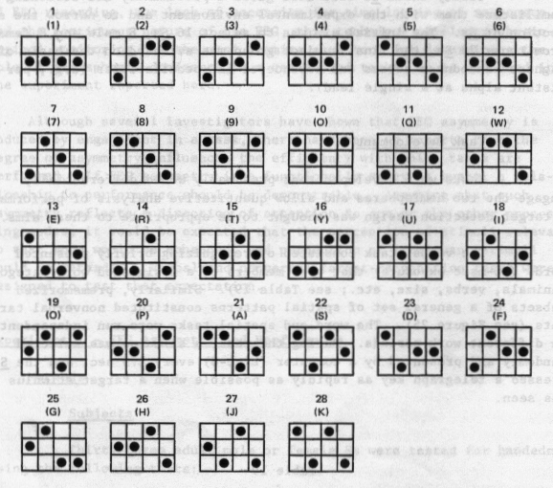

FIGURE 25 MODERATELY DIFFICULT SET OF DOT PATTERNS USED IN THE SPATIAL TASK

Numbers 1-9 were part of a group of patterns judged to be most easily learned and recognized; Numbers 10-18 were judged to be moderately difficult; and Numbers 19-28 were most difficult to learn and recognize.

110

Several programs were developed for experimental control and data analysis. Initial programs were modified as dictated by experience with them.

Early Programs for Experimental Control

All these programs were logically the same but dealt with different content--i.e., words and three sets of patterns differing in difficulty of memorization and detection. These programs had the following characteristics and functions:

(1) Experimental Control- -Program WORDS generated and presented the list of words included in Table 19. The duration of exposure, interstimulus interval, and number of repetitions of the word list were determined by switch settings so were under experimental control. Reaction times were obtained by the computer and categorized in terms of hits (correctly detected targets) and false alarms (nontargets incorrectly responded to). The number of target hits, target errors, nontarget hits, and nontarget errors were cumulated and printed out for each stimulus set at the end of a work session, as shown in Table 20. The sequence of stimuli presented, their target or nontarget status, and the correctness or incorrectness of the response to them also was printed (Table 20). Programs for patterns (GRIDI, MODGRID, and EASYGRID) were logically the same but differed in difficulty. Only the MODGRID program has been used experimentally so far.

A program called PRACTICE was used to present patterns continuously to Ss for memorization before testing. Teletype commands were used to select any given pattern that was displayed until another was selected. This was incorporated into the GRID programs to minimize delay between memorization and testing.

Additional modification of these programs was made for use in on-line triggering of stimuli. Presentation of a stimulus was made contingent on the

PERFORMANCE DATA
Example--i Set, 1 Subject

SET 2

TARGET HITS - 6

NONTARGET HITS - 22

TARGET ERRORS - 2

NONTARGET ERRORS - 2

TARGET HIT REACTION TIMES
379 377 448 507 522 895

NONTARGET ERROR REACTION TIMES
333 665

STIMULUS SEQUENCE-STATUS-SCORE
1401 501 801 701 101 2311 2001
2311 401 2111 1501 2211 2601 1901
2700 1201 1801 901 1301 2501 1701
1101 2111 1001 301 2410 1601 2800
601 2410 2211 201
Item Target or Correct or
Number Nontarget Incorrect

presence of a signal on one computer input that was larger than one of two preset thresholds, observable on the Linc-scope as shown in Figure
26. Originally, this procedure was used in the WORD and GRID programs separately, so that the S observed only words in one work period and patterns in another. The stimuli were also triggered only by the left hemisphere in a given session and by the right in another. Another modification was made so that either a word or pattern was generated when a threshold was exceeded, and both thresholds could trigger a stimulus. The computer categorized reaction

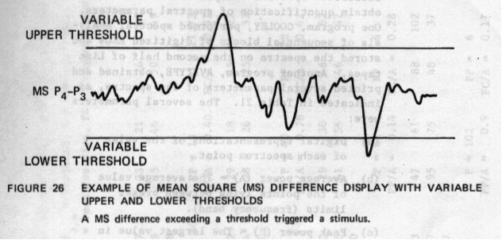

113

time into four bins in terms of the stimulus and triggering hemisphere--i.e., word left, word right, pattern left, pattern right.

Another version of the foregoing program was designed for use in a biofeedback paradigm for learning autocontrol of EEG asymmetry. Words occurred when the upper threshold was exceeded, and patterns occurred when the lower threshold was exceeded. Either left or right hemisphere alpha could be made to trigger words or patterns by changing the input polarity.

(2) Data Analysis--Programs were written to facilitate spectral analysis of EEGs and to obtain quantification of spectral parameters. One program, COOLEY, performed spectral analysis of sequential blocks of digitized EEGs and stored the spectra on the second half of Line tapes. Another program, AVETYPE, obtained and printed several parameters of the spectra, as indicated in Table 21. The several parameters were:

(a) Digital representations of the value of each spectrum point.

(b) Average power (A) = The average value of the points lying between preset limits (frequency band).

(c) Peak power (P) = The largest value in the defined frequency band.

(d) Peak position (PP) The ordinal position of the largest value, an indication of the dominant frequency in the band.

(e) FC = Frequency centroid, another measure of dominant frequency or the “balance point” of the spectrum in the frequency dimension.

n
E n,x.
FC = i=1 i i
E Xi

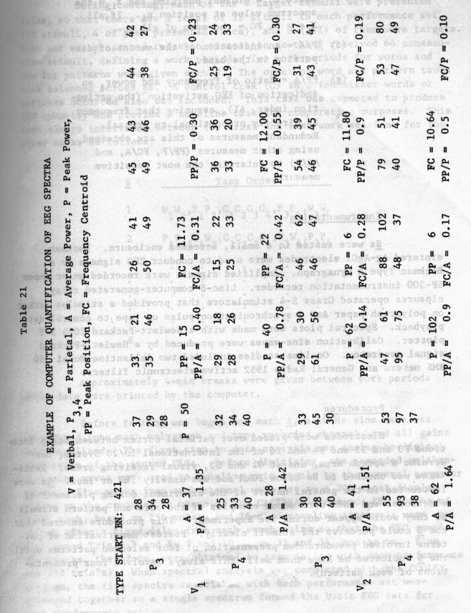
115

where n. = ordinal position and Xj = the spectrum value at position ni If all X.s = 1, FC = the mean of all n
1 i

(f) P/A = An indication of the amount of dispersion in the band.

(g) PP/A = Ratio of frequency and power, an indication of EEG activation (the activation index, Al), assuming that frequency is directly proportional to arousal. Redundant measures of this are obtained using other measures (PP/P , FC/A, and AC/P) to determine the most sensitive measure.

Ins trumentat ion

Ss were tested in a small, screened enclosure. Beckman sintered Ag-AgC1 electrodes were used to conduct EEC signals to a Beckman Type R Dynagraph. Amplified signals were recorded on an Ampex SP-300 instrumentation recorder. Linc-8 computer-generated relay closures operated Grass S-4 stimulators that provided a stimulus marker on polygraph paper and a synchronization pulse on tape to control data playback. Spectral plots were made with a Hewlett-Packard 1024 X-Y plotter. Calibration sine-waves were produced by a Hewlett-Packard signal generator. On-line studies included two Ballantine Model 350 RNS meters and General Radio 1952 active electronic filters.

Procedures

Electrodes were placed over parietal cortex between scalp locations P3 and T5 and P4 and T6 of the International 10/20 System, near Wernike’s speech area, and at 01 and 02, visual receiving areas. Resistance was checked to be below l0k~ and was usually 5k~ or less. Ss were instructed in the general nature of the experiment during placement of electrodes and then were shown examples of the word and pattern stimuli as they would appear during the experiment. This procedure ensured that the S could perceive the stimuli clearly. Pretest memorization of patterns involved pseudorandom presentation of four selected patterns until the S indicated he knew them well (this always involved four presentations of each pattern).

During testing, each of the 4 target stimuli were presented twice, so that there was a total of 32 stimuli in each performance set (28 stimuli, 4 of them presented twice), and 8 (25%) of them were targets. Each set was presented twice in succession so the S received 64 consecutive stimuli, defining a work period. Two work periods for words and two for patterns were given each S. The order of word and pattern tasks were balanced across Ss. A control task (C) in which either words or patterns occurred also was included. This task was expected to produce EEC symmetry and provide a baseline task for comparative purposes. This task always intervened between the first and last work sessions for the other tasks as follows:
S Task Order
1 w₁w₂ ,P₁P₂ ,C1C2C3C4 ,P₃P₄ ,W₃W₄
2 P₁P₂ ,W1W2 , C₁C₂C₃C₄ ,W₃W₄ ,P₃P₄
8 . . . .

Approximately 4-mm breaks were given between work periods while data were printed by the computer.

Before testing was begun for each S, a 10-Hz sine wave was introduced into each polygraph and tape recorder channel, and all gains were equalized. The first step in data analysis was analog-to-digital conversion of the stored EEGs. Before digitizing, the recorded calibration sine waves were used to equalize gain levels to the several computer inputs. Sine waves from each channel were set to ± 200 octal display points on the computer by means of the CALLBRAT program. EEG epochs of 4 sec each, based on 256 points and 16-msec sampling intervals were obtained after a fixed delay from each synch pulse so that the EEG sample overlapped Trials 3 and 4, 9 and 10, ..., 33 and 34, and so on. Five
• EEC epochs, therefore, were obtained in association with each performance set (32 trials). When spectral analysis was completed with the COOLEY program, the five spectra associated with each performance set were averaged together so a single spectrum formed the basic EEG data for each performance set..

To define each S’S alpha band, all of each S’s spectra that evidenced alpha were averaged together, stored on Line tape, and plotted. The plots were studied to determine at what frequency alpha activity be-gan to appear and diminish. Positions on the spectra that were judged to delimit alpha were marked (Figure 27), and the octal numbers representing the horizontal positions were obtained with a cursor program on the Linc-8. If alpha was not clearly present, the whole 8- to 13-Hz band was used. This procedure seemed more realistic than arbitrarily applying fixed limits to all Ss. Clearly, individual differences in EEC spectra exist. Some Ss have very consistent and narrow alpha bands, whereas others have wide bands, and some Ss have alpha of different center frequencies than others. Spectrum values were obtained with AVETYPE and analyzed in terms of hemispheric asymmetry associated with the tasks and their relationships to performance efficiency.

Results

After 8 Ss were run, preliminary analyses were undertaken to determine whether meaningful data were being generated. First, differences in general hemispheric activity were studied as a function of the tasks. We expected that the relative amount of alpha activity in the right hemisphere would be less in the spatial task than in the verbal task.

Figure 28 shows the relative amounts of average alpha power (expressed in arbitrary units) in the hemispheres during performance in the two tasks. In both verbal and spatial tasks, average alpha power was greater in the right than in left hemisphere (D = 12.63, t = 3.0, df = 7, p < 0.02; = 20.13, t = 4.41, df = 7, p < 0.02; two tailed). There was no significant difference in the right over left (R/L) ratios for verbal and spatial tasks, but in terms of right-left difference scores, the verbal and spatial comparison approached significance (D = 7.5, t = 2.65, df = 7, p < 0.05). Thus, there was a general bias in terms of greater right hemisphere alpha power in the parietal region, and the suggestion of enhancement of that bias in the spatial task.

The apparent differences in the occipital region shown in Figure 28 were not statistically reliable.

Alpha frequency in the two hemispheres and tasks as measured by peak position is shown in Figure 29. The pattern of mean frequencies across hemispheres and tasks is as would be expected--i.e., higher frequency in the left than the right during verbal processing and vice versa for spatial processing. However, the Task X Placement interaction was not statistically significant, and this pattern was not duplicated when

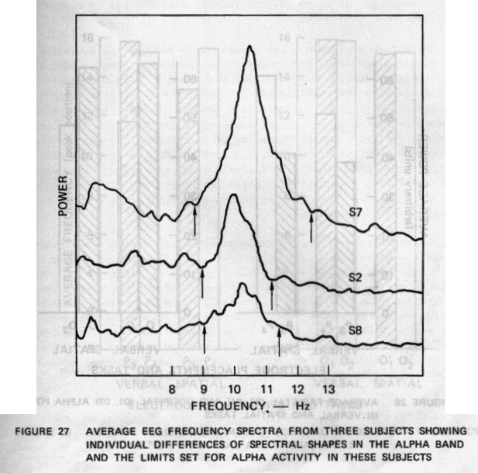

119

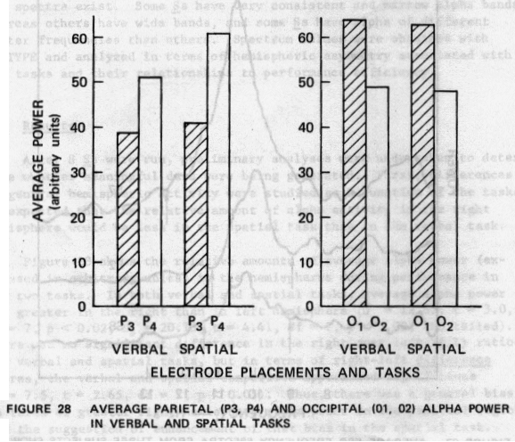

120

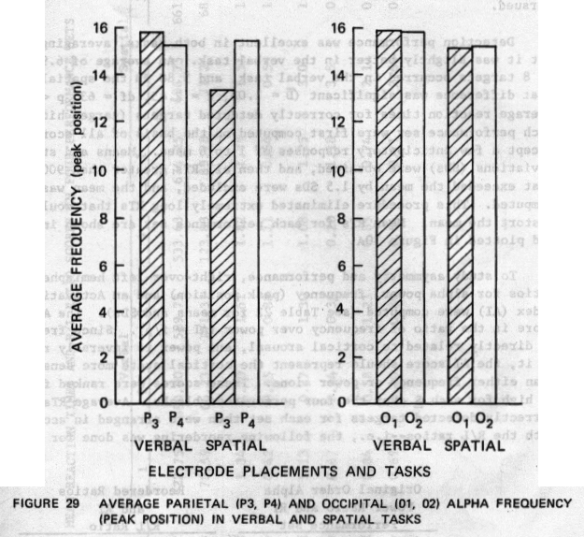

121

the frequency centroid measure was used. There were essentially no differences at the occipital sites (Figure 29).

Although contrary to the expected direction of induced alpha power asymmetry, the parietal difference in verbal and spatial tasks (enhanced alpha in the right hemisphere in the spatial task) was the same in seven of the eight Ss, so study of performance relationships to asymmetry was pursued.

Detection performance was excellent in both tasks, averaging 80%, but it was slightly better in the verbal task. An average of 6.91 hits of 8 targets occurred in the verbal task, and 5.88 in the spatial task. That difference was significant (D 1.03, t = 2.45, df = 63, p < 0.02). Average reaction times for correctly detected targets (target hits) for each performance set were first computed on the basis of all scores except a few anticipatory responses of 1 to 6 msec. Means and standard deviations (SDs) were obtained, and then all RTs greater than 900 insec that exceeded the mean by 1.5 SDs were excluded, and the mean was recomputed. This procedure eliminated extremely long RTs that would distort the mean. Mean RTs for each performance set are shown in Table 22 and plotted in Figure 30A.

To study asymmetry and performance, right-over-left hemisphere ratios for alpha power, frequency (peak position) and an Activation Index (Al) were computed (see Table 22 for means and SDs). The Al score is the ratio of frequency over power (Al = f/p). Since frequency is directly related to cortical arousal, and power is inversely related to it, the Al score should represent the cortical state more sensitively than either frequency or power alone. These scores were ranked from low to high for each S over the four performance blocks. Average RTs to correctly detected targets for each set then were arranged in accordance with the R/L ratios--i.e., the following reordering was done for each S:
Original Order Alpha Reordered Ratios
Power Ratio and RT and RT
Performance Set - R/L Ratio
1 2 3 4 Low Med. Mod. High
R/L Ratio 0.79 1.19 0.64 0.59 0.59 0.64 0.79 1.19
RT 549 521 405 392 392 405 549 521

Means and standard deviations of RT ordered according to the three asymmetry measures are shown in Table 23. Figure 30B shows mean RTs as

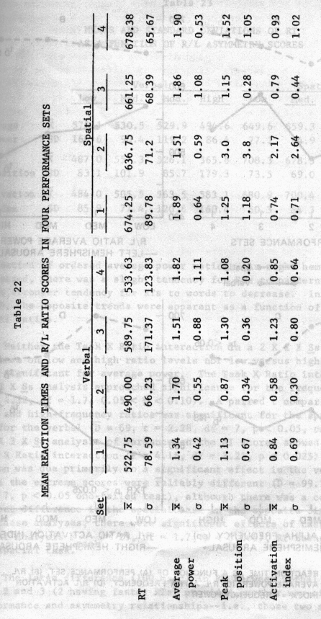
123

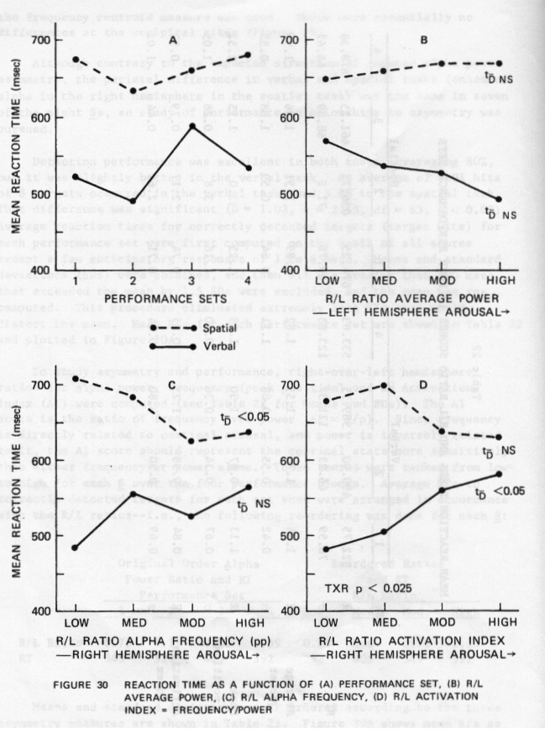

124

MEANS AND STANDARD DEVIATIONS OF RT
AS A FUNCTION OF R/L ASYMMETRY SCORES
Verbal Spatial
Low Med. Mod. High Low Med. Mod. High
Average x 573.1 530.5 529.9 494.6 649.6 659.3 670.8 671.0
power SD 166.6 90.4 119.2 86.4 77.2 94.9 72.8 51.9
Peak x 487.0 557.3 526.1 565.8 708.3 678.5 624.6 639.3
position SD 83.1 101.9 85.7 179.3 73.5 69.0 60.8 67.3
Activation 484.0 505.5 563.5 583.1 680.9 700.4 638.5 630.9
index SD 85.9 77.4 120.6 160.4 50.3 84.3 69.7 70.9

a function of ordered average power ratios. As right hemisphere power increased, there was a slight tendency for RTs to patterns to increase and a stronger tendency for RTs to words to decrease. In Figures 30C and D, the opposite trends were apparent as a function of alpha frequency and Al ratios.

Neither the Task X Ratio interaction in a 2 X 2 X Ss analysis of variance on low and high ratio levels nor low versus high t comparisons were significant for average power. The Task X Ratio interaction in a 2 X 2 X analysis approached significance for the frequency measure (F 4.32, df = 1.7, 0.05 < p < 0.10). A paired t comparison on RT at low- and high-frequency ratios was significant for the spatial task but not for the verbal (D = 69, t = 2.28, df = 7, p < 0.05, one-tailed test). A 4 X 3 X Ss analysis of variance on the Al scores showed a significant Task X Ratio interaction (F = 4.15, cif = 3.21, p < 0.025). This interaction was due primarily to a significant effect in the verbal task where the extreme scores were reliably different (D = 99.13, t = 2.06, df 7, p < 0.05 one-tailed test), although there was a contributing 50-msec difference in the spatial task in the opposite direction. In all these analyses, there were significant effects of task (e.g., for the Al analysis Ft sk = 29, df = 1.7, p < 0.005), RT being slower in the spatial task. a

The large difference (100 msec) in RT between verbal performance Sets 2 and 3 (2 having faster RTs) provided another way of observing performance and asymmetry relationships--i.e., those two sets were

compared in terms of EEG asymmetry to determine whether asymmetry scores differed between them. For the power measure, 6 of the 8 Ss had larger R/L ratios in Set 2 than in Set 3--i.e., greater left hemisphere arousal associated with fast RTs to words. The magnitudes of the scores were highly variable, however, and the mean difference was not significant. The frequency and Al scores were significantly different in the two sets, especially the latter score--7 of the 8 Ss had smaller R/L ratios in the second than in the third sets (Dpp = 0.24, t = 2.11, df = 7, p < 0.05 one-tailed test; DAI = 0.65, t = 2.74, df = 7, p < 0.025 one-tailed test)--i.e., greater left hemisphere arousal associated with fast RTs to words.

Discussion

Because unexpected enhancement of right hemisphere alpha by the spatial task was observed during preliminary examination of the data after only half the planned Ss were run, more thorough analyses of the data were thought to be necessary. The paradoxical enhancement occurred in 7 of 8 Ss and could not be explained by misplacement of electrodes or other technical errors. Therefore, performance relationships were determined to test the adequacy of the general paradigm. Because of the small number of Ss, these data were construed tp provide a preliminary test, rather than definitive data, but it seemed prudent to undertake the analyses rather than continue to run Ss in a possibly inadequate paradigm.

Analysis of Standard Alpha Band

To check the assumption derived from the previous data that it was advantageous to establish alpha bands on an individual basis, we reanalyzed the data using a standard 9- to 12-Hz band for each S. Figure 31 shows a plot of RT as a function of alpha power ratios using either-individual or standard definition of alpha. There are no differences in the plots indicating that, for the purposes of studying asymmetry-performance relationships, the standard measure is adequate.

Evoked Potentials to Correctly Detected Targets

When words and patterns are flashed separately to right and
• left visual fields, differences in evoked potentials (EPs) are evident (Buchsbaum and Fedio, 1969). In this experiment, both fields were stimulated, but, theoretically, the hemispheres specialized for verbal and nonverbal processing should still evidence difference in the EPs to word

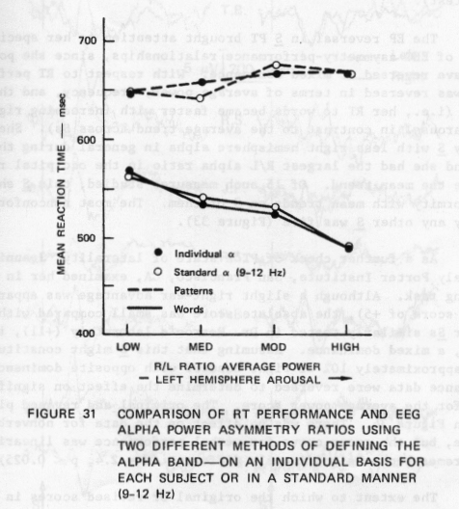

127

and pattern stimuli. In these results, the EPs were not very clear to words, and no obvious differences existed between the hemispheres. However, potentials evoked by pattern stimuli, primarily the first negative component, were usually (in 5 out of the 8 Ss--TB, RS, JF, RS, MW) slightly larger in the right hemisphere than in the left (Figure 32). Excluding the reversed S, there was an average amplitude difference (base to peak) of the major negative component of 4.3 uV, the component being larger in the right hemisphere (t = 2.5, df = 6, p < 0.05, two-tailed test).

The EP reversal in S PT brought attention to her specific pattern of EEC asymmetry-performance relationships, since she possibly could have reversed or mixed dominance. With respect to RT performance, this S was reversed in terms of average power, frequency, and the Al measure (i.e., her RT to words became faster with increasing right hemisphere arousal in contrast to the average trend across Ss). She was also the only S with less right hemisphere alpha in general during the verbal task, and she had the largest R/L alpha ratio in the occipital region opposite the mean trend. Of 15 such measures studied, this S showed nonconformity with mean trends on 9 of them. The most nonconformities shown by any other S was five (Figure 33).

As a further check of PT’s state of laterality, Jeannine Herron of Langely Porter Institute, San Francisco, CA, examined her in a dichotic listening task. Although a slight right-ear advantage was apparent in the task (a score of +5), the absolute score was small compared with the mean of other Ss similarly tested in Dr. Herron’s laboratory (+11), indicating, perhaps, a mixed dominance. Assuming that this S might constitute one of the approximately 10% of right handers with opposite dominance, her performance data were reversed to determine the effect on significance levels for the average power score. The original and revised plots are shown in Figure 34. There was no effect on the data for nonverbal performance, but the group curve for verbal performance was linearized, and the extremes became significantly different (t = 2.4, p < 0.025).

The extent to which the original or revised scores in this S are taken to represent the real state of affairs in the above depends on the criteria for hemispheric dominance considered most exact. Handedness is fairly reliable, but a known proportion of dextrals do have right hemisphere dominance. The dichotic listening test was ambiguous. Indices most directly reflecting the perceptual processes under study (e.g., the evoked potentials) might be the best indicator of where in the nervous system information is preferentially treated. In the least, these results indicate that more exact procedures for selecting dominance need to be used in subsequent studies, or, perhaps, that the EP be adopted

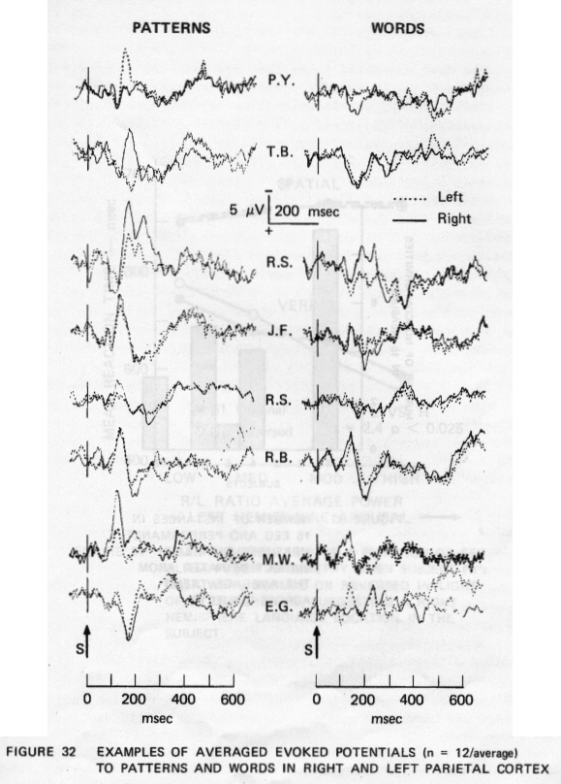

129

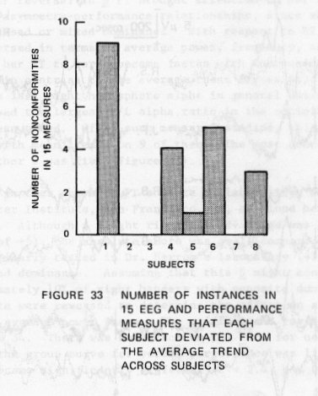

130

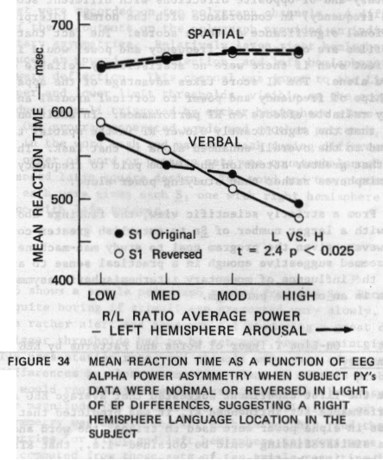

131

arbitrarily as the deciding criterion in cases of ambiguity. Ultimately, the general procedure used here might be a very sensitive one for determining cerebral dominance.

The data presented above indicate that EEG asymmetry does influence performance in the perceptual-motor task employed here. Whereas, statistically, the individual comparisons are weak, the differential profiles of RT scores as a function of task and asymmetry are complementary and of opposite directions with different scores (e.g., power and frequency) in concordance with the normal interpretation of the functional significance of those scores. The fact that the Task X Ratio profiles are opposite for frequency and power would itself suggest a real effect even if there were no statistically reliable effects using each score alone. The Al score takes advantage of the apparently opposite relationships of frequency and power to cortical arousal and shows Statistically reliable effects on RT performance. In addition, it could be argued that the significantly slower RT in the spatial task in general was related to the overall enhanced alpha in that task. The results also indicate that greater attention should be paid to frequency differences in the hemispheres rather than studying power alone.

From a strictly scientific view, the findings above must be repeated with a larger number of Ss to establish greater confidence in them.. However, given the program goal to study man-machine interaction, the data seemed suggestive enough in a practical sense to attempt to determine the influence of momentary interhemispheric asymmetries on perception in an on-line paradigm.

Experiment 2 - On-Line Trigger of Words and Patterns by EEG Alpha Power Asymmetry

Since the first experiment suggested that average EEG asymmetries over a performance set influenced RT, it was predicted that if momentary asymmetries in alpha power were used to trigger the word and pattern stimuli, a similar finding would be obtained--i.e., that RTs to words triggered by a left hemisphere alpha burst would be slower than when words were triggered by right hemisphere alpha bursts. The opposite would be expected for patterns. More generally, opposite results should be obtained for words and patterns, whatever the particular results with one of the tasks.

Methods

The same general methodology as used before was employed in this

experiment, except that stimuli were triggered by alpha asymmetries rather than automatically by computer. One effect of this was to intro-duce a variable interstimulus interval. Figure 35 indicates the method used to obtain on-line alpha power asymmetries. EEGs from left and right parietal areas were routed to General Radio 1952 active filters set to 9- to 12-Hz. Filter outputs were connected to two Ballantine 320 RNS meters that were recorded on two polygraph channels. A differential measurement of the MS outputs on the polygraph provided an indication of on-line momentary asymmetries. Relatively large right hemisphere alpha activity produced an upward pen deflection, and left hemisphere alpha caused a downward deflection. This channel was input to the Linc-8 computer. Upper and lower limit thresholds, visible on the scope, could be set to produce stimuli triggered by either hemisphere alone or by both hemispheres. One program generated words and another patterns, so that a S performed in the word task and pattern task during different work periods. The order of word or pattern sets was counterbalanced across Ss with a balanced latin square design. Two word and two pattern sets of 64 stimuli each were given each S, one with right hemisphere alpha trigger and one with left trigger.

Results

Figure 36 shows a sample polygraph record from one S. Because the task becomes quite boring if stimuli are presented very slowly, and because Ss are rather alert and thus are not producing a great deal of alpha, the trigger thresholds had to be set very low to maintain an adequate stimulus presentation rate, and stimuli were very often triggered by trivial differences in alpha asymmetry. Because of this problem, not all RT scores would represent an event associated with clear asymmetry. Therefore, the magnitude (in millimeters of pen deflection) of each triggering asymmetry was determined for each target hit, and the ten largest asymmetries for right and left hemisphere triggers were obtained. Mean RTs were computed from those sets of ten trials resulting in four mean RTs for each S--RTs to right- and left-hemisphere-triggered words (WR and WL), and right- and left-hemisphere-triggered patterns (PR and PL), which are shown in Table 24.

Comparisons of RTs to right- and left-triggered stimuli across Ss were not significant in either task. In other words, Ss were not consistent in showing slower RTs to left-triggered words, right-triggered patterns, and so on. However, arrangement of the means in a 2 X 2

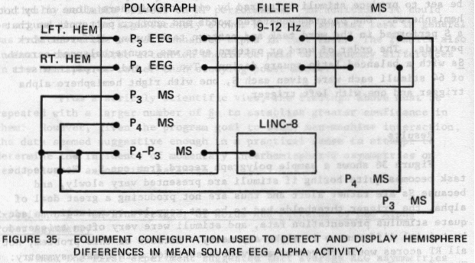

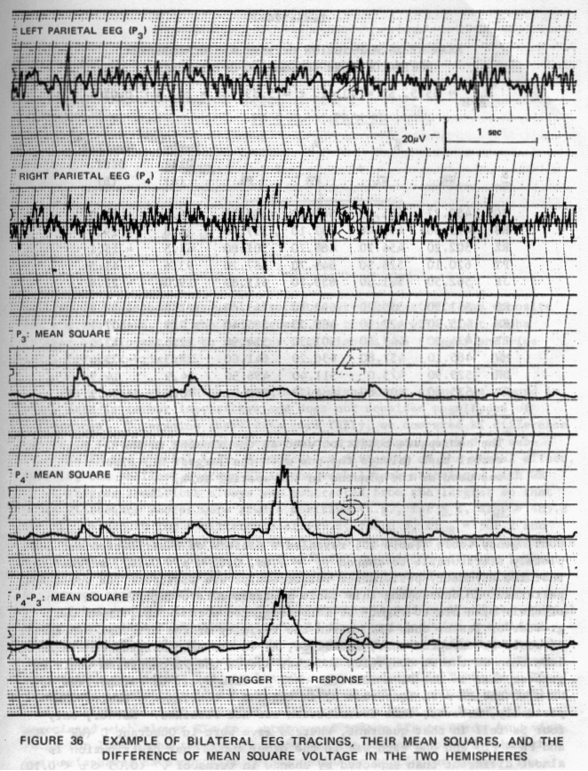

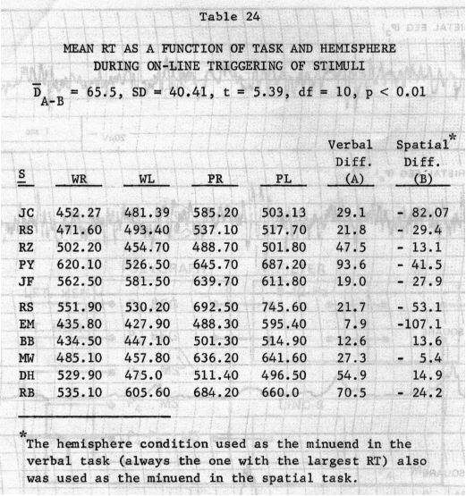

contingency table (Table 25) revealed a pattern of distribution not completely attributable to chance (x2 = 4.66, 0.05 < p < 0.10), suggesting that the asymmetry-performance relationships are different for words and patterns. In developing this table Ss first were categorized in terms of their mean RTs to right- or left-triggered words--i.e., if WR was greater or lesser than WL. Given the validity of the original hypothesis, it would be expected that, in all Ss, RT in the WR condition should be less than in the WL condition and that RTs in the PR condition would be greater than in the PL condition. All Ss then would be categorized as WR < WL and PR > PL (Quadrant B) in the 2 X 2 contingency table. Empirically, however, that distribution was not obtained. Rather, only fourSs fell in that quadrant, whereas five were in Quadrant C (WR > WL and PR < PL) and one each was in the other two. That distribution is almost different than expected by chance in terms of x² (0.05 < p < 0.10) and is meaningful in terms of hemispheric specialization in that the

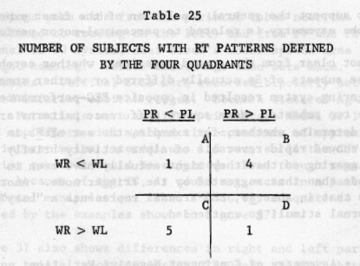

pattern of hemispheric arousal associated with fastest RTs was opposite for the two tasks. Ss who had fastest RTs to words with right alpha trigger had slowest RTs to patterns with right alpha trigger and vice versa for left triggers.

The test with which a marginally significant effect was found in these data is rather insensitive and does not consider magnitudes of differences. To examine these data more fully, we compared RT difference scores in the tasks and hemispheres using a contingent method of subtraction in the spatial task, dependent on direction of the verbal effect. That is, the smallest average RT in the verbal task associated with WR or WL trigger conditions always was subtracted from the largest so that these difference scores were always positive (e.g., for S 1, RTWL = 485.2 and RTwr = 475.10 for a difference of +29.1; for S 3, RTwr = 502.2 and RTWL = 454.7 for a difference of +47.5). To obtain the spatial difference score, the trigger condition (right or left) associated with the largest verbal RT (minuend) also always constituted the minuend in obtaining the difference score for the spatial task. If no consistent difference existed between the direction of effect in the verbal task and the spatial task, no consistent algebraic sign would be associated with the differences obtained in the spatial task, and no significant difference would occur in the means of the verbal and spatial difference columns. These subtractive procedures and results also are tabulated in Table 24. The effect was significant (D = 65.5, t = 539, df = 10, p < 0.01, two-tailed test). Although right hemisphere alpha triggers were not invariably associated with slower RTs to patterns and faster RTs to words (and vice versa for left alpha triggers), these results indicate clearly that the two hemispheres have opposite relationships to particular tasks. The

results also support the general conclusion of the first experiment that EEG alpha asymmetry is related to perceptual-motor performance.

It is not clear from the second experiment whether cerebral organization of the subsets of Ss actually differed or whether some pecularities of the triggering system resulted in opposite EEG-performance relationships in the two subsets. Mean square difference patterns are being examined to determine whether, for example, the set of Ss in Quadrant C of Table 25 showed rapid reversals of alpha activity briefly after stimulus triggering so that they might actually have been in an opposite cognitive mode than that suggested by the trigger mode. Another interpretation is that in some Ss, EEG arousal represents a “busy” mode whereby external stimuli go unattended.

Experiment 3 - Asymmetry of Contingent Negative Variation

In using measures of alpha power and frequency to assess cerebral dominance, it is assumed that these measures reflect states of cortical arousal--greater arousal being associated with higher frequency and less alpha power. Very low-frequency domains in the EEG--D.C. or slow potential (SP) changes--also appear to reflect the state of cortical excitability (Rebert et al., 1967; Rebert, 1972), and such changes often reflect alteration of the cortical state better than does the oscillatory EEG (Rebert, 1973). McAdam and Whittaker (1971) have provided data suggesting that slow motor readiness potentials are asymmetrically distributed in the hemispheres when Ss prepare to make meaningful language sounds in contrast to nonsense sounds, and Low et al. (1974) have reported that the CNV is larger in the language hemisphere when a S vocalizes a word in response to an imperative stimulus. The McAdam-Whittaker study has been sharply criticized on methodological grounds (Morrell and Huntington, 1971; Grabow and Elliot, 1974), and LOW’S studies confound motor preparation with receptive cognitive activity. Other investigators attempting to study CNV asymmetry and cognitive differences in the hemispheres (Marsh and Thompson, 1973) have not been successful. A paradigm suggested by the work of Costell et al. (1972) was used to promote the occurrence of CNV asymmetry related to cognitive differences of the hemispheres. Costell et al. used the same stimulus as S₁ and S₂, but presented it as S₁ only briefly enough to give Ss a clue as to its contents (nude figure), and then with longer exposure as S₂. Similarly, in the experiment described here, either words or spatial patterns were used as both WS and IS. The IS was, however, either an antonym or synonym of the first word or the same or different pattern as the WS. Thus, the appearance of a word WS should- have promoted relatively greater left hemisphere arousal and vice versa for patterns. Verbal and nonverbal trials were intermixed randomly.

Recordings were made from the parietal lobes near the angular gyrus (an area related to reading on the left) and from F7 and F8 of the International 10-20 system, near Broca’s motor speech area on the left and its right homolog. Vertex recordings also were made. Reference was linked mastoids. Vertical EOGs were recorded bipolarly between the superior and inferior orbital ridges. Beckman sintered Ag-AgCl electrodes were used. Potentials were amplified with Grass Model 5P-l chopper-stabilized amplifiers with matched time constants of approximately 4.5 Sec. The interstimulus interval was 1.5 sec, so little CNV attenuation from the time constant would be expected. Even though some attenuation might occur because of the TC, it could not occur in a pattern related to experimental manipulation. That the TC was adequate to record CNVs is indicated by the examples shown in Figure 37.

Figure 37 also shows differences in right and left parietal CNVs in one S during trials involving words. The left area exhibits a larger CNV than the right. Across Ss, such differences were not consistent in the parietal region, although there was a mean trend in that direction. The upper curves in Figure 38 show right and left parietal average CNV amplitudes on word and pattern trials. There is also a tendency for right CNVs to be larger than left during pattern trials, but the Stimulus X Hemisphere interaction was not significant.

Fronto-temporal CNVs are shown in the lower curves of Figure 38. The Stimulus X Hemisphere interaction is much clearer there and is significant (F = 6.93, df = 1.9, p < 0.05). CNV amplitudes at the vertex are shown in the upper center of the graph. These data reflect a typical distribution of CNV amplitude--largest at the vertex, but well sized parietally and very small fronto-temporally. At the vertex and parietal placements, CNVs were slightly larger to words than patterns, reflecting perhaps greater interest-evoking capacity of the words or greater diff iculty and more distractive disruption of the CNVs to patterns.

These data suggest that the use of warning stimuli that themselves require processing directly related to hemispheric specialization leads to a clearer induction of differential “sets” and CNVs than when secondarily meaningful cues such as different tones or lights are used as warning signals to induce differential sets (e.g., Marsh and Thompson, 1973).

One possible criticism of these results became evident on study of recent accounts in the literature concerning eye movements related to cognitive activity. Several papers (e.g., Ornstein, 1973) indicate that lateral eye movements are made in a direction opposite an activated hemisphere--e.g., right movements with left hemisphere arousal. Because

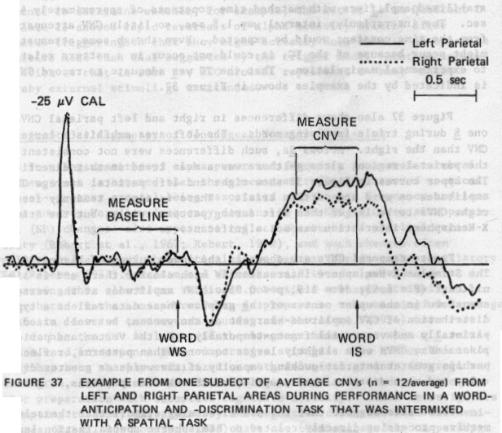

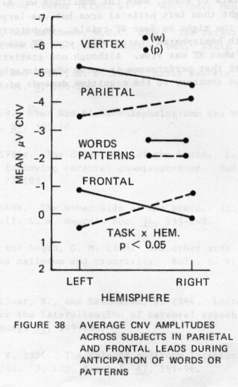

of channel limitations, vertical but not horizontal EOGs were measured in these Ss, primarily because lateral eye movements typically do not occur in the CNV paradigm. Donchin (personal corrmunication) did not detect lateral eye movements in Ss engaged in a cognitive-CNV experiment similar to the one reported here, and a second test of one of our Ss revealed no lateral eye movements as measured by lateral EOGs (between the two outer canthi).

On slow RT trials to words, mean CNV amplitude was slightly larger (0.7 uV) in the right than left parietal area but was larger in the left (1.2 uV) than the right on fast RT trials. On pattern trials, CNV was the same in both hemispheres (parietally) when RT was fast but was larger on the left when RT was slow. Although not statistically reliable, these trends suggest that performance is worse when interhemispheric arousal is patterned contrary to the cognitive demands of the task.

REFERENCES

Adey, W. R., Kado, R. T., and Walter, D. 0. 1967. Computer analysis of EEG data from Gemini flight GT-7. Aerospace Med. 38(4), 345-359.

Adrian, E. D., and Matthews, J3.H.C. 1934. The Berger rhythm: Potential changes from the occipital lobes of man. Brain 57, 355-84.

Benton, A. L., and Joynt, R. J. 1960. Early description of aphasics. Arch. Neurol. 3, 205-222.

Berger, H. 1929. Uber das Elektrenkephalogramm des Menchen. Arch. Psychiat. 87, 527-70.

Bogen, J. E. 1969a. The other side of the brain. I. Dysgraphia and dyscopia following cerebral commissurotomy. Bull. L. A. Neurol. Soc. 34, 73-105.

__________ 1969b. The other side of the brain. II. An appositional mind, Bull. L. A. Neurol. Soc. 34, 135-162.

Bogen, J. E. , and Bogen, G. M. 1969. The other side of the brain. III. The corpus callosum and creativity. Bull. L. A. Neurol. Soc. 34,
191-220.

Branch, C., Milner, B., and Rasmussen, T. 1964. Intracarotid sodium amytal for the lateralization of cerebral speech dominance.
J. Neurosurg. 21, 399-405.

Broadbent, D. E. 1954. The role of auditory location in attention and memory span. 3. Exp. Psychol. 47, 191-96.

Bryngelson, E., and Rutherford, B. 1937. A comparative study of laterality of stutterers and nonstutterers. J. Speech Dis. 2, 15-16.

Buchsbaum, M., and Fedio, P. 1969. Visual information and evoked responses from the left and right hemispheres. Electroenceph. Clin. Neurophysiol., 20, 266-272.

____________ 1970. HemisDheric differences in evoked potentials to verbal and nonverbal stimuli in the left and right visual fields. Physiol. Behav. 5, 207-210.

Butler, R. A., and Galloway, F. T. 1957. Factoral analysis of the delayed speech feedback phenomenon. J. Acoust. Soc. Amer. 29, 632-35.

Butler, S. R., and Glass, A. 1974. Asymmetries in the electroencephalogram associated with cerebral dominance. Electroenceph. Clin. Neurophysiol. 36, 481-491.

Cherry, E. C., and Sayers, M. B. 1956. Experiments upon the total inhibition of stammering by external control, and some clinical results.
J. Psychosomat. Res. 1, 233-46.

Costell, R., et al. 1972. Contingent negative variation as an indicator of sexual object preference. Science 177, 718-720.

Curry, F.K.W. 1967. A comparison of left-handed and right-handed subjects on verbal and nonverbal dichotic listening tasks. Cortex 13, 343-52.

Davis, A. E., and Wada, 3. A. 1974. Hemispheric asymmetry: Frequency anaLysis of visual and auditory evoked responses to nonverbal stimuli. Electroenceph. Clin. Neurophysiol. 37, 1-9.

Dorichin, E., and Lindsley, D. B. 1966. Average evoked potentials and reaction times to visual stimuli. EEG Clin. Neurophysiol. 20, 217-223.

Doyle, J. C., Ornstein, R., and Galin, D. 1974. Lateral specialization of cognitive mode. II. EEG frequency analysis. Psychophysiol. 11, 567- 578.

Eason, R. G., et al. 1967. Evoked cortical potentials: Relation to visual field and handedness. Science 156, 1643-1646.

Friedman, D., et al. 1975. Cortical evoked potentials elicited by reach speech words and human sounds. Electroenceph. Clin. Neurophysiol.
38, 13-19.

Galbraith, C. C. 1967. The effect of prior EEC “coupling” upon the visual evoked response. IEEE Trans. Biomed. Eng. BME-4(4), 223-229.

Calm, D., and Ellis, R. R. 1975. Asymmetry in evoked potentials as an index of lateralized cognitive processes: Relation to EEC alpha asymmetry. Neuropsychologia (in press).

Galin, D., and Ornstein, R. 1972. Lateral specialization of cognitive mode: Art EEC study. Psychophysiol. 9, 412-18.

Geschwind, N., and Levitsky, W. 1968. Human brain: Left-right asymmetries in temporal speech region. Science 161, 186-187.

Glass, A. 1964. Contrasting reactions of evoked auditory response and amplitude histogram to mental arithmetic and eye-opening in man. Free Comm. in EEG.

__________ 1970. Factors influencing changes in the amplitude histogram of the normal EEG during eye opening and mental arithmetic. EEC Clin. Neurophysiol. 28, 423-430.

Glonig, I., Glonig, K., Haub, C., and Quatember, R. 1969. Comparison of verbal behavior in right-handed and non-right-handed patients with anatomically verified lesion of one hemisphere. Cortex 5, 43-51.

Goodgiass, H. 1972. Discussion paper on cortical functioning. In Speech and Cortical Functioning. John H. Gilbert (ed.), Academic Press, New York.

Gott, P. S., and Boyarsky, L. L. 1972. The relation of cerebral dominance and handed to visual evoked potentials. J. Neurobiol. 3, 65-77.

Grabow, J. D., and Elliot, F. W. 1974. The electrophysioLogic assessment of hemispheric asymmetries during speech. J. Speech Hearing 12,
64-72.

Hall, D. J., Ball, C. H., Wolf, D. E., and Eusebio, J. W. 1968. PROMENADE--A system for on-Line pattern recognition. In The Future of Statistics. Academic Press, New York, pp. 390-413.

Hall, 3. L., and Goldstein, N. H. 1968. Representation of binaural stimuli by single units in primary auditory cortex of unanesthetized cats. 3. Acous. Soc. Amer. 3, 456-461.

Herron, 3. 1974. EEC alpha asymmetry and dichotic listening in stutters. Soc. Psychophysiol. Res., 14th Ann. Meeting, Salt Lake (abstract).

John, E. R., Ruchkin, D. S., and Villegas, J. 1964. Experimental background: Signal analysis and behavior correlates of evoked potential configurations in cats. Ann. N. Y. Acad. Sci. 112, 362-420.

Jones, R. K. 1966. Observations on stammering after localized cerebral injury. J. Neurol. Neurosurg. 29, 192-95.

Kimura, D. 1961. Cerebral dominance and the perception of verbal stimuli. Canadian 3. Psych. 15, 166-171.

__________ 1967. Functional asymmetry of the brain in dichotic listening. Cortex 3, 163-178.

__________ 1963. Speech lateralization in young children as determined by an auditory test. J. Comp. Physiol Psychol. 56, 899-902.

Lansdell, H. 1969 Verbal and nonverbal factors in right hemisphere speech.
3. Comp. Physiol. Psychol. 69, 734-38.

Levy, J. 1969. Possible basis for the evolution of lateral specialization of the human brain. Nature 224, 614-15.

Low, N. D., Wada, J., and Fox, N. 1974. Electroencephalographic localization of certain aspects of language production in the human brain. Electroenceph. Clin. Neurophysiol. 36, 562-563.

MacNeilage, P. F., and MacNeilage, L. A. 1971. Central processes controlling speech production during sleep and waking. In Conference on the Psychophysiology of Thinking, F. 3. McGuigan (ed.), Rollins College, VA, October 18-21.

March, C. R., and Thompson, L. W. 1973. Effect of verbal and nonverbal psychological set on hemispheric asymmetries in the CNV. Event-related Slow Potentials of the Brain. W. C. NcCallum and 3. R. Knott (eds.), Elsevier, Amsterdam, pp. 195-200.

Matsumiya, Y., et al. 1972 . Auditory evoked response: Meaningfulness of stimuli and hemispheric asymmetry. Science 175, 790-792.

McAdam, D. W., and Whittaker, H. A. 1971. Language production: Electroencephalographic localization in the normal human brain. Science
172, 499-502.

McGuigan, F. J. 1970. Covert oral behavior during the silent performance of language tasks. Psych. BuLl. 74, 309-326.

McKee, C., Humphrey, B., and McAdam, D. 1973. Scaled lateralization of alpha activity during linguistic and musical tasks. Psychophysiol.
10, 441-43.

Miller, E. 1971. Handedness and the pattern of human ability. Brit. J. Psychol. 62, 111-12.

Nilner, B. 1971. Interhemispheric differences in the localization of psychological processes in man. Brit. Ned. Bull. 27, 272-276.

Morgan, A. H., MacDonald, P. J., and MacDonald, H. 1971. Differences in
bilateral alpha activity as a function of experimental task, with
a note on lateral eye movements and hypnotizability. Neuropsychologia
9, 459-69.

Morgan, A. H., MacDonald, H., and Hilgard, E. 1974. EEG alpha: Lateral asymmetry related to task and hypnotizability. Psychophysiol. 11,
27 5-282.

Norrell, L. K., and Huntington, D.A. 1971. Electrocortical localization of language production. Science 174, 1359-1360.

Morrell, L. K., and Salamy, 3. C. 1971. Hemispheric asymmetry of electrocortical responses to speech stimuli. Science 174, 164-166.

Ornstein, R. 1973 (May). Right and left thinking. Psychol. Today, pp. 87-92.

Orton, S. T. 1927. Studies in stuttering. Arch. Neurol. Psych. 18,
671—72.

Quinn, P. T. 1972. Cerebral dominance and the dichotic word test. Med. 3. Australia 2, 639-43.

Penfield, W., and Jasper, H. H. 1954. Epilepsy and the Functional Anatomy of the Human Brain. Little, Brown, Boston, p. 575.

Penfield, W., and Roberts, L. 1959. Speech and Brain-Mechanisms. Prince-tort University Press, Princeton.

Perrin, K. L. 1969. An examination of ear preference for speech and non-speech stimuli in a stuttering population. Speech Pathol.

Rebert, C. S. 1972. Cortical and subcortical slow potentials in the monkey’s brain during a preparatory interval. Electroenceph. Clin. Neurophysiol. 33, 389-402.

Rebert, C. S., et al. 1967. Slow potential change in human brain related to level of motivation. J. Comp. Physiol. Psychol. 63, 20-23.

Rebért, C. S. 1973. Slow potential correlates of neuronal population responses in the catts lateral geniculate nucleus. Electroenceph. Clin. Neurophysiol. 35, 511-515.

Robbins, K. I., and McAdam, D. W. 1974. Interhemispheric alpha asymmetry and imagery mode. Brain Language 1, 189-193.

Rose, G., and Lindsley, D. B. 1965. Visually evoked electrocortical responses in kittens: Development of specific and nonspecific systems. Science 148, 1244-1246.

Rosenweig, N. R. 1951. Representations of the two ears at the auditory cortex. Am. J. Physiol. 673, 147-158.

Ruhm, H. B. 1971. Lateral specificity of acoustically-evoked EEC responses.
I. Nonverbal, nonmeaningful stimuli. J. Aud. Res. 1, 1-8.

Schwartz, G. E., Davidson, R. 3., Naer, F., and Bromfield, E. 1973. Patterns of hemispheric dominance in musical, emotional, verbal and spatial tasks. Soc. Psychophysiol. Res. Meeting, Galveston.

Stromsta, C. 1958. The effects of altering the fundamental frequency of masking on the speech performance of stutterers. National Institutes of Health Technical Report, Project B-1331.

Sussmann, H. M., and MacNeilage, P. F. 1974. Studies of hemispheric specialization for speech production. In preparation.

Teyler, T. T., et al. 1973. Human scalp-recorded evoked-potential correlates of linguistic stimuli. Bull. Psychol. Soc. 11, 333-334.

Teuber, H. 1962. Effects of brain wounds implicating right or left hemispheres in man: Hemisphere difference and hemisphere interaction in vision, audition, and somesthesis. In Interhemispheric Relations and Cerebral Dominance. V. D. Mountcastle (ed.), Johns Hopkins, Baltimore, MD, pp. 131-157.

Tomatis, A. 1954. Recherches sur La pathogenie du Begaiement. J.F.0.R.L., 3, 384-91.

1963. L’Orielle et le language. Editions du Seuil, Paris.

Travis, L. E. 1931. Speech Pathology. Appleton-Century, New York.

Van Riper, C., and Irwin, J. V. 1958. Voice and Articulation. PrenticeHall, Englewood Cliffs, NJ.

Van Riper, C. 1971. The Nature of Stuttering. Prentice-Hall, Englewood Cliffs, NJ.

Wada, J. 1949. A new method for the determination of the side of cerebral speech dominance. A preliminary report on the intracarotid injection of sodium amyta]l in man. Igaku to Seibutsugaku (Medicine and Biology) 14, 221-22. In Japanese.

Walter, D. 0. 1963. Spectral analysis for electroencephalograms: Mathematical determination of neurophysiological relationships from records of limited duration. Exp. Neurol. 8, 155-181.

Walter, D. 0., and Adey, W. R. 1965. Analysis of brain-wave generators as multiple statistical time series. IEEE Trans. Bio-Medical Eng. BME-12, 8-13.

Watson, J. B. 1930. Behaviorism. University of Chicago Press, Chicago.

Wood, C., Goff, W. R., and Day, R. S. 1971. Auditory evoked potentials during speech perception. Science 173, 1248-1251.

